Case Study Research: The Implementation of Pathways Awarua in Trades Academies

Report to the Tertiary Education Commission

December 2014

Contents
1 Introduction and methodology 4
1.1 Methodology 5
1.2 Research questions 6
1.3 Case selection 7
1.4 Data collection and analysis 7
1.5 Provision of support 9
2 Case one 10
2.1 Case description 10
2.2 Usage and impact of Pathways Awarua 12
2.3 Perspectives on Pathways Awarua 15
2.4 Perspectives on the Youth Option of the Assessment Tool 23
3 Case two 27
3.1 Case description 27
3.2 Usage and impact of Pathways Awarua 29
3.3 Perspectives on Pathways Awarua 32
3.4 Perspectives on the Youth Option of the Assessment Tool 39
4 Case three 44
4.1 Case description 44
4.2 Usage and impact of Pathways Awarua 46
4.3 Perspectives on Pathways Awarua 48
4.4 Perspectives on the Youth Option of the Assessment Tool 53
5 Cross-case findings 56
5.1 Key themes 56
5.2 Summary and recommendations 60
References 62
Appendix A: Timing of data collection 63
Appendix B: Interview schedules 64
Appendix C: Online survey 67
Appendix D: Focus group schedule 72
Appendix E: Pathways Awarua learner guides 73

Tables

Table 1: Research questions and data sources 6
Table 2: Case one overview 11
Table 3: Total numbers of Pathways Awarua reading points gained by case one learners 13
Table 4: Reading Assessment Tool results for case one learners that gained more than 500 Pathways Awarua reading points 13
Table 5: Total numbers of Pathways Awarua numeracy points gained by case one learners 14
Table 6: Numeracy Assessment Tool results for case one learners that gained more than 500 Pathways Awarua numeracy points 15
Table 7: Features of Pathways Awarua that case one learners liked 17
Table 8: Features of the Assessment Tool case one learners liked 24
Table 9: Case two overview 28
Table 10: Total numbers of Pathways Awarua reading points gained by case two learners 29
Table 11: Reading Assessment Tool results for case two learners that gained more than 500 Pathways Awarua reading points 30
Table 12: Total numbers of Pathways Awarua numeracy points gained by case two learners 31
Table 13: Numeracy Assessment Tool results for case two learners that gained more than 500 Pathways Awarua numeracy points 31
Table 14: Features of Pathways Awarua that case two learners liked 33
Table 15: Features of the Assessment Tool that case two learners liked 39
Table 16: Case three overview 45
Table 17: Total numbers of Pathways Awarua numeracy points gained by case three learners 47
Table 18: Numeracy Assessment Tool results for case three learners that gained more than 500 Pathways Awarua numeracy points 47
Table 19: Features of Pathways Awarua that case three learners liked 49
Table 20: Features of the Assessment Tool that case three learners liked 53
Table 21: Perceived value of Pathways Awarua across cases 56
Table 22: Perceived value of the Youth Option of the Assessment Tool across cases 57
Table 23: Pathways Awarua points gained across cases 57
Table 24: Pathways Awarua points gained across cases 58

Introduction and methodology
A certain level of competence in literacy and numeracy is needed for people to participate fully in information-rich societies and the development of these skills is a priority across the education sector. Adults with low levels of literacy and numeracy skills face limitations in their work, community and home lives, including finding and keeping a job and supporting their children’s learning (Satherley, Lawes, & Sok, 2008).
Information about the literacy and numeracy capabilities of the general population was obtained through New Zealand’s participation in both the 1996 International Adult Literacy Survey (IALS), and the 2006 Adult Literacy and Life Skills Survey (ALL). Concerns were raised about the skill levels of the general population, and it was found that, on average, young adults had lower levels of capability than older adults. For example, the ALL survey reported that in the 16-24 year old age group 48 percent of New Zealanders are below Level 3 for document literacy and 58 percent below Level 3 for numeracy (Satherley, Lawes, & Sok, 2008a). More concerning, 14 percent of young adults are at Level 1 for document literacy, and 23 percent of young adults are at Level 1 for numeracy (Satherley & Lawes, 2008). Level 3 is “deemed as a minimum for persons to understand and use information contained in the increasingly difficult texts and tasks that characterise the emerging knowledge society and information economy” (Statistics Canada & Organisation for Economic Cooperation and Development, 2005). Level 1 represents a very low level of literacy and numeracy competence.
In response to these findings the Government has prioritised literacy and numeracy in both the secondary and tertiary education sectors through both the Better Public Service (BPS) targets and the Tertiary Education Strategy (TES). The BPS target of “85 percent of 18-year-olds achieving the National Certificate of Educational Achievement (NCEA) Level 2 or an equivalent qualification by 2017” (Ministry of Education, 2014a) and the TES priorities of “Improving adult literacy and numeracy” and “Getting at-risk young people into a career” (Ministry of Education, 2014b) are all relevant in this regard.
The Youth Guarantee initiative is one of the ways the Government is addressing the need to improve the literacy and numeracy skills of young adults. Youth Guarantee aims to ensure all young people achieve Level 2 NCEA. It provides 16 and 17 year-olds with a range of learning opportunities by enabling schools, tertiary providers and employers to work together to deliver qualifications at Levels 1-3 on the New Zealand Qualifications Framework. As part of the Youth Guarantee initiative trades academies deliver trades and technology programmes to students in Years 11 to 13, based on partnerships between schools, tertiary organisations, industry training organisations and employers. Students in these programmes combine study at a trades academy with studies towards their NCEA. Outcomes include Level 2 NCEA and a nationally transferable Levels 1, 2, or 3 tertiary qualification.
Two key components of the Tertiary Education Commission (TEC) infrastructure focused on literacy and numeracy provision are Pathways Awarua and the Literacy and Numeracy for Adults Assessment Tool (Assessment Tool). Pathways Awarua is an online learning platform designed to support adults to improve their literacy and numeracy skills. Over 200 educational organisations within the tertiary sector choose to use it with learners working towards qualifications at Levels 1 to 3 of the New Zealand Qualifications Framework. The Assessment Tool provides online computer adaptive literacy and numeracy assessments. Results are given in relation to the Learning Progressions for Adult Literacy and Numeracy (Tertiary Education Commission, 2008). In 2011, the TEC introduced the requirement that all funded learners in Levels 1 to 3 programmes whose courses include embedded literacy and numeracy be assessed using the Assessment Tool, and providers are expected to use the reports to inform and improve their teaching. The Youth Option of the Assessment Tool was launched in 2014 to increase the engagement of young adults in the assessment process by including questions that were designed to represent contexts that are of interest to young adults.
This project investigated the implementation and impact of Pathways Awarua and the Assessment Tool within the context of trades academies. The work informs both how to most effectively use Pathways Awarua in trades academies, and the future development of Pathways Awarua content. As a secondary purpose it examines the use of the Youth Option within the Assessment Tool as a mechanism for measuring and tracking the reading and numeracy skills of youth learners.

Methodology
The project utilised Yin’s case study methodology (Yin, 2003). More specifically the approach was based on an explanatory model, as it sought to identify and elucidate effective approaches for utilising Pathways Awarua and the Assessment Tool in trades academies. A multiple case design was used, with three cases. Figure 1 provides an overview of the methodology.
Figure 1: Methodology

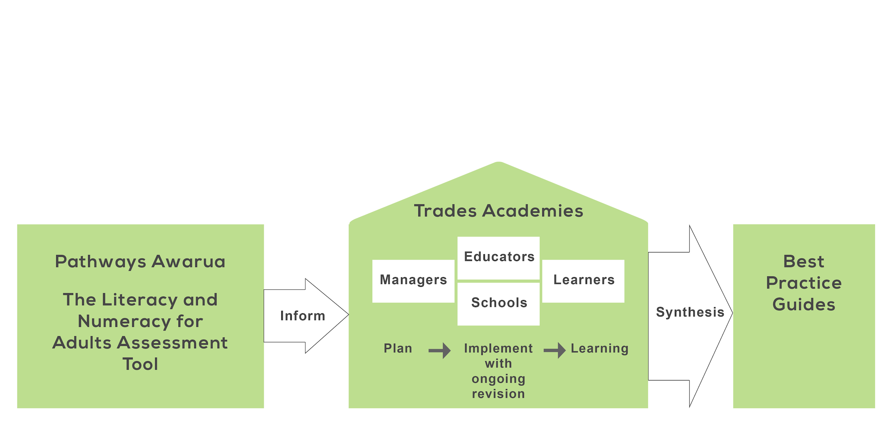

Managers and educators in each of the three trades academies were informed about Pathways Awarua, and then supported by the researchers as they planned and implemented its use with learners. Learners completed the Assessment Tool, using the Youth option where possible, at the start and end of the trades academy programme. At the completion of the programmes, the researchers reviewed the implementation in each academy, and synthesised findings across the cases to identify successful approaches. These were then used to develop Best Practice Guides for the use of Pathways Awarua in trades academies.

Research questions
The research questions addressed are listed in Table 1, along with their corresponding data sources.
Table 1: Research questions and data sources
 | Research questions | Data sources
Managers | - To what extent do managers value having access to Pathways Awarua?  - To what extent do managers value the Youth Option of the Assessment Tool?  - What is the manager’s role in the successful implementation of Pathways Awarua and the Youth Option of the Assessment Tool? | Interviews with managers (initial and final)
Educators | - What is the most effective way to engage learners with the Youth Option of the Assessment Tool?  - To what extent did learners engage with the Youth Option of the Assessment Tool compared to the Full Assessment?  - What is the most effective way to use Pathways Awarua to strengthen the literacy and numeracy skills of learners?  - How could the content or functionality of Pathways Awarua be improved to better meet the needs and/or interests of learners in Secondary-Tertiary programmes?  - To what extent do the educators value having access to Pathways Awarua and the Assessment Tool? | Interviews with educators (initial, mid-, and final)  Evidence of developing practice as implementation progresses: documents, communication logs, and observations
School | - What is the most effective way to use Pathways Awarua to within a school context to strengthen the literacy and numeracy skills of learners?  - To what extent does the school value having access to Pathways Awarua? | Interview with coordinating teachers (final)
Learners | - How did the learners use Pathways Awarua?  - What do learners value about Pathways Awarua and the Youth Option of the Assessment Tool?  - To what extent did the learners believe that Pathways Awarua improved their literacy and/or numeracy?  - To what extent did learners engage with the Youth Option of the Assessment Tool, particularly in the post assessment?  - Did the learners make measurable improvements in reading and/or numeracy? | Assessments from the Youth Option in the Assessment Tool (initial and final)  Learning records from Pathways Awarua  Online survey & focus groups (final)

A mixed-methods approach was employed, combining both qualitative and quantitative data sources. Interviews were conducted with managers, educators, and coordinating teachers from schools. An online survey and focus groups were carried out to collect information from learners. A record of the communication between educators and researchers was collected as the project progressed, and observations were noted. In terms of quantitative data, learner results from the Assessment Tool and Pathways Awarua usage logs were collected.

Case selection
Three cases were selected from the population of eleven TEC funded trades academies. Selection was made to ensure a substantial proportion of Māori and Pasifika learners were included in the sample, and both full-time and part-time models were represented. Consideration was also given to the logistics of the researchers’ travel between the academies. One of the academies declined the invitation to participate and a replacement was selected.
Trades academy courses were structured differently in each of the cases.
- Case one: The trades academy was a part-time programme, running for one full secondary school year. Learners attended the trades academy one day a week, and attended secondary school four days a week. Two-hundred-and-sixty-five learners were enrolled in the programme in 2014, and the case study focused on 49 learners who were located at one campus.
- Case two: The trades academy was a part-time, 10-week programme, which started mid-year (week 2, term 3). Learners attended the trades academy three days a week, and attended school two days a week. The course was a pilot programme for the organisation. Their regular trades academy programme was a full-year, part-time programme that learners attended one day a week. The 30 learners who were enrolled in the pilot programme all participated in the case study.
- Case three: Learners attended the trades academy full-time, in a programme that ran for the length of one full secondary school year. Learners were also enrolled at a secondary school, and were generally involved in extracurricular activities such as sport, and attended social events at school. Just over 100 learners were enrolled in 2014.

Data collection and analysis
A variety of methods were used to collect data and these are described below. Further information about the timing of data collection in each trades academy is provided in Appendix A.

Interviews
The initial interviews with managers and educators, and the final interviews with managers, educators and coordinating teachers were carried out face-to-face, with the use of interview schedules. Copies of these schedules are included as Appendix B. The interview schedules were used to structure the discussions, and the researcher explored other issues that arose as appropriate. All interviews were audio-recorded and notes were taken following the interview.
The mid-implementation interviews with educators were carried out by phone. An unstructured format was used which enabled the researcher to address the needs of each trades academy as appropriate. Notes were taken during the interviews.

Online survey
An online survey was used to gather information from learners at the conclusion of the trades academy programme. A copy is included as Appendix C. Educators were provided with a web link to access the survey, and arranged for learners to complete it at a convenient time near the end of the programme.

Focus groups
Face-to-face focus groups were held to gather further information from learners. A schedule was developed to guide discussions and a copy of this is included as Appendix D. Educators were asked to arrange groups of approximately six learners, with a mix of those who had engaged well with Pathways Awarua and those who had not. Groups consisted of three to seven learners, and one or two groups were held at each trades academy. The researcher also included additional questions to investigate other issues as they arose in discussion. Focus groups were audio-recorded, and notes were taken at the conclusion of each session.

Communication logs and observations
A copy of all communication with each trades academy was kept on file. Email messages were printed and collated, notes about phone calls were made, and any other relevant observations were also noted and filed.

Assessment Tool results and Pathways Awarua learning records
Participating trades academies provided initial and final results from the Assessment Tool for learners in the case study. Data provided included the date of the assessment, the scale score including a margin of error, and the overall step of the learning progressions the learner had been assessed at.
Learning records were downloaded from Pathways Awarua at the conclusion of each trades academy programme. Records included a list of the modules learners had used, the number of points per module, and the total points scored in each of the reading and numeracy pathways over the course of the project. The dates learners had logged in were also available.
Assessment Tool results and Pathways Awarua records were matched for individual learners using learners’ names and National Student Numbers (NSN).
Further information about the timing of data collection within each trades academy is provided in the individual case analyses, chapters three to five.
Analysis took part in two phases:
- Case analysis: each of the three cases was analysed individually. Case descriptions were developed and all relevant data was synthesised and applied to answer each of the research questions.
- Cross-case analysis: results from the analysis of each case were reviewed in order to identify common themes.

Provision of support
The researchers provided support to each trades academy over the course of the case study. While this was focused on maximising the use of Pathways Awarua and the Youth Option of the Assessment Tool, care was taken not to over-incentivise involvement to ensure findings were generalisable.
Initially, the researchers visited each trades academy to establish contact, and inform managers and educators about Pathways Awarua and the Youth Option of the Assessment Tool. At this meeting participants were also offered the opportunity to have a structure developed within their Pathways Awarua educator account to enable more than one educator to view information about learners’ usage. Two of the three trades academies (cases one and two) opted for this enhanced structure.
Following the initial meeting the trades academies were provided with a learner guide to assist them when engaging learners with Pathways Awarua. Two versions of the guide were developed in response to feedback from participants. Copies of these are included as Appendix E. Participating learners were advised that they would be eligible to enter the draw to win an iPad if they accumulated more than 1,000 points over the course of the study.
As the study progressed researchers maintained regular contact with participants, and provided support as required. This included technical support, feedback about learners’ usage, the facilitation of communication between trades academies and schools, and general encouragement.

Case one

Case description
Learners attended the case one trades academy programme one day a week, and attended secondary school for the remaining four days. The programme operated within two 15 week semesters, during terms one, two, and three of the school year. The trades academy was large and included approximately 265 learners from over 30 schools in 2014, with 11 different trades programmes on offer. Learners undertook study towards Levels 2 and 3 credits that contributed to both NCEA and industry qualifications. The case study focused on 25 learners who were enrolled in two programmes at one campus: the automotive programme, and the hair, beauty and fashion programme.
Three staff members were involved in the case study. Educator one was employed as a learning support coordinator for both programmes to provide career guidance and pastoral care, and support the development of literacy and numeracy skills. She arranged for learners to use Pathways Awarua each week, and provided encouragement and assistance during this time. She was also employed as the tutor in the hair, beauty, and fashion programme. Educator two was employed as the tutor in the automotive programme. He encouraged learners to use Pathways Awarua, but did not work with them on it directly. The manager filled the position of trades academy manager within the organisation, and had a special interest in the connection between tertiary education providers and employers.
The trades academy was already an established user of Pathways Awarua. The individual support and mentoring carried out by learning support coordinators was regarded as a very important component of the trades academy programme, and Pathways Awarua was viewed as an important component of the learning support. Learners spent the first hour of the trades academy day with their learning support coordinator. Pathways Awarua was utilised within this one hour learning support session, and learners were also encouraged to use Pathways Awarua at home or school if possible.
Several events at the organisation impacted on the case study. Initially, it was planned that two learning support coordinators would participate in the study, but one of these needed to withdraw due to workload issues. In addition, one of the case study learners died in a car accident during the study, and this impacted the programme for some time, as his best friend and his girlfriend were also learners on the programme.
Table 2 provides an overview of case one. The total number of Pathways Awarua points scored each month is provided as an indication of the extent to which the learners used Pathways Awarua. Each point gained represents one question answered correctly. Note that the trades academy programme began at the start of the school year, and the case study commenced in June. The trades academy concluded for the year at the end of the third school term (26 September) and students returned, five days a week, to their contributing schools. More detail on the dates of data collection are provided in Appendix A.
Table 2: Case one overview
Month | Data Collection | Implementation actions | Total points scored (25 learners) | Average total points per learner
June | Initial interview: manager and educator | Initial support visit: meeting key personnel, identification of potential cohorts for case study, decision on appropriate structure for educator account.  Arrangements confirmed via email: two educators to participate, each with two classes of learners.  Structure for Pathways Awarua educator account created and details provided.  Draft user guide provided and feedback received.  Second learner guide developed on basis of feedback. | 2,999 | 120
July |  | Second learner guide provided and feedback received.  Learner guides (2) delivered.  Communication about involvement of main contributing schools.  Researchers reviewed learners’ Pathways Awarua usage. | 2,026 | 81
August | Mid-implementation interview: educator | Feedback to educator on learners’ Pathways Awarua usage and assistance offered.  One educator withdraws from case study due to workload issues.  Follow up and communication regarding participation of main contributing school. Researcher invites schools to participate and educator visits schools (2) and provides information about Pathways Awarua. School one accepts invitation to participate. | 3,629 | 145
September | Final interview: educators (learning support and trades)  Final interview: manager  Learner focus group  Learners complete online survey | Researchers reviewed learners’ Pathways Awarua usage.  Follow up and communication with contributing schools. School two accepts invitation to participate.  Communication about data collection. Learner survey provided.  Learners finish trades academy programme. | 7,399 | 296
October | Initial and final Assessment Tool data received | Feedback to schools on learners’ Pathways Awarua usage. | 0 | 0
November | Pathways Awarua learning records downloaded  Interview: school staff (2) |  | 345 | 14

Initial arrangements for the case study were made in June. Case study learners began work on Pathways Awarua promptly, as they were all registered users and had worked on Pathways Awarua earlier in the trades academy programme. Learners’ usage of Pathways Awarua increased over the course of the study, but in general remained reasonably low. For example in September, the month in which the greatest number of points was gained, learners gained an average of 296 points. This indicates they completed an average of approximately three modules, and spent an estimated 90 minutes working on Pathways Awarua that month. While this is a reasonable proportion of the learning support programme, it is a minimal amount of time in terms of any learning gains that might be expected. Final interviews with trades academy staff took place in September, just prior to the conclusion of the programme. Interviews with staff of the two schools involved took place in November, following the implementation of Pathways Awarua within school programmes.
Several types of data were gathered from learners. Fifteen survey responses were received from the 25 learners enrolled in the programme and all of these were complete. One focus group was held with learners enrolled in the automotive programme, and seven learners participated. Initial and final Assessment Tool results in reading were received for 17 learners, and all of these could be matched with Pathways Awarua learner records. Similarly, initial and final Assessment Tool results in numeracy were received for 16 learners, and all of these could be matched with Pathways Awarua learner records.

Usage and impact of Pathways Awarua
Pathways Awarua was used within the learning support component of the trades academy programme. As described above learning support coordinators worked with learners to provide career guidance and pastoral care, and to support the development of literacy and numeracy skills. Each case study learner was provided with opportunities to work on Pathways Awarua during the one hour learning support session at the start of their trades academy programme day. Educator one supervised this work and provided assistance as required. She also reviewed learners’ progress and provided them with feedback about the points they had gained, and reminded them they would be in the draw to win an iPad if they gained over 1,000 points by the end of the programme.
Table 3 summarises the total numbers of points gained by learners on the Pathways Awarua reading pathway during the course of the study.

Table 3: Total numbers of Pathways Awarua reading points gained by case one learners
Number of points | Number of learners
0 to 99 | 2
100 to 199 | 2
200 to 299 | 2
300 to 399 | 1
400 to 499 | 1
500 or more | 9

The total numbers of reading points scored indicate that some learners used Pathways Awarua more extensively than others. Eight of the learners for whom data is available accumulated less than 500 reading points over the duration of the study, while nine learners accumulated more than 500 points. As each reading module contains approximately 50 points, and takes an estimated 30 minutes to complete, it is likely that learners completing less than 500 points have spent less than five hours working on Pathways Awarua and anything less than this is considered unlikely to produce any effect on learners’ achievement.
It is likely that the nine learners who gained more than 500 Pathways Awarua reading points over the duration of the study have spent more than five hours working on reading in Pathways Awarua. It is possible that, if targeted effectively, this may have had an impact on their reading competency. The initial and final reading results from the Assessment Tool for these learners are shown in Table 4. An asterisk indicates gain scores that are statistically significant. A statistically significant gain is one that represents real learning progress and cannot be explained as resulting from the imprecision associated with assessment scores.
Table 4: Reading Assessment Tool results for case one learners that gained more than 500 Pathways Awarua reading points
Learner | Pathways Awarua reading points scored | Initial scale score, learning progression step | Final scale score, learning progression step | Gain
Learner one | 542 | 463 ± 39, step 2 | 547 ± 40, step 3 | 84 ± 56
Learner two | 723 | 647 ± 43, step 4 | 582 ± 39, step 3 | -65 ± 58
Learner three | 914 | 561 ± 37, step 3 | 500 ± 37, step 2 | -61 ± 52
Learner four | 1025 | 714 ± 56, step 5 | 696 ± 49, step 5 | -18 ± 74
Learner five | 1053 | 623 ± 41, step 4 | 650 ± 44, step 4 | 27 ± 60
Learner six | 1183 | 676 ± 48, step 4 | 622 ± 43, step 4 | -54 ± 64
Learner seven | 1229 | 676 ± 48, step 4 | 612 ± 37, step 4 | -64 ± 61
Learner eight | 1250 | 676 ± 48, step 4 | 586 ± 40, step 3 | -90 ± 62
Learner nine | 2350 | 714 ± 56, step 5 | 617 ± 39, step 4 | -97 ± 68

As seen in Table 4, two learners (learner one and learner five), made learning gains as measured by the Assessment Tool, although neither of these were statistically significant. The apparent declines of the remaining learners are likely to be accounted for either within the margins of error of the initial and final scale scores, or as a result of learners’ disengagement with either or both of the assessments, resulting in inaccurate scale scores.
Overall, the low levels of engagement with Pathways Awarua reading modules, and the inconclusive results for those learners gaining over 500 points mean that it is not possible to draw any conclusions about the effectiveness of Pathways Awarua in strengthening learners’ reading skills.
Table 5 summarises the total numbers of points learners gained in the Pathways Awarua numeracy pathway during the case study.
Table 5: Total numbers of Pathways Awarua numeracy points gained by case one learners
Number of points | Number of learners
0 to 99 | 1
100 to 199 | 2
200 to 299 | 0
300 to 399 | 2
400 to 499 | 4
500 or more | 7

Consistent with the results for reading, results suggest that some learners engaged more than others with the Pathways Awarua numeracy modules. Nine learners gained less than 500 numeracy points. As described above it is likely that these learners have spent less than five hours working on numeracy in Pathways Awarua, and this is considered insufficient to produce any learning gain.
Seven learners gained more than 500 numeracy points, and it is likely that they spent at least five hours working on Pathways Awarua numeracy modules over the course of the case study. It is possible that if this work was targeted effectively, some observable learning gain may be evident. Table 6 provides the initial and final numeracy scale scores for the seven learners concerned. Note that none of the gains are statistically significant.

Table 6: Numeracy Assessment Tool results for case one learners that gained more than 500 Pathways Awarua numeracy points
Learner | Pathways Awarua reading points scored | Initial scale score, learning progression step | Final scale score, learning progression step | Gain
Learner one | 525 | 655 ± 57, step 5 | 573 ± 38, step 4 | -82 ± 69
Learner two | 532 | 470 ± 40, step 3 | 538 ± 40, step 4 | 68 ± 57
Learner three | 544 | 586 ± 44, step 4 | 636 ± 37, step 5 | 50 ± 57
Learner four | 769 | 616 ± 49, step 5 | 655 ± 38, step 5 | 39 ± 62
Learner five | 1057 | 616 ± 49, step 5 | 589 ± 37, step 4 | -27 ± 61
Learner six | 1282 | 616 ± 49, step 5 | 594 ± 37, step 4 | -22 ± 61
Learner seven | 1488 | 714 ± 76, step 6 | 612 ± 38, step 5 | -102 ± 85

Three of the learners (learners two, three, and four) made positive learning gains, although none of these were statistically significant. The apparent declines made by the remaining four learners are not statistically significant and represent the imprecision associated with the assessment scores.
In accordance with the results for reading, learners’ low levels of engagement with the numeracy modules, and the inconclusive results for learners who gained more than 500 numeracy points over the duration of the case study, do not provide sufficient evidence from which to draw any conclusions about the effectiveness of Pathway Awarua in strengthening the numeracy skills of case study learners.

Perspectives on Pathways Awarua

Learners
This section describes learners’ perceptions of Pathways Awarua, as collected by the online survey and the focus group. It is worth noting that the response rate to the survey was reasonably low, with responses received from 15 of the 25 enrolled learners. Additionally, learners’ levels of engagement with Pathways Awarua were mixed, for example eight learners spent less than five hours in total working on their reading in Pathways Awarua. Consequently, learners’ perceptions need to be regarded with care.

How did the learners use Pathways Awarua?
Learners were provided with the opportunity to work on Pathways Awarua, as part of the learning support component of their trades academy programme. Findings suggest that some students took advantage of this, while others didn’t. In survey responses 40 percent of learners indicated they logged in once a week and 47 percent indicated they logged in just a couple of times. The remaining 13 percent indicated that they logged in most days, a finding that is not substantiated by the usage data or focus group interview. Focus group participants described logging in each week, with the support of educator one, their learning support tutor.
Survey responses suggest that learners logged in to Pathways Awarua for up to an hour at a time. Sixty percent of respondents indicated that they logged in for an average of 30 minutes to one hour, and 33 percent indicated that they logged in for less than 30 minutes. Seven percent of respondents indicated that they logged in for more than an hour.
The majority of learners received support from educator one, when working on Pathways Awarua. Eighty percent of survey respondents indicated this was the case, while 7 percent indicated they had received support from friends, and 13 percent indicated they had not received any assistance. Discussion in the focus group similarly indicated that educator one provided almost all the assistance, with one learner commenting that their trades tutor “does the mechanics side”.
Findings indicate that case one learners mostly accessed Pathways Awarua from the trades academy. Ninety-three percent of survey respondents indicated this was the case, while 27 percent indicated they accessed Pathways Awarua from school and 20 percent indicated they accessed it from home. Discussion in the focus group supported this view, with just one learner stating he had logged in from school and three students describing logging in from home.
Further, focus group participants indicated they might have logged in from school more often, if they had not been so busy with schoolwork. They explained that although they miss one day of school a week when they are attending the trades academy, they carry a full school course load, and are expected to catch up with the work that is covered in that day.
Nah, I was pretty busy at school, like getting all the credits and stuff … and all our subjects are like, practical, so every day I was just trying to catch up. Learner, focus group.
Learners also outlined a number of reasons for not logging in to Pathways Awarua from home. These included lack of a computer with internet access (one learner), slow internet speeds, and siblings occupying the available computer.
I did log on from home … when my brothers and sisters weren’t on the computer. Learner, focus group.

What do learners value about Pathways Awarua?
The survey provided learners with a list of Pathways Awarua features, and asked them to indicate which features they liked. Table 7 summarises these results.

Table 7: Features of Pathways Awarua that case one learners liked
Feature | Proportion of learners (n)
Improving my maths or reading | 73% (11)
Seeing my progress on the learning file | 60% (9)
Learning at my own pace | 53% (8)
Helped me with my school work | 53% (8)
Being able to learn online or on computers | 40% (6)
Being able to retry answers | 40% (6)
Helped me with my trades academy work | 33% (5)
Getting points in modules | 33% (5)
Modules were relevant to my life | 20% (3)
Having the computer read out the writing for me | 13% (2)
Getting certificates | 7% (1)
The marking | 7% (1)

The most popular feature of Pathways Awarua was that it helped learners improve their maths or reading. Seventy-three percent of learners indicated that they liked this. Other features that were liked by the majority of leaners were seeing their progress on the learning file (60 percent of learners), learning at their own pace (53 percent of learners), and that it helped with school work (53 percent of learners).
Focus group learners were very positive about Pathways Awarua, and listed a variety of features that appealed to them. These included the realistic learning contexts, the ability to choose what they were working on, the ability to revisit and redo work, picking up from where they had previously finished working, and the open ended time frames.
The modules are very realistic, like things that actually are in real life. Learner, focus group.
The good thing is you can choose your own level, like if you start and it’s a bit [easy] … you can skip all the easy ones. And if you know some parts of maths, and some parts you don’t you can just go the part you don’t know. Learner, focus group.
You can go back and redo the answers if you get it wrong. Learner, focus group.
You can go back to them. If you’re half way through a module and go back to it you can carry on from where you were. Learner, focus group.
The modules don’t have time limits. You can take your time and there’s no pressure to answer it right then. Learner, focus group.
The survey also asked learners to identify any Pathways Awarua features that they didn’t like. Sixty-nine percent of learners indicated they did not like some of the activities: 31 percent the modules were boring, 15 percent the modules were not relevant to them, and 15 percent didn’t like some of the images.
When focus group participants were asked what they didn’t like about Pathways Awarua, discussion centered around the fact that it was essentially an English and maths site, and these were subject areas that didn’t appeal. They stressed that Pathways Awarua was as appealing as it could be for them, given they don’t really like the material it presents, and stated that they thought Pathways Awarua was better than school in this regard.
It’s boring… any sort of English and maths is boring. That’s not something that they could change. Learner, focus group.
It’s not like when you’re at home you think, “Oh I’ll go and do my maths homework.” It’s more like, “Oh, I’ll go and play x-box.” Learner, focus group.
It’s better than doing, like work at school. Learner, focus group.
Evidence suggests learners were both extrinsically motivated, and intrinsically motivated to work on Pathways Awarua. Eighty-seven percent of survey respondents indicated they worked on Pathways Awarua because it was part of their course at the trades academy, and 27 percent indicated they did so because they wanted to win an iPad. Forty-seven percent of learners surveyed indicated they worked on Pathways Awarua because they wanted to improve their reading or maths. Note that respondents could choose more than one reason if they felt it was appropriate. Focus group participants described working on Pathways Awarua because they were instructed to, but stated “we didn’t mind it, it wasn’t like a bad thing.”
While learners in the focus group felt they were unlikely to work on Pathways Awarua once they finished the programme at the trades academy, they thought they might use Pathways Awarua if they felt like they needed learning assistance in the future.
If I was struggling or something ... then yeah maybe I’d use Pathways …I f I needed to get more maths and English. Learner, focus group.

To what extent did the learners believe that Pathways Awarua improved their literacy and/or numeracy?
Survey responses indicate that most learners believe Pathways Awarua helped them improve their reading skills. Fifty-eight percent of learners who worked on reading modules indicated that it helped a little, while 8 percent indicated that it helped a lot. Thirty-three percent of learners who worked on reading modules believed that Pathways Awarua didn’t help them improve their reading. Learners’ descriptions of what they had learnt were mostly short and very general, but more specific answers included:
I learnt the requirements of a passport, among other things. Learner, survey response.
Spelling. Learner, survey response.
I did not learn, it was more like revision, but that is still good. Learner, survey response.
Similarly, survey responses from the learners who worked on maths modules indicate that most learners believe Pathways Awarua helped them improve their maths. Seventy-one percent indicated that it helped a little; 14 percent it helped a lot; while 14 percent it didn’t help. Learners’ descriptions of what they had learnt included:
Different ways to find an answer. Learner, survey response.
I learnt a lot of different kinds of maths but especially a lot of different ways to solve different kinds of problems. Learner, survey response.
Especially with fractions and things like that, like getting the hang of them more…doing it quicker. Learner, focus group.
When you want to find an answer there’s more ways to do it. Learner, focus group.
In general, focus group learners believed that Pathways Awarua would have been more effective in improving their skills, if they had spent more time working on it.
I reckon Pathways could have helped, but I don’t reckon I did enough work on it ... If I did it for like an hour a day then it would help, but I don’t, so…Learner, focus group.

Educator
This section describes the views of the two educators. Educator one was the learning support coordinator for the case study learners and was also employed as a tutor in the trades academy hair, beauty, and fashion programme. She provided learners with opportunities to log in to Pathways Awarua, and supported them as they worked on it. Educator two was employed as the tutor in the automotive programme. He encouraged learners to use Pathways Awarua, but did not work with them on it directly.

What is the most effective way to use Pathways Awarua to strengthen the literacy and numeracy skills of learners?
The educators believed that learners needed sufficient time in order to maximise their use of Pathways Awarua. They outlined that 2014 had been less successful than 2013 for Pathways Awarua in the trades academy due to a lack of time in the programme, and attributed this to several factors. The learning support programme had been restructured in 2014 to include a careers and personal development programme, worth 16 Level 2 credits, the 34 week trades academy programme had been reduced to 30 weeks, and the programme had gone from a 5.00pm finish time to a 3.00pm finish time. All these changes effectively reduced the time available in the learning support programme to address learners’ literacy and numeracy skills on Pathways Awarua.
The two educators had worked together for three years and had developed a structure for the daily trades academy programme that suited both them and their learners. They chose to spend the majority of the time allocated to learning support with all learners together at the start of the day. During this time learners worked on Pathways Awarua while educator one took care of administrative details such as the roll, provided assistance with Pathways Awarua as required, and was available to address any pastoral care matters. The careers and personal development programme was also delivered in this time. They explained that they preferred this structure to the regular learning support programme used by the organisation, which involved withdrawing learners for 10 minute one-on-one sessions with their learning support coordinator once a week, and described several benefits of their approach.
It’s a gentle way to turn their brain on. They’re learning but it’s not “blah, blah, blah” and someone up the front. We also found that our students aren’t necessarily here right on nine. Pathways allows that flexibility if they’re late, or you want to take a student out… it’s brilliant, it’s absolutely brilliant. Educator one, final interview.
The idea is that by the time I get them at 10:30, hopefully they’re all good…and it usually works that way…I usually get a settled group of students that I can work with for the rest of the day. Educator two, final interview.

Both educators agreed that Pathways Awarua would be more effective if they could integrate it more closely with the vocational component of the course. They saw two ways to achieve this: either to have learners complete relevant modules during learning support in preparation for upcoming vocational work, or to have learners complete relevant modules during vocational programme time. In order to do this they thought it would be helpful to have more detailed information about the content of each Pathways Awarua module, as this would enable them to identify the most relevant modules for each trades programme.
Next year we’ll have new lecturers, and I’ll organize a training day … and that’s where I’ll talk about it. What I’d like to be able to say to a lecturer of hospitality say … look if you’re doing measurements and gram conversions you can go onto Pathways Awarua, these students already have their login, click on module 5070, and use this to support your learning. Educator one, final interview.

The educators also explained they thought Pathways Awarua would be more effective for trades academy learners if it could be integrated into both school programmes and trades academy programmes. Educator one explained that she had contacted the two schools that contributed the largest numbers of learners to the programme. While they had been initially interested, their enthusiasm decreased when they learnt that using Pathways Awarua did not entitle learners to any additional NCEA credits. Despite this, she thought there was opportunity to get them involved.
I don’t think our schools are opposed to it, it’s just a matter of getting them on board. Educator one, final interview.

Several other factors were identified by the educators as contributing towards the effective use of Pathways Awarua in trades academies. These included feedback about the numbers of points they had gained, and general encouragement.
I’d give them feedback about the points they had scored, sporadically, from time to time, and joke with them that I was going to check on them. I just gave them a gentle reminder and some encouragement. Educator one, final interview.
Our learners are enthusiastic because we’re enthusiastic. It’s important that you’ve got enthusiastic people that really are buying in. Educator one, final interview.

How could the content or functionality of Pathways Awarua be improved to better meet the needs and/or interests of learners in trades academy programmes?
Both of the educators were very positive about Pathways Awarua, and neither identified any potential improvements. They explained that one of the biggest barriers to using Pathways Awarua for them is the slow internet speeds in the rural area the campus is located in.
The only issue we have here is the slow Internet problem. That’s incredibly frustrating for them … and then they can switch off. Educator one, final interview.

To what extent do the educators value having access to Pathways Awarua?
The educators saw Pathways Awarua as a valuable tool, and described several reasons for this. They believed the online nature of the tool appealed to learners, and thought the simple layout was easy for all learners to use and understand.
It doesn’t matter what sort of literacy and numeracy level they’re at they can understand their way around it… I think it’s a really good tool. Educator one, final interview.
Both educators planned to continue using Pathways Awarua as they felt it worked well within the trades academy programme.
These boys are doing very well with [educator two], and they’re doing very well on Pathways. I think they support each other nicely, and complement each other nicely in their learning. Educator one, final interview.
We’ll most definitely keep using it. I think it’s a marvellous tool. Educator two, final interview.

Manager

To what extent do managers value having access to Pathways Awarua?
The manager believed Pathways Awarua was a very valuable resource, and at both the initial and final interviews she described it as an integral part of the learning support programme. She believed it was responsible for some very positive learning results.
Our 2013 statistics have come through and we got one of the highest lifts in literacy and numeracy with our students last year… I believe that would have been the Pathways Awarua programme. Manager, final interview.
She agreed with the educators that changes to the course structure in 2014 had reduced the time available for the learning support programme. In particular she agreed that the introduction of a careers package of learning, the shortening of the length of the programme by four weeks, and the shortening of the length of the trades academy day by two hours had all had an effect. She was disappointed that learners had not been working on Pathways Awarua as much as they had in previous years.
I’m really disappointed this year that the students that I thought were on it, never ended up being on it. I’m really keen that … when we test them next year… all the students that are below a certain level in literacy, numeracy or both are put immediately onto Pathways Awarua from the outset. Manager, final interview.
The manager was planning to continue using Pathways Awarua in the future, and wanted to increase usage because she saw it as an effective way to improve learners’ literacy and numeracy skills.
We’ll definitely use Pathways Awarua in a much bigger way next year…because of the substantial lift that we got for those [2013] students. We are required to lift their literacy and numeracy and it is one of the most effective ways of us doing that…Pathways Awarua definitely gives them skills that we can see results from and lifts their overall ability in a lifelong skill. Manager, final interview.

Schools
The two schools that contributed the largest numbers of learners to the trades academy programmes were invited to participate in the case study. School one was a decile one, co-educational secondary school with a roll of 286 students from Years 9 to 13. School two was a larger, decile six, co-educational school, also catering for students in Years 9 to 13. They had a roll of 960 students.
Educator one initially invited both schools to participate, and demonstrated Pathways Awarua during her regular visits to the schools. Although both schools were interested, neither school integrated Pathways Awarua into school programmes while learners were attending the trades academy. The researcher made a second approach and both schools agreed to trial the use of Pathways Awarua with case study learners when they returned to school in the fourth term. Although both schools encouraged learners to use Pathways Awarua, usage was negligible. In school one, three learners scored a total of 345 points, while no students from school two logged on once their trades academy course finished for the year.
The researcher interviewed a key staff member from each school to gather their perspectives on Pathways Awarua, and literacy and numeracy provision for trades academy learners more generally. In school one, the Head of Learning Support was interviewed. She was employed in a recently established position, and had been at the school for two school terms. The Careers Advisor at school two was interviewed. She was a long-term staff member of the school, and also carried responsibility as the Head of Gateway and Transition, and the Year 13 Dean.

What is the most effective way to use Pathways Awarua within a school to strengthen the literacy and numeracy skills of learners?
Both schools trialled the use of Pathways Awarua by withdrawing learners from their regular school programmes to work online, and both schools experienced two problems with this approach. Firstly, teachers were not willing to release students from class because they were working on internally assessed NCEA credits, and secondly, students were not willing to be involved. The Careers Advisor from school two commented that students lacked motivation when they returned to school from the trades academy, and many had very poor attendance.
Staff from both schools commented on the pressure trades academy students experienced to accumulate credits.. They explained that the school workload of these students is not reduced when they attend the trades academy, and as a result they are “constantly playing catch-up.” They believed this pressure was the most likely reason that students had not engaged with Pathways Awarua at school.
Both schools could see the potential for Pathways Awarua to be used within their programmes, and agreed it would be most successful if it was integrated into these programmes in some way. School one currently addressed the needs of students with low literacy and numeracy skills in a variety of ways. They were looking to develop this further in 2015 with the introduction of a literacy support class for students in the mainstream as their current programmes were largely focused on students with special needs. School two also addressed learners’ low literacy and numeracy skills in a variety of ways, and this included a streamed Level 4 literacy class to support students to meet the NCEA literacy requirement.
The Head of Learning Support from school one believed there was potential for trades academy students to carry a lighter school workload. She thought that if this was the case, and these students were essentially enrolled in four school subjects rather than five, there would be space in their timetable to enable them to work on trades academy related work. She thought Pathways Awarua would fit well into such a timetable.

To what extent does the school value having access to Pathways Awarua?
Both schools saw the school and the trades academy as sharing responsibility for developing learners’ literacy and numeracy skills. Equally, both schools believed Pathways Awarua had the potential to be a useful tool in this regard.
There is room for the school to work with the trades academy to deliver literacy and numeracy and this programme [Pathways Awarua] is a good tool to support schools to do that. Head of learning support, school one, final interview.
The Head of learning Support from school one further commented that she had used Pathways Awarua with school students in learning support programmes prior to the case study. She had found that students engaged well with it.

Perspectives on the Youth Option of the Assessment Tool
Note that case one learners’ initial assessment was non-adaptive, and learners completed it using pen and paper. The organisation chose to do this because providing computer access for all trades academy learners was problematic, and they also believed learners were more likely to engage with a pen and paper assessment, as it more closely resembled test conditions that were familiar to them. Case one learners’ final assessments were computer adaptive, and were carried out online using the Youth Version of the Assessment Tool.

Learners

What do learners value about the Youth Option of the Assessment Tool?
The survey provided learners with a list of the Assessment Tool’s features, and asked then to identify any features they liked. Table 8 provides these results.
Table 8: Features of the Assessment Tool case one learners liked
Feature | Proportion of learners
I could take as long as I wanted | 53% (8)
Answering the questions on a computer | 53% (8)
The questions were interesting | 27% (4)
Everyone got their own questions | 13% (2)

The two most popular features of the Assessment Tool with learners were answering the questions on a computer, and taking as long as they liked to complete the assessment. Fifty-three percent of learners surveyed indicated they liked these aspects. In addition, 27 percent of learners indicated that the questions were interesting. Aspects of the Assessment Tool that appealed to learners in the focus group included the short texts in the reading assessment, and the short answer responses required.
The reading was good because the bits you had to read weren’t too long. Learner, focus group.
I liked that you didn’t have to write too much … you just click on the answer. Learner, focus group.
Learners were also asked about aspects of the Assessment Tool that they didn’t like. Survey responses indicate that the least popular aspect among learners was the length of the assessments, with 50 percent of respondents indicating they didn’t like that it took too long. Learners also indicated that questions were boring (42 percent of respondents), that questions were hard (33 percent), and that using a computer was hard (17 percent). Learners in the focus group expressed frustration with the online assessments due to slow internet speeds, and it is likely that this accounts, to some extent, for learners’ views that the assessment took too long.
It just took like 10 minutes for each question to load… it was so frustrating. Learner, focus group.
Learners also thought it was confusing that a calculator was permitted for some questions and not others in the numeracy assessment.

To what extent did learners engage with the Youth Option of the Assessment Tool, particularly in the post assessment?
Results suggest that some learners tried their best in the final assessments, while others did not. Forty-seven percent of survey respondents indicated they did try their best, while 27 percent indicated they ‘sort of’ tried their best, and 27 percent indicated they had ‘not really’ tried their best.
Learners in the focus group all agreed that they had not really tried their best in the final assessment, and attributed this to the slow Internet connection, and the difficulty of the questions. Comments from survey respondents supported these views.
No, I definitely didn’t try my best … the Internet was way too slow. Learner, focus group.
I didn’t try very hard because the computers were slow and it took me so long to do anything. Learner, survey response.
The thing was some of the questions, like the difficulty of them... when you read them and realize how hard it is you don’t want to work it out, ‘cause it’s just too hard. Learner, focus group.

Educator
Although educator one administered the Youth Option of the Assessment Tool, she explained that she had fulfilled a supervisory role, and had not really engaged with the tool itself to any extent. Her views reflect this experience.

What is the most effective way to engage learners with the Youth Option of the Assessment Tool?
Educator one believed the timing of assessments was an important factor that helped determine learner engagement. She thought assessments were best undertaken early in the day when learners were attentive.
Do it early in the day so they aren’t all distracted and keen to leave. Educator one, final interview.
She also outlined that she thought it was important to brief the learners about the assessments before they sat them, explaining why it was important and encouraging them to try their best.

To what extent did learners engage with the Youth Option of the Assessment Tool compared to the Full Assessment?
The educator believed that most learners had not tried their best in the final assessment. She explained that in her view this was most likely due to the slow internet connection.
No, I don’t think they tried their best in the final assessment. I think they got frustrated with the Internet. Educator one, final interview.

To what extent do the educators value having access to the Assessment Tool?
Educator one was very positive about the Assessment Tool, and in particular liked the electronic nature of it, as she felt this was more engaging for students. She made it clear that it was not her decision to use paper-based versions for the initial assessments, and if it were possible, her preference would be to use the Youth Option of the Assessment Tool in the future.
I hope we’ll be using the Youth Version again, but I don’t get a say in that. Educator one, final interview.
The one criticism of the tool that was expressed by educator one, was around the use of calculators in the numeracy assessment. While she understood that calculators were allowed for some questions and not for others, she felt trades academy learners could not be relied on to follow the symbols with regards to calculator use, and this was difficult to monitor.

Manager

To what extent do managers value the Youth Option of the Assessment Tool?
In general, the manager found the Assessment Tool valuable, and believed it provided information that was very useful for the learning support programmes of the trades academy. While she could not comment on the Youth Option directly – she had not worked with it herself – she believed that learners engaged more fully with the non-adaptive paper based assessments, than they did with the computer adaptive assessments.
When you give them a piece of paper it’s like an exam at school and they give it a bit more thought. When we had kids on the computer, last year in particular, we found that if it was on a computer it was a game … so we’ve gone back to doing paper based. Manager, final interview.

What is the manager’s role in the successful implementation of the Youth Option of the Assessment Tool?
Because the manager had no experience with the Youth Option of the Assessment Tool she had no views about the way it could be successfully implemented in trades academies.

Case two

Case description
Case two was a nine-week part-time programme. Learners attended the trades academy three days a week, and attended school for the remaining two days. The shortened course was a pilot programme for the organisation whose regular trades academy was a full-year, part-time programme that learners attended one day a week.
Thirty learners were enrolled in the pilot programme and all of these participated in the case study. Learners came from three contributing schools, with the majority coming from one secondary school. Two trades courses were included in the pilot programme: hair and beauty services, and integrated trade skills. Learners undertook a cohesive programme, designed for them to gain credits in the service industry vocational pathway or the construction and infrastructure vocational pathway. The majority of credits contributed towards both NCEA Level 2, and a Vocational Pathway award.
Four staff members were involved in the case study. The manager and the educator were both actively involved, and two trades’ tutors had a minimal involvement. The manager was a long-standing staff member of the organisation and was employed as trades academy manager. The educator in the case study held the administrative role of trades academy coordinator within the organisation. She was delegated the responsibility of supervising learners’ use of Pathways Awarua for the purposes of the case study. Two trades’ tutors, one from each of the trades in the programme, also supervised learners’ use of Pathways Awarua, although no data was collected directly from them.
The structure of the trades academy programme did not include a direct focus on literacy and numeracy. All timetabled classes were taught by trades’ tutors, and focused on trades’ skills. For the purposes of the case study learners were provided with access to Pathways Awarua for at least half an hour each week.
Table 9 provides an overview of case two. The total number of points scored in Pathways Awarua is provided as an indication of the extent to which Pathways Awarua was utilised. Each point represents one question answered correctly. Note that the trades academy programme ran from 28 July to 26 September, 2014. The dates of data collection are provided in Appendix A.

Table 9: Case two overview
Month | Data Collection | Implementation actions | Total points scored (30 learners) | Average total points per learner
June | Initial interview: manager and educator | Initial support visit: meeting key personnel, demonstration of Pathways Awarua to trades academy tutors, identification of potential cohorts for case study.  Arrangements confirmed via email.  Draft user guide provided and feedback received.  Second learner guide developed on basis of feedback. | 0 | 0
July |  | Second learner guide provided and feedback received.  Learner guides (2) delivered.  Teleconference to confirm cohort, start date, and preferred structure for Pathways Awarua educator account.  Structure for Pathways Awarua educator account created and details provided.  Assistance on creating Pathways Awarua learner accounts provided.  Communication about involvement of main contributing school. Invitation to participate extended. | 2,439 | 81
August | Mid-implementation interview: educator  Initial Assessment Tool data received | Researchers reviewed learners’ Pathways Awarua usage.  Assistance on using Pathways Awarua educator account provided.  Feedback to educator on learners’ Pathways Awarua usage and assistance offered.  Follow up and communication regarding participation of main contributing school. | 8,242 | 275
September | Final interview: educator  Final interview: manager  Learner focus group  Learners complete online survey  Final Assessment Tool data received | Feedback to educator on learners’ Pathways Awarua usage and assistance offered.  Follow up and communication regarding participation of main contributing school.  Communication about data collection. Learner survey provided. | 1,007 | 34
October |  | Researchers follow up with main contributing school and extend further invitation to participate. | 0
November | Pathways Awarua learning records downloaded  Interview: school principal |  | 0

Arrangements for the case study took place in June and July and the trades academy programme began on 28 July. Learner accounts within Pathways Awarua were quickly created and initial usage of Pathways Awarua was very high among a small number of learners, with two learners gaining 1,000 points in the first week and a half of the programme. Learners continued to use Pathways Awarua throughout August and September, and regular feedback on points scored was provided to the educator.
The main contributing school was invited to participate in July, and on-going communication with the school took place throughout the project. Although the school did not formally participate the principal was interviewed to enable schools’ perspectives to be included. The programme concluded on 26 September, and the majority of the final data collection took place in that month.
Several types of data were gathered from learners. Twenty-seven survey responses were received from the 30 learners enrolled in the programme and 26 of these were complete. Two focus groups were held, and a total of seven learners participated. Three of these learners were enrolled in the integrated trade skills programme, and the other four were enrolled in the hair and beauty services programme. Reading and numeracy Assessment Tool results were received for 28 learners, and these were able to be matched with Pathways Awarua learner records for 27 learners. The remaining learner had not logged into Pathways Awarua in the July to September period.

Usage and impact of Pathways Awarua
Learners were provided with access to Pathways Awarua for half an hour each week during the trades academy programme. The educator supervised their use of Pathways Awarua during this time to ensure learners were on task, and was available to answer any questions that arose. The two trades tutors also circulated among the learners from time to time. Learners were free to work on reading or numeracy modules, and were instructed to work at the step of the learning progressions that the initial assessment had placed them on. The educator provided learners with regular feedback on the number of points scored and regularly reminded them they would be in the draw to win an iPad if they gained 1,000 points by the end of the programme.
Table 10 summarises the total numbers of points scored by learners on the Pathways Awarua reading pathway during the course of the case study.
Table 10: Total numbers of Pathways Awarua reading points gained by case two learners
Number of points | Number of learners
0 to 99 | 11
100 to 199 | 6
200 to 299 | 4
300 to 399 | 1
400 to 499 | 2
500 or more | 3

The total numbers of points scored by learners over the course of the study indicates that learners’ usage of Pathways Awarua was reasonably low. Each reading module contains approximately 50 points, and takes approximately 30 minutes to complete. Eleven of the 27 learners scored less than 99 points in total, which indicates they completed approximately two reading modules, and spent about an hour working on reading in Pathways Awarua over the duration of the study. Learners who accumulated less than 500 points are likely to have spent less than five hours working on Pathways Awarua, and anything less than this is not considered sufficient to produce any effect on learners’ achievement.
Three learners gained at least 500 reading points on Pathways Awarua during the course of the study. These learners are likely to have spent more than five hours on Pathways Awarua, and it is possible that, if it was targeted effectively, it may have had an impact on their reading competency. The initial and final reading results of these learners are shown in Table 11. An asterisk indicates gain scores that are statistically significant.
Table 11: Reading Assessment Tool results for case two learners that gained more than 500 Pathways Awarua reading points
Learner | Pathways Awarua reading points scored | Initial scale score, learning progression step | Final scale score, learning progression step | Gain
Learner one | 656 | 581 ± 38, step 3 | 574 ± 38, step 3 | -7 ± 54
Learner two | 735 | 466 ± 36, step 2 | 559 ± 42, step 3 | 93 ± 55*
Learner three | 1459 | 517 ± 38, step 2 | 518 ± 36, step 2 | 1 ± 52

Learners two and three made positive gains, and the apparent decline shown by learner one is likely to be accounted for within the margins of error of the initial and final scores. Alternatively, learner one may not have fully engaged with either or both of the initial and final assessments, resulting in inaccurate scale scores. Learner two made a statistically significant gain, one that represents real learning progress and cannot be explained as resulting from the imprecision associated with the assessment scores.
Overall, the low levels of learner engagement with Pathways Awarua reading modules mean that it is not possible to draw any conclusions about the effectiveness of Pathways Awarua in strengthening the reading competencies of learners in trades academy settings.
Table 12 provides a summary of the total numbers of Pathways Awarua numeracy points scored by learners during the case study.

Table 12: Total numbers of Pathways Awarua numeracy points gained by case two learners
Number of points | Number of learners
0 to 99 | 5
100 to 199 | 2
200 to 299 | 8
300 to 399 | 3
400 to 499 | 0
500 or more | 9

In general, learners scored more numeracy points than reading points during the course of the study, although usage was still reasonably low. Eighteen learners scored less than 500 points, and as described above, this is not considered sufficient to produce any effect on learners’ achievement.
Nine learners scored more than 500 numeracy points during the course of the case study. It is likely these learners have each spent at least five hours engaging in numeracy activities on Pathways Awarua, and it is possible that if this was targeted effectively some evidence of its impact may be seen in their assessment scores. Table 13 provides the initial and final numeracy results for these learners. Note that none of the gain scores are statistically significant.
Table 13: Numeracy Assessment Tool results for case two learners that gained more than 500 Pathways Awarua numeracy points
Learner | Pathways Awarua numeracy points scored | Initial scale score, learning progression step | Final scale score, learning progression step | Gain
Learner one | 510 | 520 ± 43, step 3 | 493 ± 38, step 3 | -27 ± 57
Learner two | 549 | 469 ± 39, step 3 | 532 ± 37, step 4 | 63 ± 54
Learner three | 575 | 507 ± 37, step 3 | 514 ± 38, step 3 | 7 ± 53
Learner four | 715 | 495 ± 36, step 3 | 555 ± 38, step 4 | 60 ± 52
Learner five | 756 | 565 ± 39, step 4 | 511 ± 38, step 3 | -54 ± 54
Learner six | 782 | 453 ± 38, step 2 | 487 ± 38, step 3 | 34 ± 54
Learner seven | 812 | 552 ± 39, step 4 | 573 ± 38, step 4 | 21 ± 54
Learner eight | 1539 | 442 ± 37, step 2 | 466 ± 37, step 3 | 24 ± 52
Learner nine | 1936 | 580 ± 39, step 4 | 589 ± 37, step 4 | 9 ± 54

Seven of the nine learners that gained over 500 numeracy points during the course of the study made positive numeracy gains, although none of these were statistically significant. As described above the apparent declines in achievement may be explained within the margins of error, or as a result of learner disengagement in the assessment process.

Consistent with the reading results for these learners, the low levels of learner engagement mean that it is not possible to draw any conclusions about the effectiveness of Pathways Awarua in strengthening the numeracy competencies of learners in this context.

Perspectives on Pathways Awarua

Learners
This section describes learners’ perspectives gathered by the online survey and the focus group. Although the response rate to the survey was high with 27 of the 30 learners participating, learners’ use of Pathways Awarua was low, with just three learners gaining more than 500 reading points, and nine learners gaining more than 500 numeracy points. Consequently, learners’ perceptions need to be interpreted with caution.

How did the learners use Pathways Awarua?
The learners were provided with an opportunity to log in and work on Pathways Awarua at least once a week, though findings indicate the majority of learners did not log in regularly. Eighty-two percent of learners surveyed indicated they logged in to Pathways Awarua just a couple of times, 15 percent indicated they logged in most days, and 4 percent logged in most weeks.
Survey results suggest that most learners logged in for an average of up to one hour at a time. Forty-four percent of learners indicated they logged in for less than 30 minutes on average, 48 percent indicated they logged in for an average time of 30 minutes to one hour, and 7 percent noted they usually logged in for more than an hour. Learners in the focus groups explained that they were expected to use Pathways Awarua for half an hour and were then free to look at other sites. They also outlined that they were free to choose to work on either reading or numeracy modules, but encouraged to work at the step that the initial assessment had placed them on.
We get to pick reading or maths, but you had to use a certain level. Learner, focus group.
Findings suggest nearly all of learners’ work on Pathways Awarua took place at the trades academy. One hundred percent of survey respondents indicated they had logged in from the trades academy, 11 percent indicated they had logged in from school, and 7 percent had logged in from home. Focus group discussion supports this view. Just one of the seven learners in the group described working on Pathways Awarua at school, during lunchtime, in the academy room. He explained:
I did it ’cos I was bored and just felt like doing something… and I felt like getting better at maths. Learner, focus group.
None of the learners in the focus group had a computer with an internet connection at home, though one learner had logged on using his sister’s smartphone.
The educator supervised learners’ use of Pathways Awarua, and provided assistance where it was needed. Seventy-eight percent of learners surveyed indicated the educator had helped with the modules, and 7 percent indicated they had also received assistance from friends. Twenty-two percent indicated nobody had helped them. Learners in the focus groups described the educator’s role as more supervisory than supportive.
[The tutors] just kept an eye on us … yeah … make sure we don’t go on Facebook or anything like that. Learner, focus group.

What do learners value about Pathways Awarua?
The survey asked learners to indicate what they liked about Pathways Awarua, They were provided with a list of possible reasons and asked to identify the ones that applied to them. Table 14 summarises these results.
Table 14: Features of Pathways Awarua that case two learners liked
Feature | Proportion of learners (n)
Improving my maths or reading | 56% (15)
Learning at my own pace | 37% (10)
Helped me with my trades academy work | 22% (6)
Being able to learn online or on computers | 22% (6)
Seeing my progress on the learning file | 19% (5)
Being able to retry answers | 15% (4)
Getting points in modules | 15% (4)
Helped me with my school work | 15% (4)
Getting certificates | 11% (3)
The marking | 11% (3)
Having the computer read out the writing for me | 11% (3)
Modules were interesting | 11% (3)
Modules were relevant to my life | 4% (1)

Learners thought that the most popular aspect of Pathways Awarua was that it helped improve their maths or reading. Fifty-six percent of learners indicated they liked this. Thirty-seven percent of learners indicated they liked learning at their own pace, while 22 percent indicated they liked being able to learn online or on computers. Other popular aspects of Pathways Awarua were that it helped with trades academy work (also 22 percent of learners), and being able to view progress on the learning file (19 percent of learners). Discussion in the focus group indicated learners liked a variety of Pathways Awarua features.
You could retry it eh…that was actually better, ‘cos then we know the answer and we can improve next time. Learner, focus group.
I like how they set the questions out, it’s easy to read. Learner, focus group.
The survey also collected information about the aspects of Pathways Awarua that learners did not like. These included that the modules were boring (52 percent of learners), that the modules were not relevant to them (20 percent of learners), and some of the activities (20 percent of learners). A small proportion of learners (4 percent) indicated they did not like some of the images or that using a computer was hard. When learners in the focus group were asked what they did not like about Pathways Awarua, discussion centred on the fact that they found it challenging.
It was hard because I don’t like maths. Learner, focus group.
The questions were a bit too hard. Learner, focus group.
Findings indicate that learners were not intrinsically motivated to work on Pathways Awarua. In survey responses 59 percent of learners indicated they worked on Pathways because it was part of the trades academy course, 41percent were motivated by the chance to win an iPad, while 33 percent did it because they wanted to improve their maths or reading. Note that learners were able to identify more than one reason for working on Pathways Awarua.
Focus group discussions indicated that many learners lacked motivation to work on Pathways Awarua as they did not enjoy reading or mathematics. Additionally, many learners did not see the value or purpose in improving their literacy and numeracy skills.
Well, I’ve never liked reading, no. If I had spare time I would rather go on Facebook. Learner, focus group.
You don’t need English and maths to do hair and beauty. I don’t get the point of maths, there’s calculators now. Learner, focus group.
Interestingly, the one focus group learner that was motivated to work on Pathways Awarua saw a purpose in the work. He had been accepted into the Army and wanted to ensure his skills were above step three to avoid further literacy and numeracy instruction after he entered the forces.
It’s helping me…preparing me for when I go into the Army. I need to be level three maths, and Pathways is helping me. Learner, focus group.
This learner was intrinsically motived, and was the same learner that had chosen to work on Pathways Awarua during school time. He was also the only learner in the focus group who indicated he would continue to use Pathways Awarua after he finished at the trades academy.
When asked whether Pathways Awarua would be useful for learners in other Trades Academies, learners in the focus group indicated that they thought it would be, as long as these learners were interested in improving their skills.
Probably, if they wanted to learn about reading and maths, yeah. Learner, focus group.
Probably, it depends if they want to learn. Learner, focus group.

All of the learners in the focus group indicated that if they were given the choice of attending regular English and maths classes or working on Pathways Awarua, they would choose Pathways Awarua.

To what extent did the learners believe that Pathways Awarua improved their literacy and/or numeracy?
Survey results suggest that learners believe Pathways Awarua helped them improve their reading skills. Forty-six percent of learners indicated that it had helped a little, and 39 percent that it had helped a lot. Fifteen percent indicated that Pathways didn’t help them improve their reading skills. When asked to describe the reading skills they had learnt most learners gave short non-specific answers such as “everything” and “a lot.” Answers that were more specific included:
I learned how to compare pictures with the same meaning and sound of the word. Learner, survey response.
Learned how to break the sentences up. Learner, survey response.
I learnt I could keep trying. Learner, survey response.
Learners’ beliefs about the extent to which Pathways Awarua helped them improve their numeracy were similar to those for reading. Fifty-six percent of learners indicated Pathways had helped them improve their mathematics a little, 30 percent it had helped a lot, and 15 percent it didn’t help. Specific descriptions of mathematics content learnt included:
How to work out things in my head. Learner, survey response.
I learnt about fractions, division, and multiplication…it’s getting better. Learner, survey response.
It got me better at maths…that pi thing … I didn’t know about that till I went onto Pathways. Learner, focus group.

Educator
This section describes the educator’s perspectives on Pathways Awarua. Note that an educational administrator filled the role of educator and supervised learners’ use of Pathways Awarua for the purposes of the pilot programme that was the focus of this case study. The views described here reflect her perspective.

What is the most effective way to use Pathways Awarua to strengthen the literacy and numeracy skills of learners?
The educator strongly believed that Pathways Awarua needed to be integrated into the trades component of the trades academy course, and supported by the trades tutors, in order to be effective. She outlined that while she was very happy to fill the role of educator in the current project, she didn’t believe it was effective because learners did not see Pathways Awarua as part of their core work. She believed learners would be more motivated to engage with Pathways Awarua if it was embedded in trades contexts.
The tutors definitely have to be involved and understand what it is … literacy and numeracy… you need them or else the students aren’t interested. Educator, final interview.
She saw lack of motivation as a real barrier to learner engagement, and at both the mid-implementation and final interviews outlined that the learners in the programme suffer from a lack of motivation, as they have not achieved success within the education system. She described that the pilot programme consisted largely of learners who were “serial truants” from their schools, or learners who did not have sufficient credits for NCEA Level 2. She believed schools encouraged these leaners into the trades academy programme in an effort to rekindle their engagement with education, and provide additional Level 2 credits.
Unfortunately with this pilot programme ... if you were to ask them why are you doing this programme … they’d say “So I don’t have to be at school.” Educator, final interview.
She reflected that this lack of learner motivation made it difficult to engage leaners with Pathways Awarua. She described learners as initially motivated by the opportunity to win an iPad, but their enthusiasm quickly waned.
It became a real struggle. I would constantly be going around the group and all of a sudden I’d be looking at a facebook page … they’ve got the Facebook page or the YouTube running in the background. Educator, final interview.
The educator also believed that Pathways Awarua would be most effective in trades academy programmes that learners attended for more than one day a week. She described the difficulties she experienced in fitting Pathways into the three-day-a-week pilot programme and reflected that this would not have been possible in their regular one-day-a-week programme.
I can’t see how it would work in the one-day-a-week programmes, there’s just not enough time. By the time you get them here and they do the rolls and they get their overalls on and they all settle in … the real work probably starts like 9:30, then they expect to have a break, then they have half an hour for lunch, and then from just after 2:00 they’re doing the pack-down cause the buses leave at 2:30. Educator, final interview.
She also believed the logistics of computer access for their larger one-day-a-week programme would be problematic as scheduling and accessing computer labs across the campus would be very time consuming.

How could the content or functionality of Pathways Awarua be improved to better meet the needs and/or interests of learners in trades academy programmes?
The educator did not have any suggestions to improve Pathways Awarua for trades academy learners. She commented that, as an administrator, she could see there was scope to improve the reporting features of Pathways Awarua for educators. In particular, she thought it would be useful if the total points each learner had gained were available, and if the printing feature was more user friendly.

To what extent do educators value having access to Pathways Awarua?
Because the educator did not regularly work with learners in trades academy programmes she did not have the broader perspective of an educator on the value of access to Pathways Awarua.

What is the manager’s role in the successful implementation of Pathways Awarua?
The educator did not believe it was her place to comment on the manager’s role in the implementation of Pathways Awarua, given she is employed as an administrator within the trades academy.

Manager
This section describes the manager’s perspectives on Pathways Awarua. His views reflect his reasonably direct involvement with the programme.

To what extent do managers value having access to Pathways Awarua?
While the manager acknowledged that Pathways Awarua had been used minimally by learners in the pilot trades academy programme, he was very positive about the potential of Pathways for trades academy learners in general. In particular, he believed Pathways Awarua could be a very useful tool to strengthen learners’ literacy and numeracy skills, if trades academies and schools worked together on its implementation. He outlined the ideal scenario from his point of view, which was school implementation of Pathways Awarua during the four days a week learners are in attendance, with follow up and support from the trades academy.
…because we at our end of the equation focus on technical/industry based skills and the other four days a week we default to the school to work on literacy and numeracy. I don’t know if the tertiary provider has the time to do that. At school they are often enrolled in NCEA maths or English. Manager, final interview.
He outlined that he had spent a reasonable amount of time during the case study talking to the principal of the secondary school that most of the learners in the pilot programme attended about the possibility of using Pathways Awarua within school programmes. While she was very interested in the opportunity, she had delegated responsibility to her learning team and unfortunately no arrangements were made. Despite this, the manager planned to pursue the opportunity further with schools, and described a particular group of schools he would like to work with to trial a joint implementation.
I’d love to have it [Pathways Awarua] as a product, and I’d sincerely like to experiment with it on the coast … There’s a lack of opportunity up there and it’s a hard one. I would really like to discuss it with the schools. Manager, final interview.
The manager also outlined his broader views around literacy and numeracy provision for trades academy learners. He believed literacy and numeracy were most appropriately addressed within the school environment, while the trades academy was best placed to deliver trades skills.
The English teacher thinks it’s their job to get them prepared for English, the maths teachers thinks it’s their job to get them prepared for maths … our tutors see it as their job to tell them how to bake the best cake, to make the best coffee, and that’s my perspective on it too … that’s their role ... they’re here to teach them technical expertise. Manager, final interview.
While he did not believe literacy and numeracy were within the role of the trades academy, he did acknowledge that they bore the responsibility of addressing learners’ needs, given they were funded to do so. He saw Pathways Awarua had the potential to be a powerful tool to address these needs, if partnerships with schools could be arranged.
The manager also echoed the educator’s comments with regard to the nature of trades academy learners. He described them as largely disengaged from learning, and believed that the trades academy provided several opportunities for these learners: the opportunity to experience tertiary education to re-engage in education, the opportunity to “kick-start their vocation”, and the opportunity to gain NCEA Level 2 credits.
He believed this was a view the school principals shared.
Principals saw it [the pilot project] as an attempt to re-engage. The maturity level of some of these kids is such that they’re just struggling, they haven’t managed … some of these kids have had a pretty tough life and they don’t value the educational process just yet. Manager, final interview.

What is the manager’s role in the successful implementation of Pathways Awarua?
As described above, the manager believed Pathways Awarua would be most effective if schools and trades academies could work together on its implementation with learners. He thought managers could have a role to play in working with schools to facilitate this.

Schools
This section outlines the views of the principal of the school that the majority of the case study learners attended. It is a co-educational decile one secondary school, and 96 percent of students enrolled identify as Māori or Pasifika.
The manager had spent some time during the case study talking with the principal about the possibility of using Pathways Awarua within school programmes. The researchers also followed up with the objective of facilitating learners’ use of Pathways Awarua by trades academy students on their return to school. Although the school did not use Pathways Awarua within their programmes, the principal’s views provide a valuable perspective on literacy and numeracy provision for these learners and the potential value of Pathways Awarua for trades academy learners.

What is the most effective way to use Pathways Awarua within a school to strengthen the literacy and numeracy skills of learners?
The principal believed that Pathways Awarua would be a valuable tool for the school to add to their repertoire of resources. She outlined that the majority of students at her school were regarded as either priority learners or learners at risk, and consequently had Individual Education Plans. She described a range of programmes and interventions that the school used to meet students’ learning needs.
She believed Pathways Awarua would fit well within the school’s existing structure of support, and in particular believed it could be used effectively in their learning center. Students are released from scheduled classes to work in the learning centre, and are assisted by a full-time SENCO (special education needs coordinator), a range of teacher aides, and a librarian. A variety of programmes operate within the learning centre space which usually has five or six students working at a time, and Pathways Awarua would fit well within this context. She thought it would be ideal if students’ work on Pathways Awarua could contribute to the evidence base required for the NCEA literacy and numeracy unit standards.
The principal viewed it as the school’s responsibility to improve the literacy and numeracy skills of all their learners, including those in the trades academy programme. She saw this as a shared responsibility, and indicated she believed trades academy staff “would be looking to contribute” to the development of these skills.

To what extent does the school value having access to Pathways Awarua?
The principal emphasised that it was not lack of interest in Pathways Awarua that had prevented the school from participating, and she did see Pathways Awarua as a potentially valuable resource. She had passed the information about Pathways Awarua to the staff in the learning centre, and they had simply been too busy to follow up.
It’s not about lack of interest; it’s a matter of too many balls in the air. Principal, interview.
She valued the fact that Pathways Awarua is an online resource, as research indicates this increases learner engagement. She also believed it would be useful to have Pathways Awarua as a link between schools and the trades academy. She saw Pathways Awarua acting as a portal providing some continuity between two components of the learners’ work.

Perspectives on the Youth Option of the Assessment Tool

Learners
Note that case two learners used the Youth Option of the Assessment for both the initial and final reading and numeracy assessments. This is because the pilot programme that was the focus of the case study began later in the year, following the launch of the Youth Version.

What do learners value about the Youth Option of the Assessment Tool?
The survey listed features of the Assessment Tool and asked learners to identify those that they liked. Table 15 summarises this information. 15: Features of the Assessment Tool that case two learners liked
Feature | Proportion of learners
I could take as long as I wanted | 54% (14)
Answering the questions on a computer | 46% (12)
The questions were interesting | 35% (9)
The report at the end | 27% (7)
Everyone got their own questions | 19% (5)

Learners viewed the most appealing feature of the Assessment Tool as being able to take as long as they wanted to complete assessments. Fifty-four percent of learners indicated that they liked this. Other features which appealed to learners included answering questions on a computer (liked by 46 percent of learners), and the interesting questions (liked by 35 percent of learners). In addition, the focus group indicated they liked the layout of the screen and the images used in the tool.
I like the pictures. If you’re doing a maths test at school there’s no pictures. Learner, focus group.
Learners also identified features of the Assessment Tool that they did not like. These included the boring questions (67 percent of learners), the questions were hard (33percent) and the assessment took too long (17 percent). One learner (4 percent) noted that using a computer was hard. Discussion about unpopular features of the Assessment Tool in the focus group centred around the fact that a lot of reading is required to complete the reading assessment, and the questions (both reading and numeracy) could be difficult to interpret.
There was too much reading and I didn’t understand the question properly [comment regarding reading items]. Learner, focus group.
You don’t understand what the questions mean…there’s one they were asking something about tonnes and. … I didn’t understand… and it said, like one minute,.., and I was like … what? I didn’t understand what it was saying. Learner, focus group.
Some of the questions are kinda tricky, and you’ve got to take time to actually read the questions… Learner, focus group.

To what extent did learners engage with the Youth Option of the Assessment Tool, particularly in the post assessment?
Findings suggest some learners engaged better with the Youth Option of the Assessment Tool than others. Fifty-four percent of learners surveyed indicated they had tried their best in the final assessment, 35 percent said they had ‘sort of’ tried their best, and 12 percent had ‘not really’ tried their best.
Focus group discussion supports the view that learner engagement in the post assessment was mixed. Learners in the first focus group generally agreed they had tried their best.
My results in maths were bad, ‘cos I didn’t get half of the questions, what they were saying, so I just guessed the answer. If I knew what the question was saying I would put the correct answer but I didn’t know … so I just did anything. Learner, focus group.
Learners in the second focus group agreed they hadn’t tried their best on the final assessment and commented this may have been because they had to complete it early in the morning.
Learner 1: ‘Cos I was like, I can’t be bothered, I’ll pick that one…and that one…
Learner 2 [interrupts]: That’s what I was doing! Learners, focus group.

Educator
As described above, an educational administrator filled the role of educator for the purposes of the pilot programme. The views described here reflect her perspective. She was responsible for administering both the initial and final assessments, and this was part of her regular administrative role within the trades academy. The Youth Option of the tool was used for both the initial and the final assessment.

What is the most effective way to engage learners with the Youth Option of the Assessment Tool?
The educator described her process for encouraging the learners to try their best in the final assessment. She outlined that she advised learners they were about to sit reading and numeracy assessments, and explained that the purpose of these was to see if the trades academy programme had helped them improve their literacy and numeracy skills. She admitted that she found it difficult to get learners to engage in the assessment, and she was not confident that her approach was effective.
To be honest they were mostly logging on, I’m not sure whether they were listening half the time. Educator, final interview.

To what extent did learners engage with the Youth Option of the Assessment Tool compared to the Full Assessment?
The educator was able to compare her experiences of using the Youth Option of the Assessment Tool, with her previous experiences of administering the full version of the tool. She believed learners generally found the Youth Option more engaging although she thought some learners engaged more than others.
You’re always gonna get a mix, some try their best and some don’t. Sometimes you can see them thinking...just click anything… get through the damn thing. Educator, final interview.
She reflected on the fact that she fielded fewer questions from learners sitting the Youth Option of the assessment than she had in the past from learners sitting the full version and thought this could likely be attributed to the Youth Option. She also believed learners found the layout and design of the Youth Option more appealing.
I think they did find it more engaging. I certainly don’t remember being asked as many questions … I think it certainly was more visually appealing to them too. Educator, final interview.
She recalled one instance where the question looked so authentic she mistakenly thought a learner was on Facebook, instead of working on his assessment as instructed.
The funky questions are more appealing to them… in actual fact I told one student off … what the hell are you doing on that Facebook page.and it was one of the questions and I had to apologise. I honestly thought they were on Facebook. Educator, final interview.

To what extent do the educators value having access to the Assessment Tool?
The educator preferred the Youth Option of the Assessment Tool to the full version, as she believed learners found it more engaging. She was planning to use the Youth Option in the future.
I definitely prefer the Youth Option … it’s absolutely better for our learners. Educator, final assessment.

Manager

To what extent do managers value the Youth Option of the Assessment Tool?
The manager took the view that administering the Assessment Tool was a time consuming and costly process that trades academies should not be expected to complete.
I maintain the Assessment Tool is a compliance cost at this stage and I can’t see why we’re doing it. School based providers don’t have to do it, why am I being required to commit all the time and energy assessing it … for what purpose? What’s it telling us? 80 percent of their learning is at school, and they are doing lots of metrics at school. We don’t need to do it here. Educator, final interview.
As described previously the manager saw the school as holding the responsibility for improving the literacy and numeracy skills of trades academy learners. He consequently believed information from the Assessment Tool was not relevant to the trades academy.
The manager did qualify his views, and explained that he did see value in completing the initial assessment and providing that information to contributing schools. He explained that most schools are interested in the results as they provide an independent measure of learners’ skills. He also described that sometimes learners will score a lot more highly than the school expects, and in his view this is often because teachers have underestimated learners’ skills.
Despite these views the manager did believe the Youth Option of the Assessment Tool was more engaging for learners, and was planning on using the Youth Option in the future.
I’m attacking the philosophical question of whether we should have to be doing it… but if we have to do it, we will definitely continue with the Youth Option. Manager, final interview.

What is the manager’s role in the successful implementation of the Youth Option of the Assessment Tool?
The manager believed he had a role to play in providing information from the Assessment Tool to contributing schools, and communicating with them as required.

Case three

Case description
Case three was a full-time trades academy programme that ran for the length of one full school year. Learners were also enrolled at a secondary school, through which they participated in extracurricular activities such as sport and social events. Learners came from approximately 25 contributing schools, and seven trades courses were available: automotive technology, building construction, creative technologies – digital media, hairdressing and beauty services, hospitality, mechanical engineering, and recreation and sport. Just over 100 learners were enrolled in the programme in 2014, which was the first year the programme was fully subscribed. Qualifications on offer included NCEA Level 2, and trades-related National Certificates at Levels 1-3.
Two staff members were involved in the case study. The educator who had the largest involvement was employed as a core studies tutor within the programme. He was employed full-time to work with learners on their numeracy skills. He was an experienced secondary school mathematics teacher, and had spent several years as a school dean. The head of the school of foundation studies had a small involvement in the case study, and although the organisation included an associate head of the school of foundation studies, who was responsible for the trades academy programmes, he was not involved because he was initially on medical leave, and then other organisational matters took precedence.
The programme was structured to enable learners’ literacy and numeracy skills to be addressed directly. Learners spent four days a week studying with their trades tutor, and one day a week studying literacy and numeracy in the core skills programme. This programme was broadly focused on developing employment skills that had been identified by business and included a focus on literacy and numeracy skills. The daily timetable for the core skills programme included three one-and-a-half hour sessions. Learners were grouped, with approximately 18 learners in each group, and the groups rotated around three core studies tutors each day. Leaners that had not met the literacy or numeracy requirements for NCEA were grouped together to work on the unit standards for these requirements during the core skills programme.
During the case study a review of the trades academy was held. The School of Foundation Studies was disestablished, the manager involved in the case study was made redundant, and the educator faced a three-month period of uncertainty until his position was confirmed. This organisational change had a reasonably large impact on the case study. The educator commented:
The future shape, if not existence, of the trades academy is also very uncertain so we are a little distracted. We have had to change our core programme and I am still to work out how to fit Pathways into that. Educator, email correspondence.
Despite the unsettled organisational context the educator persevered in using Pathways Awarua with the learners and the case study continued.
Table 16 provides an overview of case three. The total number of Pathways Awarua numeracy points scored in each month is provided as an indication of the extent to which Pathways Awarua was being utilised within the programme, as numeracy was the area of focus in this case. Each point represents one question answered correctly. Note that the trades academy programme operated for the full school year, and the case study commenced in June. Dates of data collection are provided in Appendix A.
Table 16: Case three overview
Month | Data Collection | Implementation actions | Total numeracy points scored (100 learners) | Average numeracy points per learner
June | Initial interview: manager and educator | Initial visit to meet key staff and provide information.  Arrangements confirmed via email.  Draft user guide provided and feedback received.  Second learner guide developed on basis of feedback. | 137 | 1
July |  | Second learner guide provided and feedback received.  Learner guides (2) delivered.  Researchers advised of organisational review.  Email communication about implications for case study. | 37 | 0.4
August |  | Phone conversation confirmed case study would proceed.  Feedback to educator on learners’ Pathways Awarua usage and assistance offered. | 1,095 | 11
September | Mid-implementation interview: educator  Initial Assessment Tool data received | Researchers reviewed learners Pathways Awarua usage.  Communication about data collection. Link to learner survey provided. | 2,647 | 26
October |  | Feedback to educator on learners’ Pathways Awarua usage and assistance offered. | 0
November | Final interview: educator  Learner focus group  Learners complete online survey  Final Assessment Tool data received  Pathways Awarua learning records downloaded |  | 0

As seen in Table 16 initial arrangements for the case study were made in June and early July, and the learner guides were developed and supplied in this timeframe. Unfortunately, these initial plans were interrupted by an organisational review that delayed the start of the study until August when plans were re-confirmed. Learners used Pathways Awarua most extensively in August and September, although the average numbers of points scored by learners indicate usage was very low. The highest average number of points gained was 26 points (September), and this indicates that, on average, learners completed approximately half a module a month, taking an estimated 15 minutes of work. While implementation continued in August and September, researchers reviewed Pathways Awarua usage, provided feedback on this to the educator, and offered support. The final data collection took place in November.
Several types of data were gathered from learners. Thirty-eight survey responses were received from the 101 learners enrolled in the programme and 35 of these were complete. One focus group was held, and this included six learners from three different trades: building construction (two learners), creative technologies – digital media (three learners), and hairdressing and beauty services (one learner). Numeracy Assessment Tool results were received for 83 learners and these were able to be matched with Pathways Awarua learner records for 48 learners. The remaining learners had not logged into Pathways Awarua in the June to November period.

Usage and impact of Pathways Awarua
Pathways Awarua was used within the core skills programme of the trades academy. As a result of the programme structure the educator had 90 minutes contact time each week with the 100 learners in the programme, in groups of approximately 18 learners. He aimed to spend approximately half an hour each week with the learners working on Pathways Awarua, but admitted this was not always possible. Almost all of the learners’ work on Pathways Awarua work was focused on numeracy because this was the area of focus for the educator involved. Learners were encouraged to work on modules that were located on the learning step that the initial numeracy assessment had placed them on, or one step higher than this. The educator provided learners with feedback on the number of Pathways Awarua points they had scored each week, and reminded them they would be in the draw to win an iPad if they gained over 1,000 points by the end of the programme.
Table 17 summarises the total numbers of points scored by learners on the Pathways Awarua numeracy pathway during the course of the case study.

Table 17: Total numbers of Pathways Awarua numeracy points gained by case three learners
Number of points | Number of learners
0 to 99 | 23
100 to 199 | 11
200 to 299 | 6
300 to 399 | 4
400 to 499 | 1
500 or more | 3

Table 17 provides further evidence that learners’ usage of Pathways Awarua during the case study was very low. Twenty-three of the 48 learners represented scored less than 99 points. As each numeracy module contains approximately 50 points, and takes approximately 30 minutes to complete, this indicates these 23 learners spent less than an hour working on Pathways Awarua over the course of the study. Learners that have accumulated less than 500 points are likely to have spent less than five hours working on Pathways Awarua and anything less than this is not considered sufficient to produce any effect on learners’ achievement.
Three learners gained at least 500 numeracy points on Pathways Awarua during the course of the study. These learners are likely to have spent more than five hours on Pathways Awarua, and it is possible that, if it was targeted effectively, it may have had an impact on their numeracy competency. The initial and final numeracy results of these learners are shown in Table 18. An asterisk indicates gain scores that are statistically significant.

Table 18: Numeracy Assessment Tool results for case three learners that gained more than 500 Pathways Awarua numeracy points
Learner | Pathways Awarua points scored | Initial scale score, learning progression step | Final scale score, learning progression step | Gain
Learner one | 569 | 638 ± 28, step 5 | 676 ± 37, step 5 | 38 ± 46
Learner two | 666 | 618 ± 29, step 5 | 742 ± 42, step 6 | 123 ± 51*
Learner three | 715 | 560 ± 29, step 4 | 592 ± 41, step 4 | 32 ± 50

The three learners all made positive gains but only learner two made a statistically significant gain. A statistically significant gain from the Assessment Tool indicates that the difference between two scale scores represents real learning progress and cannot be explained as resulting from the imprecision associated with the assessment scores.
Learners’ very low levels of engagement with Pathways Awarua in case three means that it is not possible to draw any conclusions about the effectiveness of Pathways Awarua in strengthening the numeracy competencies of learners in this context.

Perspectives on Pathways Awarua

Learners’ perspectives
This section reports on learners’ perspectives as gathered by the online survey and the focus group. It needs to be noted that the survey sample is small, and represented just 38 of the 100 learners in the trades academy programme. Additionally, learners’ use of Pathways Awarua was low, with just three learners gaining more than 500 points. Consequently, learners’ perceptions need to be interpreted with caution.

How did the learners use Pathways Awarua?
The educator provided learners with an opportunity to log in to Pathways Awarua once a week, during the core studies programme, though the majority of learners did not take advantage of this. Survey results suggest 37 percent of learners logged in once a week, with the majority of the remaining learners logging in less frequently, just once or twice in total (58 percent). Five percent of learners indicated they logged in most days.
Results suggest most learners usually logged into Pathways Awarua for less than 30 minutes at a time. In survey responses 58 percent of learners indicated they logged in for less than 30 minutes at a time on average, 24 percent indicated they spent 30 minutes to one hour, and 8 percent indicated they spent more than an hour at a time logged in.
All of the learners surveyed indicated they accessed Pathways Awarua exclusively from the trades academy, and they had never logged in from home. The focus group confirmed this was the case and learners provided two reasons for this. They described one of the good things about the trades academy was that there were no homework requirements, and this was an aspect they enjoyed. Secondly, they noted that the educator retained their login details so they couldn’t log in from home. The educator explained that he kept the login details at the programme to avoid learners losing them, and then claiming they couldn’t work on Pathways Awarua because they had lost them.
You’ve been doing homework for the past year or two at college non-stop and when you come to [the trades academy] you only need to worry about [the trades academy], so it’s like … sweet … and you don’t have to worry about doing anything. Learner, focus group.
I would have done it at home but I forgot the password… [educator] keeps the passwords separate … cause we’d lose them. Learner, focus group.
The educator provided support to the majority of the learners as they worked on the Pathways Awarua modules. Seventy-one percent of learners surveyed indicated that the educator had helped them with the modules, while 29 percent indicated nobody had helped them.

What do learners value about Pathways Awarua?
The survey asked learners to indicate what they liked about Pathways Awarua. They were provided with a list of possible reasons, and responded by selecting the reasons that applied to them. Table 19 provides these results.
Table 19: Features of Pathways Awarua that case three learners liked
Feature | Proportion of learners (n)
Improving my maths or reading | 49% (18)
Helped me with my trades academy work | 35% (13)
Being able to retry answers | 19% (7)
Learning at my own pace | 16% (6)
Being able to learn online or on computers | 16% (6)
Getting points in modules | 14% (5)
Getting certificates | 14% (5)
Seeing my progress on the learning file | 14% (5)
The marking | 11% (4)
Helped me with my school work | 11% (4)
Having the computer read out the writing for me | 8% (3)
Modules were relevant to my life | 8% (3)
Modules were interesting | 5% (2)

Learners felt that the most popular aspect of Pathways Awarua was that it helped them improve their maths or reading. Forty-nine percent of learners indicated they liked this. The second most popular aspect was that it helped with their trades academy work, and 35 percent of learners indicated they liked this about Pathways Awarua. Other reasons learners liked Pathways Awarua included being able to retry answers (19 percent of learners), learning at their own pace (16 percent) and the ability to learn online or on computers (16 percent). Discussion in the focus group supported the view that learners liked Pathways Awarua because it improved their knowledge.
It was like, refreshing your memory. Learner, focus group.
Learners’ responses to the survey also indicated things they didn’t like about Pathways Awarua. These included that modules were boring (50 percent of learners), modules were not relevant to them (27 percent), some of the activities (29 percent) and some of the images (15 percent). A small proportion of learners (6 percent) indicated that using a computer was hard. When learners in the focus group were asked what they didn’t like about Pathways Awarua discussion centred around the feeling that Pathways Awarua was not appealing because they were working on mathematics, and mathematics is not appealing to them.
It was just really the same old maths that we’ve been doing. Learner, focus group.
Pathways is OK, I just don’t like maths. Learner, focus group.
Results suggest most learners were not intrinsically motivated to work on Pathways Awarua. Eighty-one percent of survey respondents indicated they worked on Pathways Awarua because it was part of their trades academy course, and 16 percent indicated they were motivated by the chance to win an iPad. Nineteen percent of respondents indicated they worked on Pathways Awarua because they wanted to improve their maths skills. Discussion in the focus group indicated that learners were not motivated by the iPad draw, as they didn’t believe they would win. They commented they would have been more likely to log in for café vouchers or pizza.
One of the people in class was like, there’s a draw for an iPad, and I was like… yeah, good luck. Learner, focus group.
Five of the six learners in the focus group indicated they wouldn’t continue with Pathways Awarua after they finished at the trades academy. One learner thought he might continue because he is hoping to get into another tertiary course next year and he would like to improve his skills for that.
‘Cos my course includes maths as well, and we might be doing a lot of calculations as well, and so I’d just…eh…refresh my memory. Learner, focus group.

To what extent do learners believe that Pathways Awarua improved their numeracy?
Results suggest that learners believe Pathways Awarua helped them improve their maths. Fifty percent of learners surveyed indicated that it helped a little, while 23 percent indicated that it helped a lot. Twenty-seven percent of learners indicated that Pathways Awarua had not helped. When asked what maths they had learnt while using Pathways Awarua a wide variety of answers were received. Most responses were very short, and non-specific such as “maths” or “heaps.” More descriptive responses included:
I learnt about geometry. Learner, survey response.
It helped me refresh the things I learnt last year. Learner, survey response.
Division and times tables. Learner, survey response.

Educator’s perspective
This section reports on the educator’s perspectives, as gathered through the initial, mid-implementation, and final interviews, and from the communication log and research observations. It is structured around the research questions.

What is the most effective way to use Pathways Awarua to strengthen the literacy and numeracy skills of learners?
The educator strongly believed that the literacy and numeracy skills of trades academy learners are most effectively strengthened within a trades context. He reflected that while he provided an opportunity for learners to engage in Pathways Awarua, some chose not to do so.
They were all locked in but they weren’t necessarily doing very much. Educator, final interview.
He believed engagement would have increased if the literacy and numeracy had been more strongly linked to learners’ work in the trades component of the programme.
The ideal picture would have been to have had a closer connection between the trades and the core. We try and do that to make our work more contextualised within the trade, and we’d like them to provide support… and with some tutors we get that, and others we don’t. Educator, final interview.
The need to embed literacy and numeracy was a strong theme, and was mentioned by the educator in all three interviews. He believed it was important to utilise the trades context, and complement that part of the programme, because without it learners find literacy and numeracy very similar to school, and therefore disengaging. In the final interview the educator explained that at one stage during the year a reasonable proportion of learners were not attending the core skills day at all so the decision was made to distribute the learners’ bus passes on this day to incentivise attendance. This was partially successful, but some learners still chose not to attend and pay their own transport costs as a consequence.
The decision to implement Pathways Awarua as part of the core skills component consequently meant that it was also more likely to be viewed by learners as lacking relevance to their trades courses.
No matter what we try, core studies day is, for most of them, a waste of time … we’d love to have better relationships with the trade staff but we can’t get that. Educator, final interview.
The manager shared the view that literacy and numeracy were most effectively taught embedded in trades contexts, and in the initial interview commented that some trades viewed literacy and numeracy as their responsibility, while other trades didn’t. A lack of time in the trades component of the programme was also identified as a reason for the difficulties experienced in trying to embed literacy and numeracy.
As the educator reflected on learners’ use of Pathways Awarua, he thought that their engagement levels were very mixed. Some learners, generally the more capable among the group, really enjoyed it and were self-motivated. Other learners, generally the less capable, were less willing to engage as they found maths unappealing.
It’s hard to hook some kids in because they have already decided maths is not for them. Educator, final interview.
The educator believed these learners were more likely to engage with Pathways Awarua if they were directly supported as they worked on the site.
I do it with them, otherwise they’d just be back onto Facebook. You can’t depend on the kids to do it. Educator, final interview.
He also explained that working with the learners in this way provided him with some opportunities to explain mathematics content, which he saw as very positive. He further commented that he believed it was important to ensure learners were working at an appropriate level of difficulty. He encouraged learners to work on modules that were located at the learning progression step they had initially been assessed at, or one step higher, in order to maximise their opportunity to learn.

How could the content or functionality of Pathways Awarua be improved to better meet the needs and/or interests of learners in trades academy programmes?
The educator did not identify any improvements to the content or functionality of Pathways Awarua that would ensure the needs of trades academy learners were better met. He reflected that Pathways really worked well for some learners in the programme, and while it was not effective for all learners, he felt that the tool itself was not responsible for this.
I don’t think it would matter what the tool was, I really don’t. It could be as glitzy as you like. They know they can’t do maths … therefore I’m dumb, therefore why would I prove yet again that I can’t do it? Educator, final interview.
The educator commented that even the incentive to win an iPad was not effective with some of the learners in the programme. He described that they found food to be a more effective motivator with trades academy learners as they respond to direct and immediate feedback.
The delayed gratification of going into a draw doesn’t wash with them… They’re a difficult lot. Educator, final interview.

To what extent do the educators value having access to Pathways Awarua?
In general the educator found Pathways Awarua valuable because it was very effective with some learners.
It’s a really useful tool and I think it’s neat... it’s a really useful tool to have. Educator, final interview.
In particular he found that using Pathways Awarua had facilitated some helpful discussions with learners about how to interpret word problems in mathematics. He reflected that there was less learner resistance to using Pathways Awarua than other learning platforms.
I can get them 100 percent on Pathways when they’re with me. I don’t get that with anything else I do. There’s something there that appeals. Educator, mid-implementation interview.
He also liked the fact that Pathways Awarua enabled a group of learners to all be working at an appropriate level of difficulty, making it a useful tool for what he described as “the ultimate multi-level classroom” including learners from steps 1 to 6 on the numeracy learning progressions. He planned to continue using Pathways Awarua, and would work on improving its links to the trades component of the course to increase its effectiveness.

What is the manager’s role in the successful implementation of Pathways Awarua?
The educator believed there was nothing else the organisation could have done to maximise the use of Pathways Awarua within the trades academy programme. He thought Pathways Awarua was most appropriately incorporated into the core studies programme, although this provided challenges in terms of embedding literacy and numeracy.
We took it on board, but it was also a reality thing as far as we’re concerned, we knew it wouldn’t work within the trades. Educator, final interview.

Perspectives on the Youth Option of the Assessment Tool

Learners’ perspectives
As described above the perspectives described in this section represent those of a small sample of case three learners, and in general learners’ usage of Pathways Awarua was very low. Consequently, this information needs to be interpreted with caution.

What do learners value about the Youth Option of the Assessment Tool?
Learners were asked to indicate what they liked about the online maths assessments and they responded by indicating what they liked from a list of features. Table 20 shows these results. Note that learners could indicate more than one feature.
Table 20: Features of the Assessment Tool that case three learners liked
Feature | Proportion of learners
Answering the questions on a computer | 63% (19)
I could take as long as I wanted | 40% (12)
The report at the end | 27% (8)
The questions were interesting | 20% (6)
Everyone got their own questions | 20% (6)

The most popular aspect of the Youth Option of the Assessment Tool was answering the questions on a computer. Sixty-three percent of learners indicated that they liked this. Also popular were the fact that learners could take as long as they wanted (40 percent of learners liked this) and the report at the end of the assessment (27 percent of learners liked this). Discussion in the focus group supported these findings:
Multi-choice on the computer are good…it’s better than writing. Learner, focus group.
You get to take your time as well. Learner, focus group.
Learners’ survey responses also indicated things they did not like about the Assessment Tool. These included boring questions (55 percent of learners), the assessment took too long (35 percent of learners) and the questions were hard (14 percent of learners). A small proportion of learners (7 percent) noted that using a computer was hard.

To what extent did learners engage with the Youth Option of the Assessment Tool, particularly in the post assessment?
Results suggest that there were a variety of learner engagement levels in the final assessment. When asked whether they had tried their best, 50 percent of learners surveyed indicated they had ‘sort of’ tried their best, 35 percent had tried their best, and 15 percent had ‘not really’ tried their best.
Discussion in the focus group reflected this mixed response. Four learners described trying their best in the final assessment, while two admitted they spent time randomly clicking answers to get through the assessment.
I thought I better take my time and go through it, and yeah, I got a better result than last time. Learner, focus group.
It did a couple, but the majority of them I was just clicking… Learner, focus group.

Educator’s perspectives

What is the most effective way to engage learners with the Youth Option of the Assessment Tool?
The educator described several strategies he and his colleagues in the core skills programme had tried to encourage learner engagement in the post assessment. These included explaining to the learners that they were about to sit a test, and describing what it would be like, setting the expectation that all learners would stay for the entire duration of the assessment to discourage them from rushing through the questions, and ensuring the environment for the assessment was quiet and calm. In addition they provided all learners with their initial assessment results on the assessment tool immediately prior to the final assessment, and encouraged them to achieve more highly in the final assessment.
He believed these measures had been reasonably effective in increasing learner engagement and thought he would continue to use these strategies.
It ran more smoothly. I put that down to the fact that we geared them up for it better this time. Educator, final interview.

To what extent did learners engage with the Youth Option of the Assessment Tool compared to the Full Assessment?
The learners had been assessed using the full version of the Assessment Tool at the beginning of the programme, and the Youth Option of the Assessment Tool at the end of the programme. This enabled the educator to compare the two assessments in terms of learners’ levels of engagement, although the comparison was complicated by the fact that the educators had instigated additional measures at the final assessment to encourage engagement.
Overall, the educator felt it was likely that learners had found the Youth Option of the assessment more engaging, and he made two comments in this regard. The first of these was that they had fielded fewer questions from learners about the questions in the Youth Option of assessment than those in the full version.
I think they were more engaged… on reflection I think they mostly tried their best and it likely did have something to do with the assessment. We didn’t get as many queries about the assessment while they were sitting it. Educator, final interview.
The second reason the educator believed the Youth Option of the assessment was more engaging than the full version was that learners completed the Youth Options more quickly. When using the full version of the assessment learners had taken up three hours to complete both reading and numeracy assessments, and when using the Youth Option this was reduced to one-and-a-half hours.

To what extent do the educators value having access to the Assessment Tool?
The educator indicated he would continue to use the Youth Option of the Assessment Tool in the future, as he believed it had been more engaging for the learners.

Cross-case findings
Results from the analysis of each case were reviewed in order to identify common themes. This chapter describes the six key themes that emerged, and then concludes with a summary and recommendations.

Key themes

Value
In general, educators, managers and schools in all three cases saw Pathways Awarua as a valuable tool for trades academy learners. Table 21 provides an overview of these perspectives.
Table 21: Perceived value of Pathways Awarua across cases
 | Case One | Case Two | Case Three
Educators | Both learning support and vocational educators see Pathways Awarua as a valuable resource. In particular they value its appeal to learners, its ease of use, and it’s versatility: learners of all skill levels can use it. | The educator was employed in an administrative role within the organisation so did not have a broad view from which to comment. | Pathways Awarua seen as valuable because it was very effective with some learners, it helped facilitate teaching, and it was appropriate for learners of all skill levels.
Managers | Pathways Awarua viewed as a valuable and effective resource, integral to the learning support programme. | Pathways Awarua viewed as a powerful tool, provided that schools and trades academies work together on its implementation. | Manager not involved in case study three.
Schools | Schools saw the potential to work with trades academies to strengthen the literacy and numeracy skills of trades academy learners. Pathways Awarua seen as a useful tool in this work. | Pathways Awarua seen as a useful tool for schools to support trades academy learners. In particular the online nature of the tool is viewed favourably as this was likely to engage learners. Noted the potential for Pathways Awarua to provide some continuity between school and the trades academy. | No school involved in case three as it was a full time trades academy programme.

The most positive features of Pathways Awarua for trades academy learners were its versatility (the fact that it is appropriate for learners of all skill levels), it’s ease of use, and its effectiveness. The potential for schools and trades academies to work together to strengthen learners’ literacy and numeracy skills was highlighted by case two, and substantiated by the schools involved. Schools believed Pathways Awarua had the potential to be a useful tool in school programmes, particularly because of its online nature which learners find engaging. They also noted that Pathways Awarua has the potential to provide continuity between school and trades academy programmes.

Table 22: Perceived value of the Youth Option of the Assessment Tool across cases
 | Case One | Case Two | Case Three
Educators | Assessment Tool seen as valuable; more engaging for learners than the non-adaptive paper-based assessment because of its electronic nature. | Thought the Youth Option was more engaging than the full version. Question contexts were more appropriate for youth, and the learners asked fewer questions. | Youth Option viewed as more engaging for learners than the full version. Learners asked fewer questions about it and it took less time to complete.
Managers | Prefers non-adaptive paper-based assessment as believes learners engage with it more fully than the computer-adaptive Assessment Tool. | Views the Youth Option as more engaging for trades academy learners than the full version, and plans to continue using it in the future. | Manager not involved in case study three.

Overall, the educators and managers involved believed the Assessment Tool increased learner engagement in assessment. In cases two and three, where the comparison between the Youth Option and the full version was possible, the Youth Option was seen as more engaging. Educators in both cases noted that learners asked fewer questions, and the assessments took less time when using the Youth Option. In contrast to these views, the manager in case one believed learners were more likely to engage with non-adaptive paper-based assessments as they provide more familiar test conditions.

Engagement
Generally, learners’ levels of engagement with Pathways Awarua were low. Table 23 provides information on the numbers of points learners gained. Note that each point gained represents one question answered correctly.
Table 23: Pathways Awarua points gained across cases
 | Case One  25 learners |  | Case Two  30 learners |  | Case Three  100 learners
 | Reading | Numeracy | Reading | Numeracy | Reading | Numeracy
Average number of total points per learner | 390 | 272 | 171 | 218 | - | 39
Estimated average total time per learner | 4 hours | 3 hours | 2 hours | 2 hours | - | 30 minutes

Table 23 shows that learners spent minimal amounts of time working on their reading and numeracy on Pathways Awarua. On average, learners gained up to 390 points, and spent an estimated four hours maximum working on their reading or numeracy skills. These relatively small amounts of time are considered insufficient to produce any learning gains.
Small numbers of learners gained more than 500 points in either reading or numeracy. These learners are estimated to have spent at least five hours working on their reading or numeracy skills, and it is possible that, if this work was targeted effectively, some observable learning gain may be evident. Table 24 provides this information for all three cases, and shows the numbers of these learners who were measured as having a statistically significant learning gain. A statistically significant learning gain is one that represents real progress and cannot be explained as resulting from the imprecision associated with the assessment scores.
Table 24: Pathways Awarua points gained across cases
 | Case One  25 learners |  |  | Case Two  30 learners |  |  | Case Three  100 learners
 | Reading | Numeracy | Reading |  | Numeracy | Reading |  | Numeracy
Number of learners who gained more than 500 points | 9 | 7 | 3 |  | 9 | - |  | 3
Number of learners who gained more than 500 points that made significant learning gain | 0 | 1 | 1 |  | 0 | - |  | 1

Learner engagement was highest in cases one and two, where up to nine learners gained more than 500 reading or numeracy points on Pathways Awarua. Three learners in case three gained this number, however very small numbers of these learners made statistically significant learning gains.
Overall, the low levels of learner engagement with Pathways Awarua, and the inconclusive results for learners gaining more than 500 points, provide insufficient evidence from which to draw any conclusions about the impact of Pathways Awarua in trades academy programmes.

Motivation
Overall, learners lacked motivation. This was observable in the low numbers of points learners gained, and the minimal usage of Pathways Awarua from home or school environments. In general, learners only logged into Pathways Awarua when they were required to as part of the trades academy programme.
Three reasons for this lack of motivation were identified. Firstly, focus group learners in all three cases expressed the view that Pathways Awarua was unappealing, simply because it was a reading and maths site.
It’s boring … any sort of English and maths is boring. That’s not something they could change. Case one learner, focus group.
Pathways is OK, I just don’t like maths. Case three learner, focus group.

Secondly, in cases two and three the view was held that learners were reluctant to engage because they had not experienced success in the school system to date.
I don’t think it would matter what the tool was, I really don’t. It could be as glitzy as you like. They know they can’t do maths … therefore I’m dumb, therefore why would I prove yet again that I can’t do it? Case three, educator, final interview.
Thirdly, it was evident in all three cases that learners don’t see the value or purpose of literacy and numeracy skills. One learner commented:
You don’t need English and maths to do hair and beauty. I don’t get the point of maths, there’s calculators now. Case two learner, focus group.
The very few case study learners that had chosen to engage more substantively with Pathways Awarua, and opted to access it from home or school, were all motivated by a purpose for their learning. For example, one case two learner had been accepted into the Army and wanted to ensure his literacy and numeracy skills were high enough to exempt him from further literacy and numeracy work on entry to the forces, and one case three learner was hoping to gain entry into another tertiary course the following year. Both of these learners engaged more with Pathways Awarua than their peers. Overall, very few of these independently motivated learners were identified, and in general trades academy learners were not considered self-motivated.

Integration with trades component
The educators in all three cases expressed the view that Pathways Awarua would be more effective if it could be integrated into the trades component of the trades academy courses.
In case one, where literacy was included in a separately scheduled programme, the educators saw two ways to achieve this: either have learners complete relevant modules during the learning support programme in preparation for upcoming vocational work, or have learners complete relevant modules during vocational programme time. The contextualised trades modules on Pathways Awarua have the most potential in this regard.
Educators believed that learners would be more likely to engage with the literacy and numeracy content of Pathways Awarua if it was delivered in the trades programme. Cases two and three highlighted that when literacy and numeracy is delivered independently, learners tend to view it as traditional schoolwork, which does not appeal to them.
The [trades] tutors definitely have to be involved and understand what it is…literacy and numeracy…you need them or else the students aren’t interested. Case two educator, final interview.
Additionally learners are more likely to see a purpose in the work if it is delivered in a trades programme, and will therefore be more likely to engage. This may be problematic, as all three cases suggest that although some vocational tutors view the delivery of literacy and numeracy as their responsibility many others don’t.
The English teacher thinks it’s their job to get them prepared for English, the maths teachers thinks it’s their job to get them prepared for maths … our tutors see it as their job to tell them how to bake the best cake, to make the best coffee, and that’s my perspective on it too … that’s their role ... they’re here to teach them technical expertise. Case two manager, final interview.

Programme structure
The structure of the trades academy programme can either support or inhibit the integration of Pathways Awarua, and literacy and numeracy more generally, into the trades related aspects of the programme.
In cases two and three, literacy and numeracy were delivered in a separate programme component by staff that did not have technical expertise, and no integration was possible. In case one, literacy and numeracy skills were addressed alongside careers and personal development work, and pastoral care. Although literacy and numeracy were not integrated with trades, they weren’t isolated as a separate and exclusive area of work, and both the educator responsible for literacy and numeracy, and the trades focused educator believed the structure worked well for both them and the learners.

Partnerships with schools
Cases one and two operated part-time models where learners attended the trades academy for one or two days a week, and attended school for the other days. Both the schools and the trades academies in these cases believed there was opportunity to strengthen the links between their organisations, and that Pathways Awarua had the potential to be a useful tool in this regard.
The case two manager firmly believed that literacy and numeracy were best delivered to trades academy students during the school programme. He acknowledged that the trades academy did share some responsibility for supporting learners to improve their literacy and numeracy skills but believed it would be ideal if learners used Pathways Awarua during school time with the trades academy providing more limited opportunities to log in to Pathways Awarua as well as support and encouragement. The case one educators also thought it would be ideal if learners could work on Pathways Awarua during school time as it would provide some continuity for learners between the two aspects of the programme.
The three schools involved also saw the value of increased connection between schools and trades academies. While they already had a number of resources available to them to support learners with low literacy and numeracy skills they felt Pathways Awarua would be a useful tool.
There is room for the school to work with the trades academy to deliver literacy and numeracy, and this programme [Pathways Awarua] is a good tool to support schools to do that. Case one, head of learning support, school one, final interview.

Summary and recommendations
As the trades academies worked to use Pathways Awarua within their programmes to strengthen the literacy and numeracy skills of their learners, the managers, educators and schools involved all responded positively. They believed Pathways Awarua was a useful tool for trades academy learners, and they valued its versatility, its ease of use, and its effectiveness.
Despite these positive views two issues were evident: learners did not engage well with Pathways Awarua so usage remained low, and learners were not motivated to use Pathways Awarua. Both of these issues reflect learner disposition. Trades academy learners are generally not self-motivated or independent in their approach and the majority have negative dispositions to literacy and numeracy.
Because trades academy learners are generally not self-motivated and because they generally have negative views of literacy and numeracy, they need either to be motivated or required to use Pathways Awarua, if they are to get maximum benefit from the tool. Therefore, three recommendations are made:
Recommendation 1: Support learners to understand and appreciate the relevance of literacy and numeracy to their lives as adults; that it will impact on their work, their opportunities for further learning, and the roles they play in the home and community.
Recommendation 2: Motivate trades academy learners to engage with Pathways Awarua by integrating its use with the trades components of trades academy programmes. This will require a programme structure in which literacy and numeracy are embedded into the trades components rather than delivered separately, as stand-alone skills.
Recommendation 3: Increase the requirement for learners to engage with Pathways Awarua by including it in school programmes as well as trades academy programmes. This will necessitate improved partnerships between trades academies and schools, which will provide some continuity for learners between the two aspects of the programme.

References
Ministry of Education, (2014a). Increasing education achievement for young people. Retrieved 13 November 2014, from: http://www.minedu.govt.nz/theMinistry/BetterPublicServices/BoostingSkillsEmployment/SupportingYoungPeopleQs.aspx

Ministry of Education, (2014b). Tertiary Education Strategy 2014 -2019. Retrieved 13 November 2014, from: http://www.minedu.govt.nz/NZEducation/EducationPolicies/TertiaryEducation/PolicyAndStrategy/TertiaryEducationStrategy2014-2019.aspx

Satherley, P., Lawes, E. (2008). The Adult Literacy and Life Skills (ALL) Survey: Age and literacy. Wellington.

Satherley, P., Lawes, E., & Sok, S. (2008). The Adult Literacy and Life Skills (ALL) Survey: Education, work and literacy. Wellington.

Satherley, P., Lawes, E., & Sok, S. (2008a). The Adult Literacy and Life Skills (ALL) Survey: overview and international comparisons. Wellington.

Statistics Canada & Organisation for Economic Cooperation and Development. (2005). Learning a Living: first results of the adult literacy and life skills survey. Ottawa and Paris.

Tertiary Education Commission, (2008). Learning progressions for adult literacy and numeracy: background information. Wellington.

Yin, R. (2003). Case Study Research, Design and Methods. Thousand Oaks, CA: Sage

Appendix A: Timing of data collection

 | Participants | Case one | Case two | Case three
Initial interviews | Manager and educator | 4 June | 3 June | 5 June
Mid-implementation interviews | Educator | 14 August | 26 August | 24 September
Final interviews | Manager | 29 September | 22 September | -
 | Educator | 18 September | 22 September | 6 November
 | School coordinator | School one: 14 November  School two: 18 November | 18 November | -
Online survey | Learners | 26 September | 15 September | 2-3 November
Focus groups | Learners | 18 September | 22 September | 6 November
Initial Assessment Tool results reading | Learners | 14-15 April | 28 July – 5 August | -
Final Assessment Tool results reading | Learners | 9-25 September | 15-23 September | -
Initial Assessment Tool results numeracy | Learners | 13 February – 15 April | 28 July – 5 August | 4 February – 27 March
Final Assessment Tool results numeracy | Learners | 9-25 September | 15-23 September | 13 October – 11 November
Pathways Awarua learning records | Learners | Downloaded 10 November | Downloaded 10 November | Downloaded 17 November

Appendix B: Interview schedules

Initial interview: Managers and educators
Students
How many?
What year levels?
How many schools?
What’s the profile of students on entry:
Have they met literacy and numeracy NCEA requirements?
What are their assessment tool results?
Programme
How many days a week?
When does the year finish?
Which programmes do most students do?
Which programmes currently use Pathways?
What do most students do when they complete their year?
School/home relationships
How do you communicate with participating schools?
Do you communicate with parents? Homework requirements?
Literacy and numeracy
How big an issue?
Is it an issue in all programmes or some?
What do you currently do to support literacy and numeracy?
What do the schools do to support?
Assessment Tool
What use do you currently make of the Assessment Tool results?
What issues do you face in using the tool?
Have you used the Youth Option? If so, what did you think of it?
Do you share results with the schools?
Pathways Awarua
What use do you currently make of Pathways Awarua? Details (frequency, independent, location)
What issues do you face when using it?
Do you communicate with schools about students’ use of Pathways?
The research
Which programmes shall we work with?
Which tutors shall we work with?
Which students shall we work with?
Assessment Tool, tracking impact of pathways:
Do you have initial results for target students?
Where do you store these results?
How will you share this with us?
What would be a good control for these students? Could be current or historic.
Supporting your use: What can we do to help you?
Pathways Awarua, supporting your use, what would be helpful? Possibilities:
Learner guide for students
Educator guide
Webinar/PD session for tutors
Information/guide for schools
Setting up an organisational structure
Support to customise reports
Next steps for this project:
Contact person
Assessment tool results for target students and Pathways Awarua accounts
Drafting support materials for feedback and improvement
Mid-implementation contact (August/Sept.)
Visit/teleconference/survey/other, what suits best?
Information from manager and tutors

Managers: final interview
- Have you done anything specific to support the implementation of Pathways Awarua? How has that gone?
- How valuable have you found Pathways Awarua for your Trades Academy learners? Why/why not?
- Have you had any feedback from tutors about Pathways and the way they’re using it? Tell me more.
- Have you had any feedback from students about Pathways and the way they’re using it? Tell me more.
- Will you continue to use Pathways Awarua in your Trades Academy programmes? Why/Why not?
- What other support would have been helpful to maximise your use of Pathways Awarua?
- Is there anything you could do differently to help maximise the use of Pathways in your organisation? What?
- What advice would you give to other Trades Academies that were considering implementing Pathways Awarua with their learners?
- Have you seen the Youth Option of the Assessment Tool? Do you think it is more appropriate for Trades Academy learners than the adult assessment? Why/Why not?
- How valuable have you found the Youth Option of the Assessment Tool for your Trades Academy learners? Tell me more.
- Have you had any feedback from tutors about the Youth Option of the Assessment Tool? Tell me more.
- Have you had any feedback from students about Youth Option of the Assessment Tool? Tell me more.
- Have you used Assessment Tool results as one of the pieces of evidence for students to attain the literacy and numeracy requirements for NCEA? For how many students? (i.e. what proportion)

Schools: final interview
- Is there any particular reason why the offer of using Pathways for the Trades Academy students wasn’t taken up on a larger scale?
- Who do you see as bearing the responsibility for addressing the literacy and numeracy skills of students in the Trades Academy? The trades academy, the school, or both?
- How does the school address the literacy and numeracy skills of these students during the time they are at school (4 days a week)
- Do you think Pathways could be useful in the school environment?
Would it fit into your timetable? (Details about how often this would be, and how long)
Is there somebody that could monitor students’ usage of it and support them?
Would it be useful to have a link between school and the Trades Academy?
- Are there any other comments you’d like to make?

Educators: final interview
- Is there anything else your organisation could have done to help you maximise the students’ use of Pathways Awarua? Tell me more.
- Who in your organisation facilitated students’ use of Pathways? In what ways?
- What have you done to support students to use Pathways? Encouragement? Feedback about progress?
- Did students regularly use Pathways Awarua during class time? How often did they use it each week, and for how long? How was their use of Pathways directed in this time?
- What has the response from students to Pathways Awarua been like?
- What aspects of Pathways appeal to your Trades Academy students? What aspects don’t appeal?
- Have you encouraged students to use Pathways at home? How has that gone? Is there anything else you could do to help facilitate this?
- Have you encouraged students to use Pathways at school? How has that gone? Is there anything else you could do to help facilitate this?
- What are the barriers to students using Pathways in the Trades Academy course? Is there any way the effect of these could be minimised?
- Is there anything else you could do to encourage leaners to use Pathways more?
- Have you seen any evidence that Pathways has helped strengthen students’ literacy or numeracy skills? What?
- Have you seen any evidence that Pathways has helped improve students’ confidence and engagement in learning? What?
- Will you use Pathways Awarua with your Trades Academy students in the future? Why/why not?
- What advice would you give to tutors from other Trades Academies that were considering implementing Pathways Awarua with their students?
- Do you have any suggestions for ways the content or functionality of Pathways Awarua could be improved to better meet the needs and/or interests of students in Trades Academies? Tell me about these.
- Did the students engage with the youth version of the Assessment Tool more than other versions? Why/why not?
- Do you think students tried their best in the final assessment? Why/why not?
- Did you do anything to encourage students to try their best in the final assessment? (E.g. giving them information about why they’re doing it) Was this helpful? Tell me more. If you didn’t do this, do you think it would be effective to support them in some way? What ways?
- Did you show students the videos associated with the Youth Option of the Assessment Tool? What was their response?
- What was the most useful feature of the Youth Option of the Assessment Tool for your Trades Academy students? Tell me more.
- Were there any features of the Youth Option of the Assessment Tool that were unhelpful for your Trades Academy students? Tell me more.
- Have you had any feedback from students about the Youth Option of the Assessment Tool? Tell me more.
- Will you be using the Youth Option of the Assessment Tool for Trades Academy students again? Why/Why not?
- What communication have you had with contributing schools about Pathways?
- Has it been helpful to have Pathways as a link between the Trades Academy and schools? Tell me more.

Appendix C: Online survey
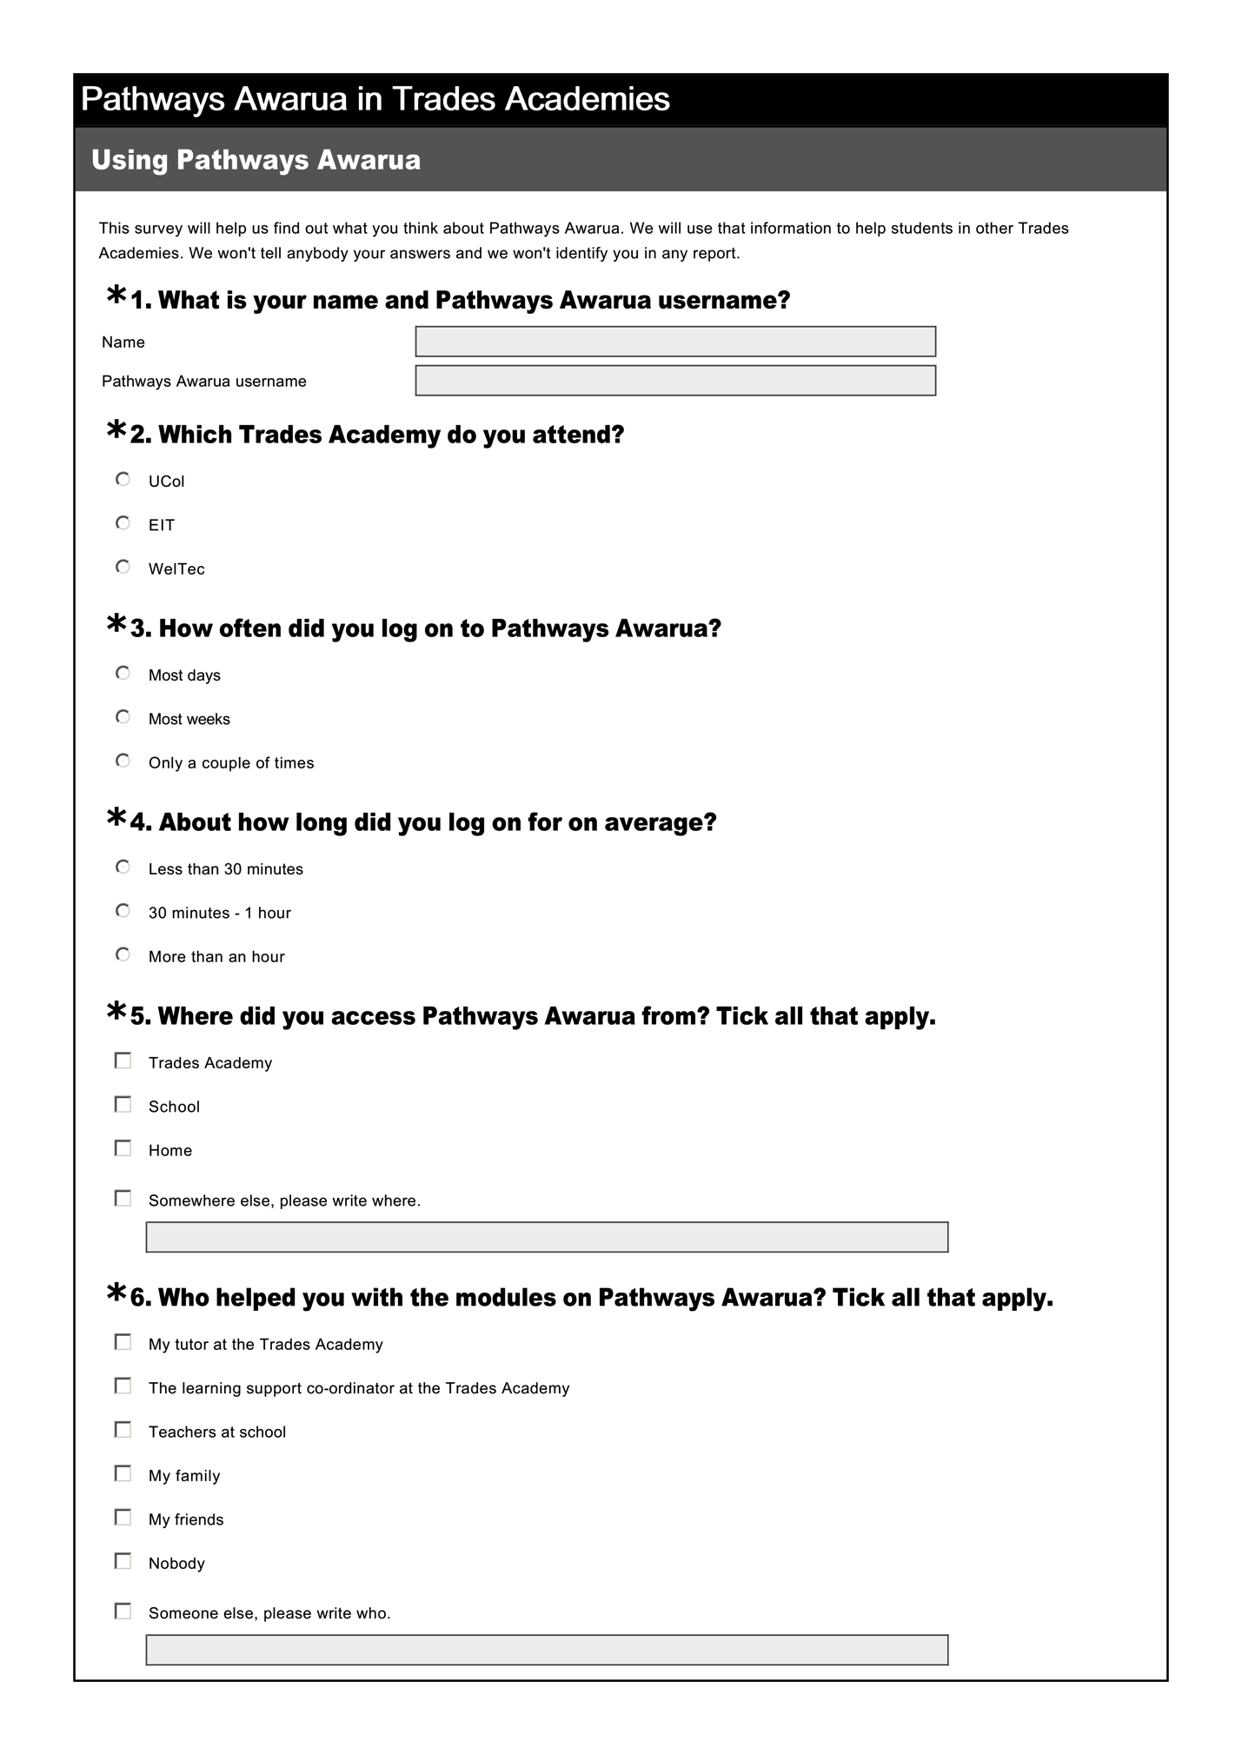

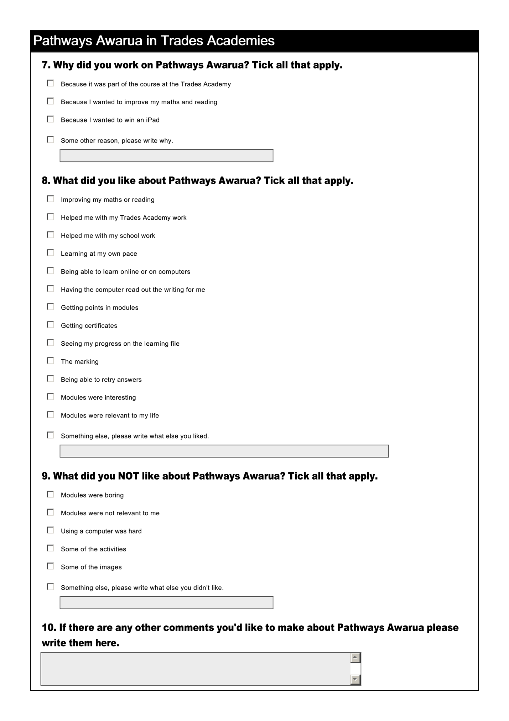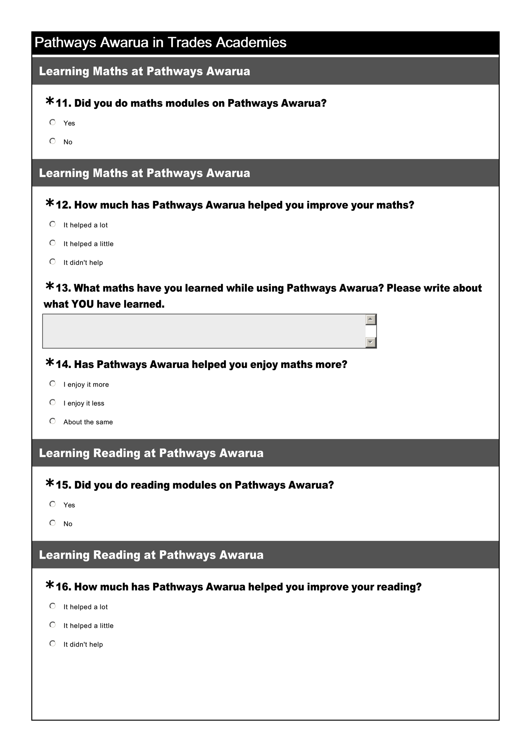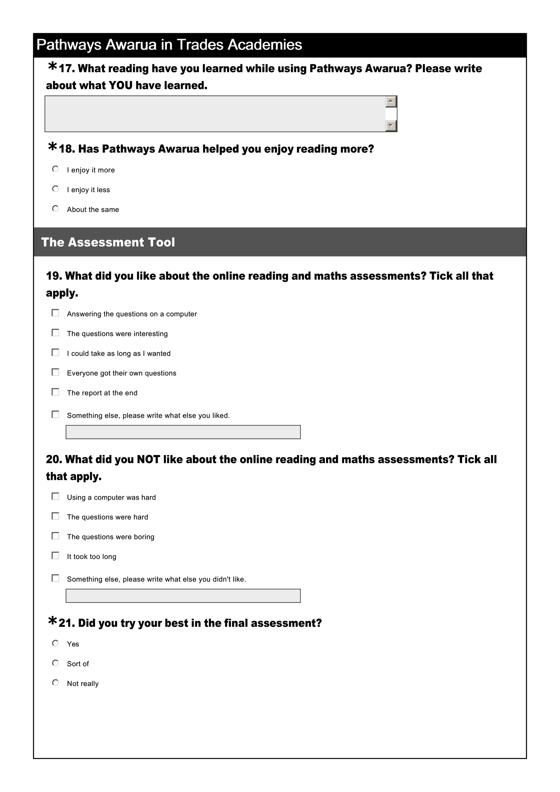

Appendix D: Focus group schedule
- Did you use Pathways Awarua during class time? How often did you use it each week, and for how long?
- Which tutors helped with your Pathways Awarua learning?
- Did you use Pathways at home? Why/why not? How often did you use it at home?
- If you used Pathways at home did other people get involved? Who? How? (helping or doing it themselves?)
- Did you use Pathways at school? Why/why not? When did you do it? How often? Did you have to do it? Did you get any help?
- Was there a computer you could use Pathways on? an iPad or tablet? Would you have used pathways on a smartphone if an app was available? (have you got a smartphone?)
- What do you like about Pathways?
- What do you NOT like about Pathways?
- Do you think Pathways helped you get better at reading or maths? Why/why not? If yes, does your reading or maths help you in other things that you do? Tell me more.
- Has Pathways helped you enjoy reading more? Tell me about that.
- Has Pathways helped you enjoy maths more? Tell me about that.
- Why did you do Pathways? Did you know there was a draw for an iPad? (Just to win an iPad?)
- Do you think you will you keep doing Pathways when you finish at the Trades Academy? Why/why not?
- Do you think Pathways would be helpful for students in other Trades Academies? Why/why not?
- Did you like doing the reading assessments on the computer? Why/why not?
- Did you like doing the maths assessments on the computer? Why/why not?
- What were some of the things about the online assessment that you liked?
- What were some of the things about the online assessment that you DIDN’T like?
- Did you try your best in the final assessment? Why/why not?

Appendix E: Pathways Awarua learner guides
Brochure one, one vertical fold, outside:
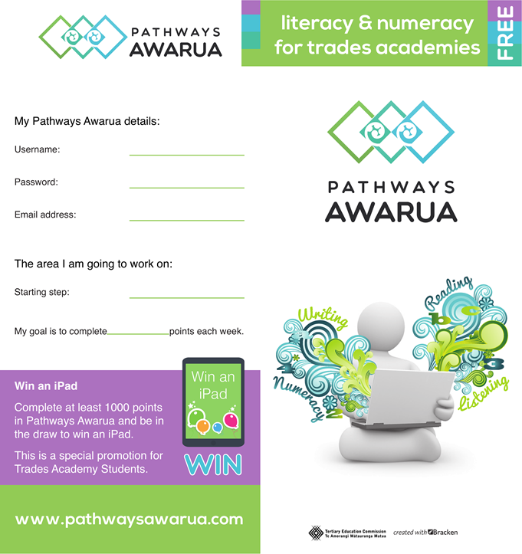
Inside brochure one:
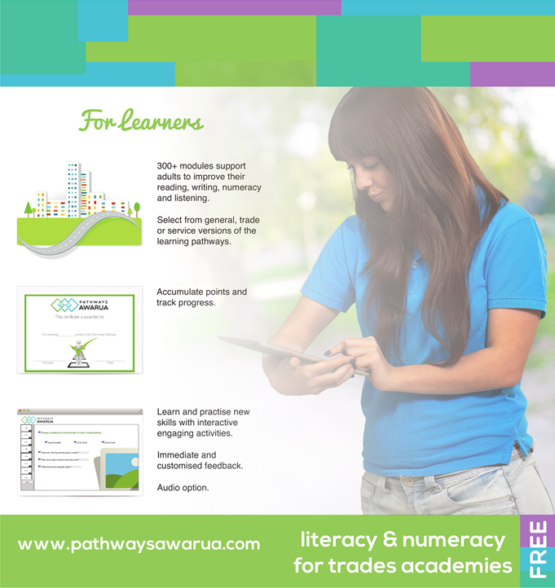
Brochure two, two vertical folds, outside:
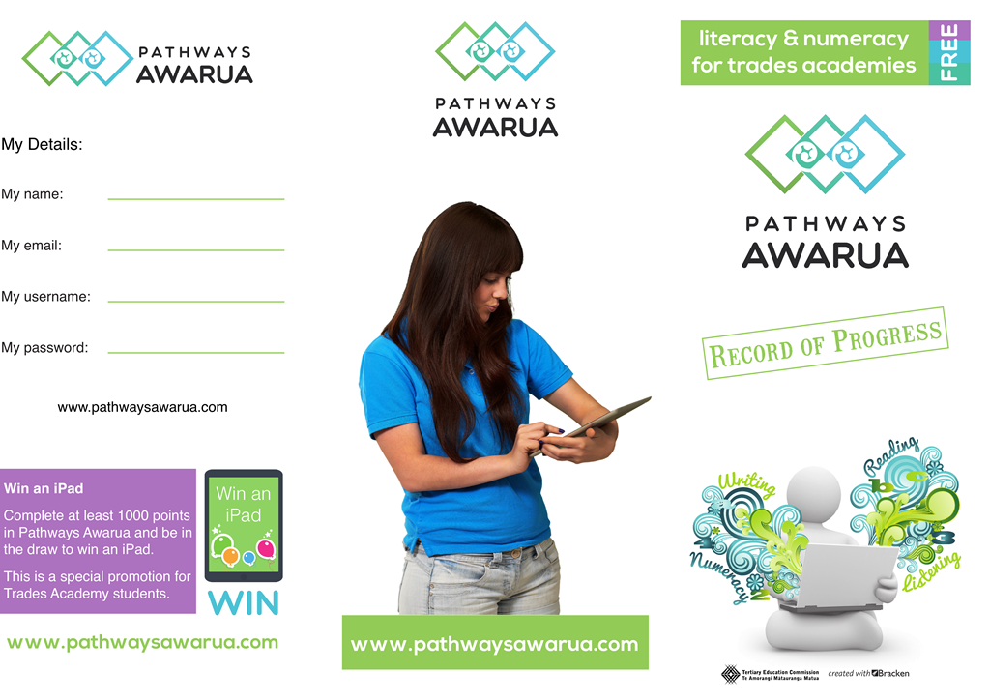

Inside brochure two:
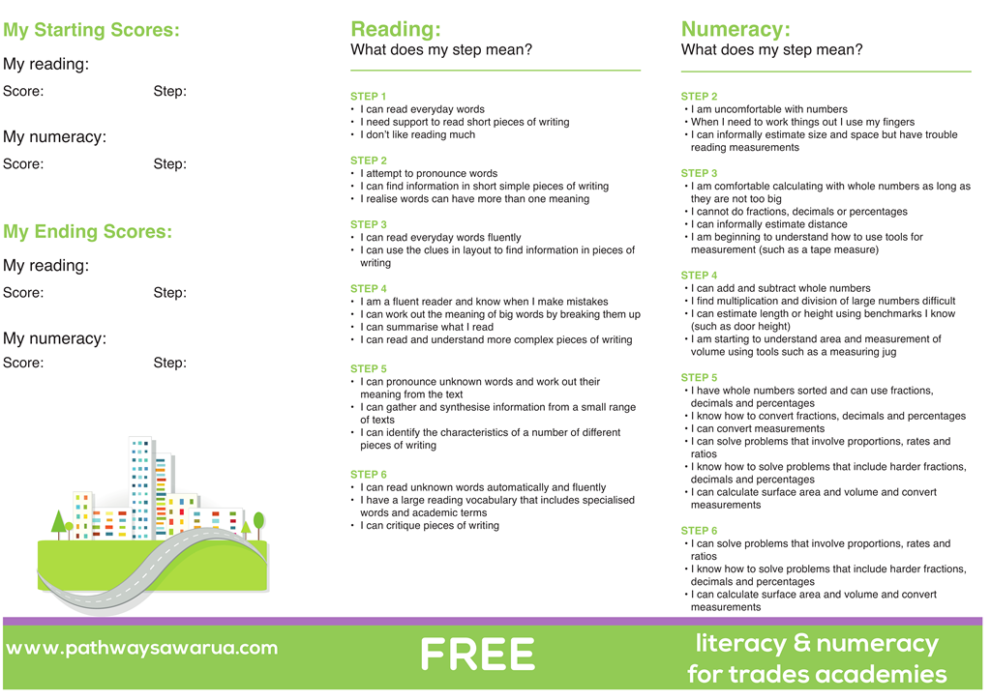

Omitted in case three due to circumstances within the trades academy.
Omitted in case three as learners attended the trades academy full-time.
This information is available on Pathways Awarua, and researchers provided information about this to the educators.
The total number of points per learner per pathway is available in Pathways Awarua
Likely impacted by school holidays 7-18 July
Likely impacted by school holidays 29 September-10 October

