Alignment of Literacy and Numeracy Measures

Research for the Tertiary Education Commission

Gill Thomas, Michael Johnston, Jenny Ward

25 August 2014

CONTENTS

1 Executive Summary 5
2 Background 7
2.1 Introduction 7
2.2 The measures 7
3 Methodological approach 11
3.1 Methodology and research questions 11
3.2 Data sources and participants 12
3.3 Analysis 15
4 Review of previously established links 16
4.1 ALL and the learning progressions 16
4.2 Summarising the alignments 18
5 Aligning the learning progressions with NCEA requirements 20
5.1 Association between the literacy and numeracy requirements for NCEA and qualifications 20
5.2 Reading and numeracy profiles of students 25
6 Aligning the learning progressions with the National Standards 31
7 Synthesis and Suggestions 35
References 39

List of Tables

Table 1 Cut points on the Assessment Tool scale for steps on the learning progressions 9
Table 2 Data sources 13
Table 3 Comparison of the subset of the school sample with Assessment Tool results in reading, with national demographic data, showing percentages of students in each decile, gender and ethnic category. 14
Table 4 Comparison of the subset of the school sample with Assessment Tool results in numeracy, with national demographic data, showing percentages of students in each decile, gender and ethnic category. 15
Table 6 Percentages of students in the school sample attaining the literacy requirement for NCEA by either or both of the unit and achievement standard pathways, who achieved NCEA Level 1 and NCEA Level 2, disaggregated by year level. 21
Table 8 Percentages of students in the tertiary cohort at each step of the reading scale attaining the literacy requirement for NCEA. 25
Table 9 The percentage distribution on the numeracy steps of year 11 and 12 students from the school sample attaining the NCEA numeracy requirement under each set of rules. 26
Table 10 The percentage distribution on the reading steps of year 11 and 12 students from the school sample attaining the NCEA literacy requirement under each set of rules. 27
Table 11 Distributions on the numeracy steps of year 8 students in the school sample judged well below, below, at and above the End of Year 8 Mathematics Standard. 31
Table 12 Distributions on the reading steps of year 8 students in the school sample judged well below, below, at and above the End of Year 8 Reading Standard. 32
Table 13 Percentages and numbers of year 8 students from the school sample at or above the End of Year 8 Mathematics Standard disaggregated by numeracy step. 33
Table 14 Percentages and numbers of year 8 students from the school sample at or above the End of Year 8 Reading Standard disaggregated by reading step. 34

List of Figures

Figure 1 Methodology 11
Figure 2 Using the numeracy scale to align the ALL levels to the steps of the learning progressions and the numeracy requirement for NCEA. 18
Figure 3 Using the reading scale to align the ALL levels to the steps of the learning progressions and the literacy requirement for NCEA. 19
Figure 4 Probability of attaining the numeracy requirement for NCEA conditioned on the numeracy scale score. Probabilities were estimated using logistic regression. Tertiary cohort. 23
Figure 5 Probability of attaining the literacy requirement for NCEA conditioned on the reading scale score. Probabilities were estimated using logistic regression. Tertiary cohort. 24
Figure 6 Logistic regression functions depicting the probability of the tertiary cohort attaining NCEA Levels 1, 2 and 3 conditioned on performance on the numeracy scale. 28
Figure 7 Logistic regression functions depicting the probability of the tertiary cohort attaining NCEA Levels 1, 2 and 3 conditioned on performance on the reading scale. 30
Figure 8 Probability of being rated at or above the End of Year 8 Mathematics Standard conditioned on the numeracy scale score. Probabilities were estimated using logistic regression. School sample. 32
Figure 9 Probability of being rated at or above the End of Year 8 Reading Standard conditioned on the reading scale score. Probabilities were estimated using logistic regression. School sample. 33
Figure 10 Distributions of Year 8 students, Year 11 students with NCEA Level 1, Year 12 students with NCEA Level 2, tertiary students with the NCEA literacy requirement and tertiary students without the NCEA literacy requirement on the reading scale. 36
Figure 11 Distributions of Year 8 students, Year 11 students with NCEA Level 1, Year 12 students with NCEA Level 2, tertiary students with the NCEA numeracy requirement and tertiary students without the NCEA numeracy requirement on the numeracy scale. 36

Executive Summary
This report presents analysis of the empirical relationship between four measures of literacy and numeracy in use in New Zealand. The first of these are the proficiency levels used in the Adult Literacy and Life Skills (ALL) survey. The second measure is the Learning Progressions for Adult Literacy and Numeracy (learning progressions) as measured by the Literacy and Numeracy for Adults Assessment Tool (Assessment Tool). The Assessment Tool is primarily used in the tertiary sector and is underpinned by a measurement scale that is related to the steps of the learning progressions. The Assessment Tool scale served as a lynchpin for aligning the other two measures: the literacy and numeracy requirements for the National Certificate in Educational Achievement (NCEA); and the New Zealand Curriculum National Standards (National Standards) at Year 8 for reading and mathematics. Results from the Assessment Tool were also used to investigate the distributions of reading and numeracy competencies for students attaining NCEA Levels 1 and 2.
The analysis in the report drew upon two main sources of data; the tertiary cohort of approximately 36,000 students aged 16-20 years and the school sample of approximately 1,000 students at Year 8 and 800 students from each of Years 11 and 12. The tertiary cohort is a subset of all students completing qualifications at Levels 1 to 3 of the New Zealand Qualifications Framework who were assessed using the Assessment Tool in 2012, so excludes university students, and anyone aged 21 and older. The school sample was constituted to be as representative of the population as possible, and the participating schools completed assessments using the Assessment Tool specifically for the purposes of the present research.
The alignment between the reading and numeracy scales of the Assessment Tool, and Level 3 of the Adult Literacy and Life Skills (ALL) survey was explored through a critical analysis of previous empirical work. This was undertaken because ALL Level 3 is established as a benchmark that describes the literacy and numeracy competencies that people need to operate in an information-rich society. It was concluded that Step 5 on the numeracy scale and Step 4 on the reading scale are best aligned to ALL Level 3. These steps are referred to throughout this report as the literacy and numeracy benchmarks.
The literacy and numeracy requirements for NCEA can be met by either of two pathways: by completing a set of three unit standards specifically designed for each of these requirements, or by achieving 10 credits from each of two (extensive) sets of achievement standards deemed to respectively entail substantial literacy and numeracy demands. It was shown that students completing the achievement standard pathway have a high probability of attaining NCEA Level 1 by the end of Year 11 and NCEA Level 2 by the end of Year 12, but that the probabilities of attaining these qualifications is much lower for students completing the unit standard pathways.
Logistic regression analyses were reported, modelling the probability of attaining each of the literacy and numeracy requirements for NCEA, as well as each level of the certificate itself, on the basis of performance on reading and numeracy assessments from the Assessment Tool. These analyses showed that performance on the Assessment Tool does not strongly discriminate students with a high probability of attaining these credentials from students unlikely to attain them. The empirical distributions of students attaining these credentials on the reading and numeracy scales of the Assessment Tool suggest that none except NCEA Level 3 can be taken to indicate a high probability that students are operating at the literacy and numeracy benchmarks. The distributions of students from the school sample in Years 11 and 12 on the reading and numeracy scales who had attained NCEA Levels 1 and 2 are concerning. Approximately half of the Year 11 students with NCEA Level 1 were below each of Step 4 on the reading progressions (51 percent) and Step 5 on the numeracy progressions (47 percent). Approximately 40 percent of the Year 12 students with NCEA Level 2 were below each of Step 4 on the reading progressions (42 percent) and Step 5 on the numeracy progressions (41 percent). Even more concerning are the proportions of students who are at the lowest steps on the progressions. For example, 9.1 percent of the Year 12 students with NCEA Level 2 were below Step 3 on the reading progressions and 15.2 percent were below Step 4 of the numeracy progressions.
Logistic regression analysis of the End of Year 8 National Standards data showed a much tighter relationship between performance on the Assessment Tool and the probability of being judged at or above the standard, than was evident in the logistic regression analysis of the NCEA data. The distributions on the reading and numeracy scales of the Assessment Tool of Year 8 students in each National Standards judgement category (well below, below, at and above) showed that substantial proportions of students judged as being above the standard are already performing at the literacy and numeracy benchmarks, and that the performance of those judged as being at the standard are predominately just one step below the benchmarks.
The distributions of the tertiary cohort on the reading and numeracy scales of the Assessment Tool were explored, and the results are concerning. Those who have met the literacy and numeracy requirements for NCEA are distributed similarly to the Year 11 students in the school sample who attained NCEA Level 1 on the reading and numeracy scales respectively, with very close to half of each group performing at the literacy and numeracy benchmarks. Tertiary students without the NCEA literacy and numeracy requirements are distributed similarly to the Year 8 sample on the respective scales, with just one quarter performing at the literacy and numeracy benchmarks.
No formal recommendations were made in the report, but some suggestions to consider were put forward. These include: (1) confirmation of the minimum levels of literacy and numeracy required by New Zealand adults to operate in an information-rich society; (2) ensuring any requirement is properly and rigorously assessed (3) credentialing literacy and numeracy independently from qualifications; (4) the introduction of formal requirements for literacy and numeracy to be met by the end of Year 10, prior to undertaking formal qualifications.

Background

Introduction
A certain level of competence in literacy and numeracy is needed for people to participate fully in information-rich societies, and the development of these skills is a priority across the compulsory sector. Adults with low levels of literacy and numeracy skills face limitations in their work, community and home lives, including finding and keeping a job and supporting their children’s learning.
Raising the literacy and numeracy skills of New Zealanders not only helps the prospects of individuals but it also leads to a more productive workforce. As workplaces become more dynamic and increasingly technology-based, individuals need to have stronger basic skills, especially in literacy and numeracy, to maintain sustainable careers (Ministry of Education, 2014).
Education plays an important role in providing young people with the key skills and competencies they need for further learning or to enter the workforce. This is one of the reasons why the Government introduced the Better Public Services (BPS) target of 85 percent of 18-year-olds achieving NCEA Level 2 or equivalent qualifications (Ministry of Education, 2014b). Embedded within NCEA qualifications is a requirement to obtain a minimum number of literacy and numeracy credits.
Two requirements need to be met in order to increase the proportion of adult New Zealanders with the literacy and numeracy skills required to cope with the demands of everyday life and work in a complex, advanced society. These are, first, an effective mechanism for identifying people whose literacy and numeracy skills are below an identified minimum, and, second, a strategy to support these people to strengthen their skills. This project is focused on the former, and explores the relationships between four different measures of literacy and numeracy in New Zealand. These measures are the Adult Literacy and Life Skills (ALL) survey, the Literacy and Numeracy for Adults Assessment Tool (Assessment Tool), the literacy and numeracy requirements for NCEA and the New Zealand Curriculum National Standards (National Standards).

The measures

The ALL survey
The ALL survey was an international survey of literacy, numeracy and problem-solving skills undertaken in 2006 by a representative sample of New Zealanders aged between 16 and 65. It provided information on the skills of the population, as well as a wide range of background information on employment, qualifications and demographic characteristics. The ALL scale was divided into five levels of proficiency with Level 3 “deemed as a minimum for persons to understand and use information contained in the increasingly difficult texts and tasks that characterise the emerging knowledge society and information economy”. (Statistics Canada & Organisation for Economic Cooperation and Development, 2005). A central message from the ALL analysis in New Zealand is that what people know and can do has a major impact on their life opportunities. For example, higher numeracy and literacy competencies are associated with those in the higher income groups (Satherley, Lawes, & Sok, 2008).
The ALL survey reported that 43 percent of New Zealanders are below Level 3 for document literacy, and 51 percent are below Level 3 for numeracy (Satherley, Lawes, & Sok, 2008a). Overall, the 16-24-year-old age group had lower levels of competency, with 48 percent below Level 3 for document literacy and 58 percent below the Level 3 for numeracy.
The analysis of New Zealand’s ALL results also included an examination of the relationship between a person’s literacy and numeracy levels and their educational qualifications. While literacy and numeracy levels were found to be related to educational qualifications, the analysis concluded that “educational qualifications do not provide a robust way of predicting the literacy or numeracy levels of individuals and should be used with caution” (Ministry of Education, 2009, p.1).

The Adult Learning Progressions and the Assessment Tool
The Adult Learning Progressions were developed to identify what individuals may need to learn in order to strengthen their literacy and numeracy competencies. The Assessment Tool was developed to measure against Learning Progressions for Adult Literacy and Numeracy (learning progressions; Tertiary Education Commission, 2008).
The learning progressions were developed in strands to reflect the key competencies of listening, speaking, reading, writing and numeracy. Each strand is made up of a number of progressions that together describe the developing expertise in that strand. The term progression is used to describe a series of steps along the continuum of developing expertise. The steps within any progression represent significant shifts in development and some require more learning than others. Consequently the steps within each progression are not evenly spaced, although there was an attempt to roughly align the steps between progressions within each strand. For example, in the six learning progressions for the Make Sense of Number to Solve Problems strand, Step 5 of each is of similar complexity.
The Assessment Tool provides assessments against three of the seven strands of the learning progressions, namely: Reading with Understanding, Making Sense of Number to Solve Problems, and Writing to Communicate. In addition, the measurement progression was included from the Measure and Interpret Shape and Space strand. Note that measures of writing, listening and speaking which are important aspects are not included in the current project.
The Assessment Tool reports assessment results against an equal-interval numerical scale from 0 to 1,000. The scale is divided into the steps of the relevant learning progressions using the cut points in Table 1. The cut points for the steps are different for reading and numeracy, which reflects the different construction of the learning progressions. The numeracy learning progressions have a lower starting point than the reading learning progressions and correspondingly the highest step on the reading learning progressions represents a greater degree of sophistication in reading than the highest step in numeracy.
Both the scale scores (referred to as the numeracy scale or the reading scale) and the learning progression steps are used in this report to analyse performance on the Assessment Tool.
Table 1 Cut points on the Assessment Tool scale for steps on the learning progressions
 | Reading | Numeracy
Step 1 | Up to 431 | Up to 396
Step 2 | 432-523 | 397-464
Step 3 | 524-608 | 465-528
Step 4 | 609-681 | 529-603
Step 5 | 682-738 | 604-689
Step 6 | 739 and over | 690 and over

The literacy and numeracy requirements for NCEA
The third measure used in this report is the literacy and numeracy requirements for NCEA (NZQA, n.d.). In order to attain a NCEA qualification, students must meet both the literacy and numeracy requirements. The New Zealand Qualifications Authority (NZQA) has recently revised these requirements, with the changes first coming into effect in 2011. There were two transition years in which the requirements could be met either by the old regulations, or by either of the two new pathways that were introduced. These transition years were 2011 and 2012, and some of the data for this project is drawn from these years.
The two new pathways for meeting the NCEA literacy and numeracy requirements are the achievement standard pathway and the unit standard pathway. The achievement standard pathway requires students to obtain 10 credits for each of literacy and numeracy from prescribed lists of achievement standards that are deemed to have a substantial literacy or numeracy demand. The focus of these achievement standards is varied and there is not necessarily any direct assessment of students’ literacy and numeracy skills under the achievement standard pathway. The unit standard pathway requires students to complete three specific unit standards for each of literacy and numeracy. Each collection of unit standards has a value of 10 credits that are assessed based on “naturally occurring evidence”, that is, evidence from their regular programme of study as opposed to specific literacy or numeracy tasks (NZQA, 2011).
Under the old regulations students needed to attain eight literacy credits from English or Reo Māori and eight numeracy credits from Mathematics, Statistics and Probability or Pāngarau, in order to meet the requirement. A variety of unit and achievement standards could be used to accumulate these credits.
Each of the new unit and achievement standards pathways to the literacy and numeracy requirements has a different focus. The achievement standard pathway was developed to align with the New Zealand Curriculum (NZC), and in particular is aligned with curriculum Level 6. In comparison, the collection of three unit standards are not directly aligned to the NZC, and were designed for use in both secondary schools and tertiary workplace programmes. They support the principle of embedded literacy and numeracy and are focused on the demands of adults’ life and work.

The New Zealand Curriculum National Standards
The fourth measure used in this report is the National Standards. The National Standards are descriptions of what students should know and be able to do in order to meet the demands of the NZC (Ministry of Education, 2009a). The standards were designed to support teachers to assess their students’ achievement in relation to the curriculum and describe what can reasonably be expected of most students at the end of each year of schooling. The National Standards were designed so that a student who meets them is on track to succeed at NCEA Level 2.
Teachers make Overall Teacher Judgments (OTJs) of students’ achievement in relation to the National Standards. OTJs describe students as operating at, above, below, or well below the appropriate year level standard.
This project utilises the End of Year 8 Reading Standard and the End of Year 8 Mathematics Standard. Although these standards both align to Level 4 of the curriculum, the way they align is somewhat different. The reading standard is related to all eight learning areas of the curriculum, as it requires students to “read, respond, and think critically about texts in order to meet the demands of the New Zealand Curriculum at Level 4” (Ministry of Education, 2009a). In comparison, the mathematics standard is focused solely on the mathematics and statistics learning area and requires students to be achieving at Level 4 in this area (Ministry of Education, 2009b).

Methodological approach
This chapter describes the project’s methodology and identifies the research questions that were addressed. The data sources and participants are also outlined. The results and discussion in chapters that follow are structured around the research questions.

Methodology and research questions
The project reviews established and previously articulated links between the various measurement scales. The alignments between these scales are then examined using the results from samples of learners in both the school and tertiary sectors. The Assessment Tool scales are used as the lynchpin to connect the scales and investigate the alignments between them. Figure 1 shows the measurement scales involved, and illustrates the links under investigation.

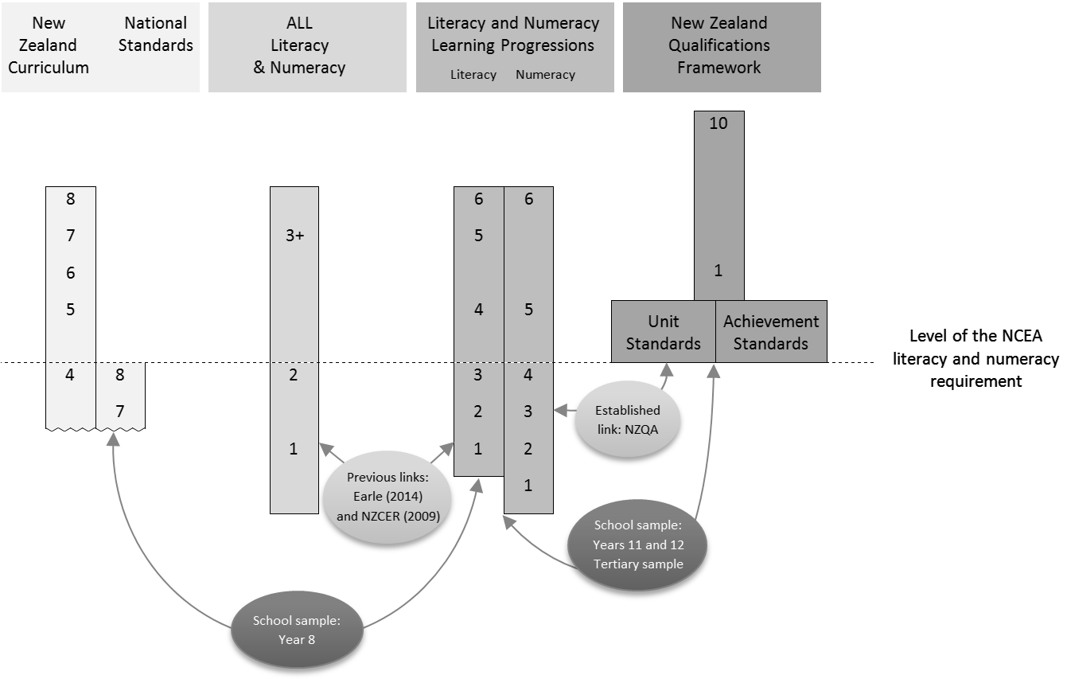

Figure 1 Methodology
The review aspect of the project, illustrated by the lighter arrows in Figure 1, synthesises the various pieces of work, and the research that has been undertaken to date to align the learning progressions, with both the ALL levels, and the literacy and numeracy requirements for NCEA. The research question is:
- What do we already know about the alignments between the scales?
The project also investigates alignments, as shown by the darker arrows in Figure 1. Learners’ achievement data is used to elucidate the alignments between the learning progressions and two other scales: the literacy and numeracy requirements for NCEA and the National Standards. The research questions are:
- Are either or both of the unit and achievement standards pathways to the literacy and numeracy requirements associated with students achieving a Level 2 NCEA qualification?
- What is the distribution on the Assessment Tool scales, and by extension, on the learning progressions, of students who gain NCEA requirements?
- What is the distribution on the Assessment Tool scales, and by extension, on the learning progressions, of students who are assessed as being at the End of Year 8 National Standard in reading and mathematics?
Results from both aspects of the project inform the final research question:
- What would constitute an integrated mechanism for identifying individuals below the literacy and numeracy benchmarks (Step 4 of the reading progressions and Step 5 of the numeracy progressions)?

Data sources and participants
Two main pieces of work were reviewed in order to examine the previously described links between the steps of the learning progressions and the ALL levels. The first of these originated from the work of the New Zealand Council for Educational Research (NZCER) and was based on the inclusion of ALL assessment items in the calibration of the Assessment Tool as it was being developed (NZCER, 2010a, 2010b). The second of these followed on from the administration of the ALL survey in New Zealand in 2006, and involved identifying learners that had a result on the Assessment Tool from within the sample of adults who had participated in the ALL data collection (Earle, 2014). Two technical reports for the Assessment Tool were also reviewed (NZCER, 2009, 2009a; NZCER, 2010a).
Information from NZQA was used to confirm the established link between the learning progressions and the literacy and numeracy requirements for NCEA.
Learner data was used to investigate the alignments. Two data sources were established for this purpose:
- Tertiary cohort. Approximately 36,000 students sourced from the administrative data sets of NZQA and the Ministry of Education. This sample included all students aged 16 to 20 years that had a result on the Assessment Tool in 2012. It needs to be noted that this cohort includes students completing courses at Levels 1 to 3 of the NZQF and therefore excludes university students.
- School sample. Approximately 1,000 students from Year 8 and 800 students from each of Years 11 and 12. This sample was sourced from 15 participating schools to be reasonably representative by school decile and ethnicity.
Three types of data were obtained for students in the tertiary and school samples:
- Data from the Assessment Tool: reading and numeracy assessment results for students in the school sample and the tertiary cohort.
- Data from NZQA in relation to students’ achievement against the literacy and numeracy requirements for NCEA, and subsequent performance in gaining a Level 1 or 2 qualification on the NZQF. This was obtained for all students in the tertiary cohort, and students in Years 11 and 12 in the school sample.
- Overall Teacher Judgments (OTJs) of students’ achievement in relation to the End of Year 8 National Standards in reading and mathematics in 2012. These were obtained for Year 8 students in the school sample.
Table 2 summarises these data sources for the tertiary and school samples.
Table 2 Data sources
Sample |  | n | Assessment Tool Data | NZQA data | OTJ data
Tertiary cohort |  | 36,270 | Administrative data sets | Administrative data sets | -
School sample | Year 11 and 12 | 1,568 | School-administered assessments | Administrative data sets | -
 | Year 8 | 1,120 | School-administered assessments | - | Provided by participating schools

Tables 3 and 4 compare the demographic characteristics of the school sample with the national profile for primary and secondary school students, based on an analysis of July 1 roll data from the Education Counts website (Ministry of Education, 2014a). Table 3 provides demographic information for students with Assessment Tool results in reading, and Table 4 provides this information for students with results in numeracy. Students were asked to complete both reading and numeracy assessments but a small number completed just one assessment.
In both of Tables 3 and 4 the decile distribution of Year 8 students in the sample is different than the national profile, with high-decile schools over-represented, medium-decile schools substantially under-represented, and low-decile schools almost unrepresented. The secondary sample is better aligned with the national decile profile, although high-decile schools are over-represented by 15.2 percentage points in Table 3 and by 10.7 percentage points in Table 4. Low-decile schools are also over-represented to a lesser extent, by 10.1 and 7.3 percentage points in Tables 3 and 4 respectively. Female students are slightly over-represented in both the Year 8 and secondary samples, more so in the former than in the latter. The ethnic profile of the Year 8 sample over-represents NZ European students, with commensurate under-representation of Māori and Pasifika. The secondary sample, however, reflects the national secondary-school ethnicity profile quite closely, although Pasifika students are somewhat over-represented and Māori students commensurately under-represented.
The modest over-representation of female students and the greater over-representation of students at high-decile schools than those at low-decile schools is likely to result in an associated over-estimation of both reading and numeracy skill, because a wealth of data show that on average, female students out-perform male students in literacy measures and that on average, students at high-decile schools out-perform students at low-decile schools in both reading and numeracy measures. Therefore, estimates of the levels of literacy and numeracy of students in these samples are likely to represent a best-case scenario; that is, they are likely to be slightly above the actual population levels.
Table 3 Comparison of the subset of the school sample with Assessment Tool results in reading, with national demographic data showing percentages of students in each decile, gender and ethnic category.
 | Sample (Secondary) | National (Secondary) | Year 8 (Sample) | National (primary)
Female | 52.4 | 49.9 | 54.7 | 51.4
Male | 47.6 | 50.1 | 45.3 | 48.6
Asian | 11.0 | 10.7 | 7.2 | 9.3
NZ European | 54.1 | 54.4 | 68.8 | 54.2
NZ Māori | 12.5 | 18.4 | 9.5 | 23.7
Pasifika | 15.8 | 9.1 | 5.2 | 9.9
Other | 6.6 | 7.4 | 9.3 | 2.9
Deciles 1-3 | 27.9 | 17.8 | 2.4 | 25
Deciles 4-7 | 15.5 | 40.8 | 18.2 | 35
Deciles 8-10 | 56.6 | 41.4 | 79.4 | 40
n | 1,541 |  | 1,088

Table 4 Comparison of the subset of the school sample with Assessment Tool results in numeracy, with national demographic data showing percentages of students in each decile, gender and ethnic category.
 | Sample (Secondary) | National (Secondary) | Year 8 (Sample) | National (primary)
Female | 52.3 | 49.9 | 52.2 | 51.4
Male | 47.7 | 50.1 | 47.8 | 48.6
Asian | 10.9 | 10.7 | 6.3 | 9.3
NZ European | 55.2 | 54.4 | 69.9 | 54.2
NZ Māori | 12.1 | 18.4 | 10.0 | 23.7
Pasifika | 15.3 | 9.1 | 5.0 | 9.9
Other | 6.5 | 7.4 | 8.9 | 2.9
Deciles 1-3 | 27.5 | 17.8 | 2.2 | 25
Deciles 4-7 | 15.5 | 40.8 | 19.0 | 35
Deciles 8-10 | 57.0 | 41.4 | 78.8 | 40
n | 1,408 |  | 1,023

Analysis
Several empirical techniques were used to investigate the alignments between the various scales. The distribution on the Assessment Tool scales and learning progression steps was examined for students that had or had not attained various outcomes, such as meeting the literacy and numeracy requirements for NCEA. Logistic regression was used to estimate the probability of attaining various outcomes as a function of performance on the Assessment Tool. Outcomes of interest include meeting the literacy and numeracy requirements for NCEA by either of the unit or achievement standards pathways, and attaining NCEA Levels 1 or 2.

Review of previously established links
Literacy and numeracy competencies are measured by a number of different scales across the compulsory and post-compulsory sectors in New Zealand. For the purposes of this project it is important to establish the links that already exist between the various scales. The research question that is the focus for this chapter is:
2. What do we already know about the alignments between the scales?

ALL and the learning progressions
Two studies (NZCER, 2010a, 2010b and Earle, 2014) report on work to equate the ALL scales with the learning progression scales. Of particular importance for the present work is to determine which steps on the learning progressions are best aligned with Level 3 on each of the corresponding ALL scales. Quite different methodologies were used in each of these studies and different alignments were reported.
NZCER, 2010a, 2010b used a psychometric approach in which approximately 20 ALL items were included in test trials for the Assessment Tool. These items were then co-calibrated with the items being tested for the Assessment Tool. On the basis of this analysis NZCER reported that ALL Levels 3 and 4 in reading correspond approximately to Steps 3 to 5 of the reading learning progressions, and that the bottom range of ALL Level 3 approximately aligns with the bottom range of Step 5 on the numeracy learning progressions.
Earle (2014) used a least-squares (linear) regression approach to describe the relationship between the final scores. Earle’s results positioned the bottom of ALL reading Level 3 close to the top of Step 4 of the reading learning progressions and ALL numeracy Level 3 close to the bottom of Step 6 (the highest step) of the numeracy learning progressions.
Both studies have some limitations, acknowledged by the respective authors. The most serious limitation of NZCER’s approach was that the original ALL scales were calibrated using a two-parameter item response model (Samejima, 1969), whereas the Assessment Tool scales (and the ALL items which were co-calibrated for the purposes of the study) were calibrated using a one-parameter model (Rasch, 1960/1980). Consequently, as the author points out, whereas the difficulty levels of the ALL items included in the trial could be compared with the difficulty levels of the reading and numeracy items with reasonable confidence, the ability of respondents required to be at a given level of proficiency could not be estimated as reliably. The position of a respondent on the ALL scale is governed by both item difficulty and item discrimination: the rate at which the probability of performing correctly on an item increases as a function of ability. On the other hand, the estimated position of a respondent on the Assessment Tool’s reading and numeracy scales is largely governed by item difficulty.
Earle’s study does not suffer from the same limitation as NZCER’s because linear regression does not depend upon the precise characteristics of the models used to construct each scale, but only on the degree of correlation between them. In this regard, Earle’s work is on quite firm ground with correlations of .77 and .78 between the Assessment Tool’s reading scale and the prose and document scales of ALL respectively, and a correlation of .72 between the Assessment Tool’s numeracy scale and the ALL numeracy scales. The greatest limitation of Earle’s study is that considerable time – between four and seven years – elapsed between the measurement of individuals on the ALL scales, and their measurement on the Assessment Tool’s reading and numeracy scales. Thus, it is likely that many respondents’ reading and numeracy improved between the two measures, and that the position on the latter scales commensurate with Level 3 (or any other level) on the ALL tools was somewhat over-estimated. Earle acknowledged this limitation and attempted to mitigate it by including only respondents aged at least 25, and whose first language was English, when they were measured on the Assessment Tools. He did this on the basis that these respondents would be less likely to have improved substantially in proficiency between the two testing occasions than younger respondents or those whose first language is not English.
Both studies are limited by the fact that ALL reading actually comprises two scales: prose and document literacy. There is no guarantee that both of these scales align in the same way to the reading scale. NZCER used items from both scales but noted that this approach yielded anomalies between the two sets of items, suggesting that the prose and document literacy scales do indeed align differently to the Assessment Tool’s reading scale. Earle used only the document literacy scale in the linear regression analysis used to align the two scales.
Bearing in mind the above discussion, there are at least three plausible sources of the discrepancy between the findings of NZCER (2010a, 2010b) and Earle (2014). The first is that the difference in the item response models used to calibrate the ALL and the reading and numeracy scales might have resulted in some misalignment in NZCER’s study. The second is that the delay between the collection of the ALL data and that of the Assessment Tool data in Earle’s study might have resulted in an over-estimate of the steps on the latter scales that are best-aligned with Level 3 on the ALL scale. The third is that the exclusive use of the document literacy data by Earle might have resulted in the different estimates for the learning progression step best aligned with ALL reading Level 3.
In the present work, we have decided to adopt conservative alignments, as we believe this will provide the best-case scenario in terms of the proportions of students achieving the various credentials of interest, who are operating at or above the level needed to operate in an information-rich society. In numeracy this means we have equated ALL Level 3 to Step 5 of the numeracy learning progressions. In the case of the literacy data, we decided on a compromise between Earle’s view that ALL Level 3 is equated to the upper range of step 4 on the reading learning progressions, and NZCER’s view that the alignment falls in the Step 3 to 4 range. Thus for the purposes of the present work we equate ALL reading Level 3 with Step 4 of the reading learning progressions. These alignments are also consistent with the NCEA literacy and numeracy requirements described in the following section.
NZQA have positioned the new unit and achievement standards pathways to the literacy and numeracy requirements differently. The unit standards were developed to meet particular steps of the learning progressions. The numeracy unit standards are aligned with Step 5 of the numeracy progressions, and the literacy unit standards are aligned with Step 4 of the reading progressions (NZQA, n.d.a). On the other hand, the achievement standards are designed to ensure students are able “to meet the demands of” Level 6 of the New Zealand Curriculum” (NZQA, n.d.b). Note that these alignments are not empirical.

Summarising the alignments
Figures 2 and 3 position the Assessment Tool scale as the lynchpin to connect the two alignments of ALL with the learning progressions. Also depicted in the figures is the level of the NCEA literacy or numeracy requirement as determined by the unit standard pathway.
Both figures illustrate that Earle (2014) estimates a higher positioning of the ALL levels in relation to the learning progression steps than NZCER. More specifically NZCER estimates that ALL 3 for numeracy is at lower Step 5 whereas Earle estimates that it is mid-way through Step 6. The comparison is less straightforward for reading because NZCER used overlapping ranges to link the ALL levels to the reading learning progressions. For reading Earle estimates that ALL Level 3 is equated to the upper range of Step 4 on the reading learning progressions while NZCER estimates that ALL reading Levels 3 and 4 correspond to Steps 3 to 5.
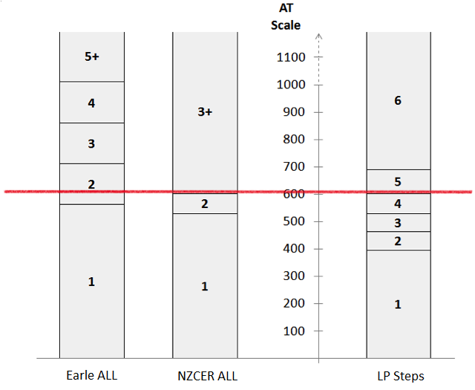
Numeracy requirement for NCEA (US pathway)
Figure 2 Using the numeracy scale to align the ALL levels to the steps of the learning progressions and the numeracy requirement for NCEA.

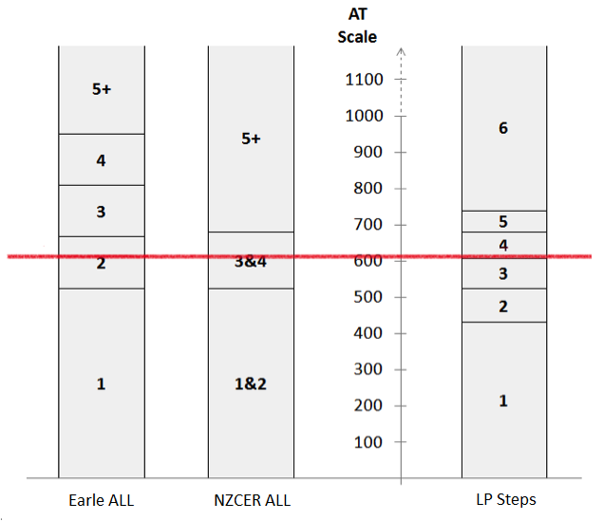
Literacy requirement for NCEA (US pathway)
Figure 3 Using the reading scale to align the ALL levels to the steps of the learning progressions and the literacy requirement for NCEA.

Aligning the learning progressions with NCEA requirements
This chapter investigates the relationship between two measures of literacy and numeracy: the learning progressions, and NCEA requirements. The analysis uses student assessment results from these measures: firstly to investigate the association between the literacy and numeracy requirements for NCEA and the attainment of NCEA qualifications; and secondly to describe the reading and numeracy competencies of students who meet NCEA literacy and numeracy requirements and gain NCEA qualifications.

Association between the literacy and numeracy requirements for NCEA and qualifications
This section uses data from both the sample school and the tertiary cohort to address the following research question:
- Are either or both of the unit and achievement standards pathways to the literacy and numeracy requirements associated with students achieving a Level 2 NCEA qualification?
In both the school sample and the tertiary cohort, a large majority of students who attained the literacy and numeracy requirements for NCEA did so under either of the new unit standard or achievement standard pathways. However, the three methods of attaining each requirement are not mutually exclusive and a number of students attained one or both of the requirements under both the old rules and one of the new unit and achievement standard pathways. The following analysis includes results for the new unit and achievement standard pathways only, and whether or not students also met the requirements under the old rules has been disregarded.
Table 5 compares the percentages of students in the school sample attaining the numeracy requirements by just one of the new pathways (unit or achievement standard), who attained NCEA Levels 1 and 2. Table 6 contains comparable information for literacy. Note that the school sample has been used for this analysis as it is reasonably representative, and NCEA requirements and qualifications are most relevant for this group.
The data for Year 11 show that the proportions of students who attained NCEA Level 1, having gained the literacy or numeracy requirement by the unit standard pathway but not the achievement standard pathway, were considerably lower than the proportions who attained NCEA Level 1, having gained the requirements by the achievement standard pathway only, or by both pathways. The proportion gaining NCEA Level 1 having attained the numeracy requirement by just the achievement standard pathway was higher than the proportion gaining NCEA Level 1 having attained the numeracy requirement by both pathways. For the literacy requirement on the other hand, the highest rate of attaining NCEA Level 1 was for students attaining the requirement by both pathways. NCEA Level 2 is only rarely attained by students prior to Year 12, and virtually no Year 11 students in the sample gained NCEA Level 2.
Not surprisingly, the proportions of Year 12 students gaining NCEA Level 1 are very high for students of all pathway combinations. The highest proportions of students gaining NCEA Level 2 were of those gaining the literacy and numeracy requirements by just the achievement standard pathway, although, in respect of the numeracy requirement, the proportion gaining NCEA Level 2 was almost as high for students gaining the requirement by both pathways. Much lower proportions of students attaining either requirement only by unit standard pathways gained NCEA Level 2.
The data in Tables 5 and 6 show that the achievement standard pathway is more strongly associated with the attainment of NCEA Level 1 in Year 11 or NCEA Level 2 in Year 12. While this finding does not show anything directly about the relative literacy and numeracy demands of the two pathways, it is at least suggestive that the literacy and numeracy competencies of the group gaining the requirements by the achievement standard pathway are stronger than those of the group using the unit standard pathway. It needs to be noted that the educational background of learners has not been controlled for in the results.
Table 5 Percentages of students in the school sample attaining the numeracy requirement for NCEA by either or both of the unit and achievement standard pathways, who achieved NCEA Level 1 and NCEA Level 2, disaggregated by year level.
Pathway | Year 11 |  |  | Year 12
 | % attaining NCEA L1 | % attaining NCEA L2 | n | % attaining NCEA L1 | % attaining NCEA L2 | n
Numeracy (AS only) | 87.8 | 0.8 | 532 | 98.9 | 91.9 | 569
Numeracy (US only) | 36.5 | 0.0 | 52 | 96.4 | 71.4 | 28
Numeracy (AS and US) | 58.3 | 0.0 | 12 | 100.0 | 87.1 | 31
Table 6 Percentages of students in the school sample attaining the literacy requirement for NCEA by either or both of the unit and achievement standard pathways, who achieved NCEA Level 1 and NCEA Level 2, disaggregated by year level.
Pathway | Year 11 |  |  | Year 12
 | % attaining NCEA L1 | % attaining NCEA L2 | n | % attaining NCEA L1 | % attaining NCEA L2 | n
Literacy (AS only) | 77.8 | 0.5 | 577 | 97.5 | 89.2 | 628
Literacy (US only) | 41.2 | 0.0 | 17 | 100.0 | 60.0 | 10
Literacy (AS and US) | 90.0 | 0.0 | 20 | 97.4 | 78.9 | 38

The following analyses address the tertiary cohort data. In some cases students had been assessed more than once on one or both of the numeracy and literacy tool measures. In these cases, the most recent measurement was used. Furthermore, in the logistic regression analyses estimating the probabilities of attaining various certifications (e.g. the NCEA literacy requirement), if students had attained the certification, they were included in the analysis only if their assessment tool data was collected in the same year as the one in which they attained that certification, or in a later year. A caveat on all of these analyses is that tertiary students were not necessarily aiming to attain the certifications in question.
Figure 4 shows a graphic depiction of a logistic regression analysis estimating the probability of attaining the numeracy requirement for NCEA Level 1 (by any pathway) conditioned on numeracy scale location. The analysis used data only from the tertiary cohort; the large numbers in this sample increase the reliability of the results.
Figure 4 suggests that performance on the numeracy scale does not strongly distinguish students who are likely to attain the numeracy requirement from those who are not; despite the considerable increment in the numeracy skills designated at each successive step of the learning progressions, there is only a modest increase in the probability of attaining the numeracy requirement associated with these increments. Students at the top of Step 1 on the numeracy learning progressions have approximately a 40 percent probability of attaining the requirement and those at the bottom of Step 6, approximately a 90 percent probability. Steps 1 and 6 are vastly different in terms of the numeracy capabilities they represent. For example, students at Step 1 are limited to counting to solve simple single-step problems, whereas students at Step 6 are able to solve complex proportional problems with understanding.
The relatively poor discrimination evident in the analysis presented in Figure 4 might be a result either of unreliable measurement by the Assessment Tool itself, or of variability in the level of numeracy that is required for different students to meet the numeracy requirement for NCEA. The latter is much more likely than the former; psychometric analysis of the Assessment Tool shows that it measures reliably and that most of the variability in performance is explained by a single dimension (Darr, 2010). On the other hand, the numeracy requirement for NCEA is very diffuse; that is, in 2011 and 2012 there were three pathways by which it could be attained (although there are now only two), and for the achievement standard pathway in particular, there are over 90 standards that can contribute to it, which are likely to vary widely in their numeracy demands.

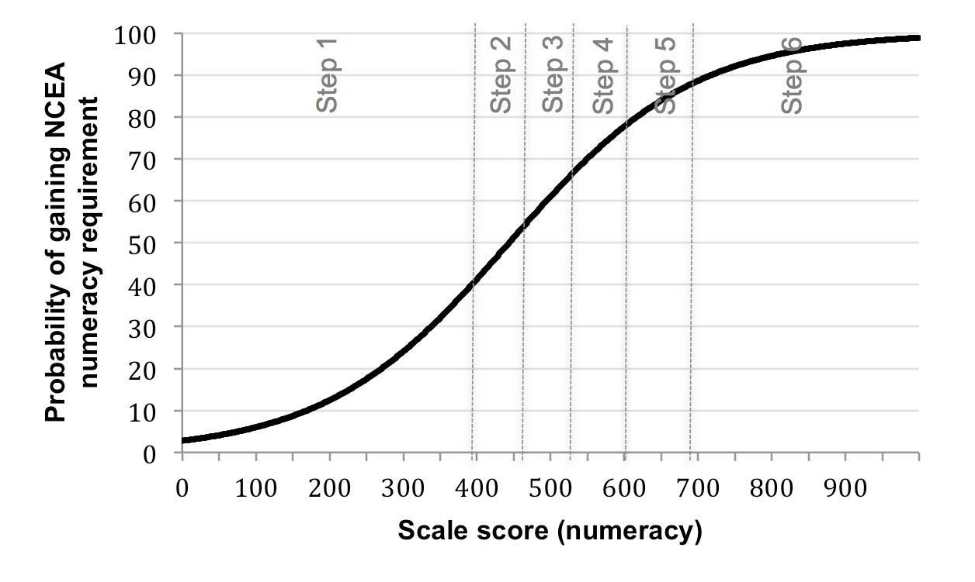
Figure 4 Probability of attaining the numeracy requirement for NCEA conditioned on the numeracy scale score. Probabilities were estimated using logistic regression. Tertiary cohort.
The analysis presented in Figure 4 shows that performance well below Step 5 on the numeracy scale, which we take to be well-aligned with ALL Level 3, is associated with relatively high probabilities of attaining the numeracy requirement for NCEA. For example, students at Step 3 have more than a 50 percent probability of meeting the requirement. Students in Step 3 are able to solve simple one-step problems involving addition and subtraction and know their multiplication facts.
Table 7 shows the empirical proportions of students at each step on the numeracy progressions attaining the numeracy requirement in the same sample that was used to conduct the logistic regression analysis. It also shows the percentage probability under the regression model, of attaining the numeracy requirement associated with performance at the minimum scale score for each step and at the mean scale score for each step. These probabilities can be taken as the percentage of students at these scale scores predicted by the model to attain the numeracy requirement. The predicted percentages at the mean scale score for each step align quite well with the empirical percentages, suggesting that the logistic model provides a reasonable fit to the data.

Table 7 Percentages of students in the tertiary cohort at each step of the numeracy scale attaining the numeracy requirement for NCEA.
Numeracy Step | attained NCEA Numeracy (%) |  | %Probability (mean) | %Probability (minimum)
1 | 37.0 | 31.5 |  | 2.8
2 | 48.7 | 48.6 |  | 40.7
3 | 63.0 | 61.0 |  | 54.1
4 | 76.5 | 72.8 |  | 66.3
5 | 87.3 | 83.1 |  | 78.2
6 | 91.4 | 91.9 |  | 87.7
n | 23,207
Note: Probability values are from a logistic regression model based on the mean scale location for students at each step, and the minimum scale score for each step.

Figure 5 shows a logistic regression function complementing that in Figure 4, depicting the probability of attaining the literacy requirement for NCEA, again by any means, conditioned on performance on the reading scale. The discrimination of this curve is similarly poor, and the probabilities of attaining the literacy requirement for students at the bottom of Steps 2 and 6 are almost identical to those of attaining the numeracy requirement for students at the bottom of these steps on the numeracy scale; approximately 40 percent and 90 percent respectively. Again, it is much more likely that the poor discrimination is a result of the diffuse nature of the NCEA literacy requirement, than that the Assessment Tool lacks reliability. Furthermore, under this analysis students in the middle of reading Step 2 have a 50 percent probability of attaining the literacy requirement. This is well below the literacy benchmark, which is at Step 4. Students at Step 2 can find information in short, simple pieces of writing.
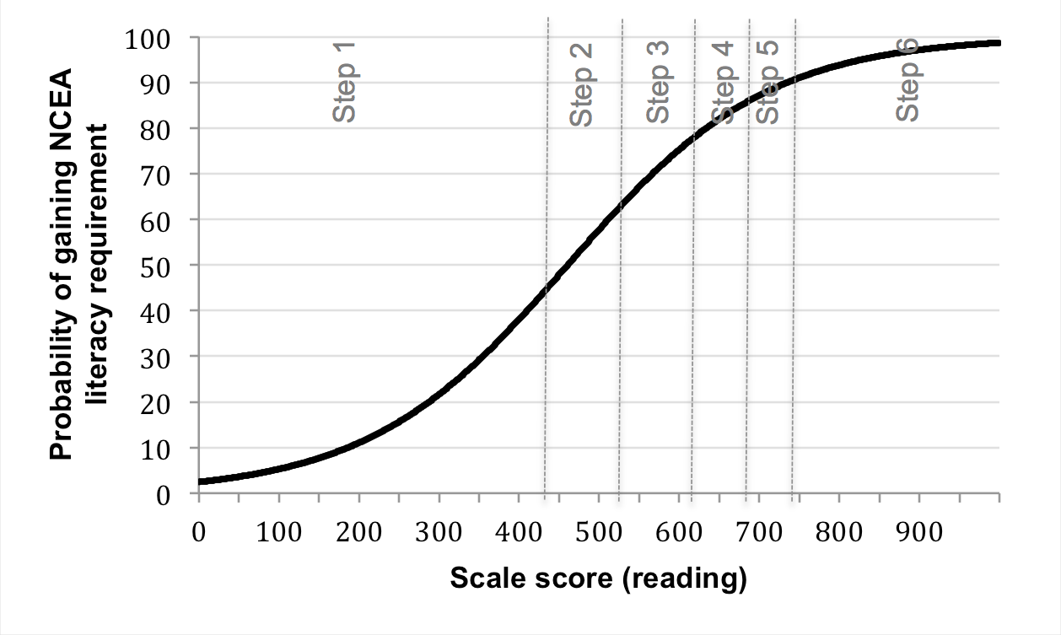
Figure 5 Probability of attaining the literacy requirement for NCEA conditioned on the reading scale score. Probabilities were estimated using logistic regression. Tertiary cohort.
Table 8 shows the empirical percentage of students in the tertiary cohort at each reading step who attained the literacy requirement for NCEA. The percentages at Steps 1 to 3 are particularly concerning, these steps being below the literacy benchmark, but nonetheless showing reasonable probabilities of attaining the requirement. As was the case for Table 7, the probability values from the logistic regression associated with the mean scale location for each step are quite well aligned with the empirical percentages attaining the literacy requirement, suggesting a good fit of the model to the data.
Table 8 Percentages of students in the tertiary cohort at each step of the reading scale attaining the literacy requirement for NCEA.
Reading Step | attained NCEA Literacy (%) | %Probability (mean) | %Probability (minimum)
1 | 36.3 | 35.2 | 2.4
2 | 53.3 | 55.1 | 44.2
3 | 68.9 | 70.3 | 62.3
4 | 82.0 | 81.0 | 76.5
5 | 87.8 | 87.6 | 85.4
6 | 88.5 | 92.8 | 90.2
n | 21,772
Note: Probability values are from a logistic regression model based on the mean scale location for students at each step, and the minimum scale score for each step.

Reading and numeracy profiles of students
This section investigates the reading and numeracy profiles of those students who met the literacy and numeracy requirements and those students who gained NCEA qualifications. Data from the school and tertiary cohorts is used to address the question:
4. What is the distribution on the Assessment Tool scales, and by extension, on the learning progressions, of students who gain NCEA literacy and numeracy requirements?
Table 9 shows the distributions on the numeracy steps, of students in the school sample who attained the numeracy requirement for NCEA by each of the three pathways; that is, under the old rules, under the new rules using the unit standard pathway, and under the new rules using the achievement standard pathway. Note that these three pathways are not mutually exclusive, and a substantial majority of students who met each of the numeracy and literacy requirements did so under both the old rules and the new achievement standard rules.
The data in Table 9 show that the distribution on the numeracy steps of students who attained the numeracy requirement under the old rules is similar to the distribution of those who attained it under the new achievement standard rules. This similarity is unsurprising given the very substantial intersection of the sets of students attaining the requirement by each of these methods. However, the distribution for students who attained the numeracy requirement using the unit standard pathway is substantially lower, with 88.6 percent of these students falling below Step 5, which is the numeracy benchmark. While the (new) achievement standard pathway shows a higher distribution on the numeracy steps, 42.4 percent of students who attained the requirement by this pathway were nonetheless below numeracy Step 5.
Table 9 The percentage distribution on the numeracy steps of year 11 and 12 students from the school sample attaining the NCEA numeracy requirement under each set of rules.
Numeracy Step | Numeracy old rules | Numeracy new rules (US) | Numeracy new rules (AS)
1 | 2.6 | 10.6 | 2.4
2 | 5.9 | 15.4 | 5.1
3 | 10.0 | 25.2 | 9.4
4 | 27.2 | 37.4 | 25.5
5 | 28.1 | 8.9 | 29.6
6 | 26.2 | 2.4 | 28.1
n | 1,246 | 123 | 1,144
Table 10 complements Table 9, showing the distributions on the reading steps of students who attained the literacy requirement by each of the three pathways. Again, the distributions for students attaining the requirement under the old rules is very similar to that of students attaining it by the new achievement standard pathway, and again, this is unsurprising in respect of the fact that most students who attained the requirement by one of these pathways also attained it by the other.
Like the numeracy distributions in Table 9, the distribution of students that attain the literacy requirement by the unit standard pathway is concerning; some 92.9percent of these students are below reading Step 4. Notwithstanding the small number of students in the sample who attained the requirement by this pathway, these findings suggest that the level of literacy certified by the unit standard pathway is below, and often well below, a functionally adult level. This is despite the fact that the new literacy unit standards are designed to be aligned to Step 4 of the learning progressions. (The 95 percent confidence interval for the 93 percent estimate is ±5.5 percent.) The 53.8 percent of students attaining the literacy requirement by the achievement standard pathway who are below reading Step 4 is considerably less than the 92.9 percent associated with the unit standard pathway, but is nonetheless concerning. These results suggest that the literacy level certified by achievement standards is not a reliable indicator of a student’s literacy competencies.

Table 10 The percentage distribution on the reading steps of year 11 and 12 students from the school sample attaining the NCEA literacy requirement under each set of rules.
Reading Step | Literacy old rules | Literacy new rules (US) | Literacy new rules (AS)
1 | 2.2 | 12.9 | 2.8
2 | 9.9 | 40.0 | 13.5
3 | 33.5 | 40.0 | 37.5
4 | 36.1 | 7.1 | 32.3
5 | 14.3 | 0.0 | 11.1
6 | 4.0 | 0.0 | 2.9
n | 1,260 | 85 | 1,263
Figure 6 shows logistic regression functions depicting the probability of attaining NCEA Level 1 or above (top panel), Level 2 or above (middle panel) and Level 3 (bottom panel), conditioned on performance on the numeracy scale. For all three levels of NCEA, the discrimination of the logistic curves is quite low; that is, the level of numeracy signified by the scale score from the Assessment Tool is not a strong predictor of students’ success or otherwise in gaining each level of NCEA. The slopes of all three curves are similarly shallow, showing that there is little variation in the (poor) predictive relationship between the numeracy scale score and the probability of attaining each NCEA level.
To some extent the poor predictive relationship between numeracy and the probability of attaining NCEA Level 1 is unsurprising; aside from meeting the 10 credit numeracy requirement, students do not have to undertake any standards in mathematics or other numerate subjects to attain the certificates. There is a progression in the probabilities of attaining each of the three levels, with any given score on the numeracy scale associated with a higher probability of attaining Level 1 than of attaining Level 2, and a higher probability of attaining Level 2 than of attaining Level 3. The probabilities of attaining NCEA Level 1, 2 and 3 for students at the bottom of numeracy Step 5, are approximately 78 percent, 60 percent and 19 percent respectively.

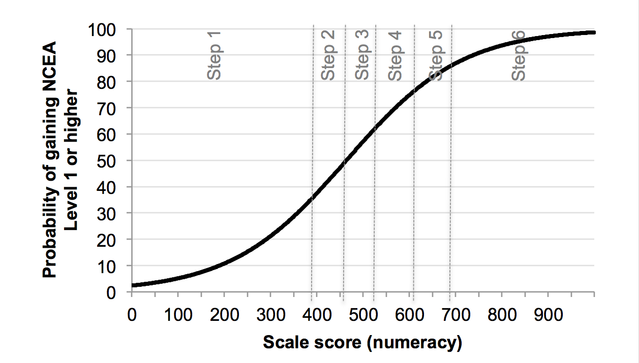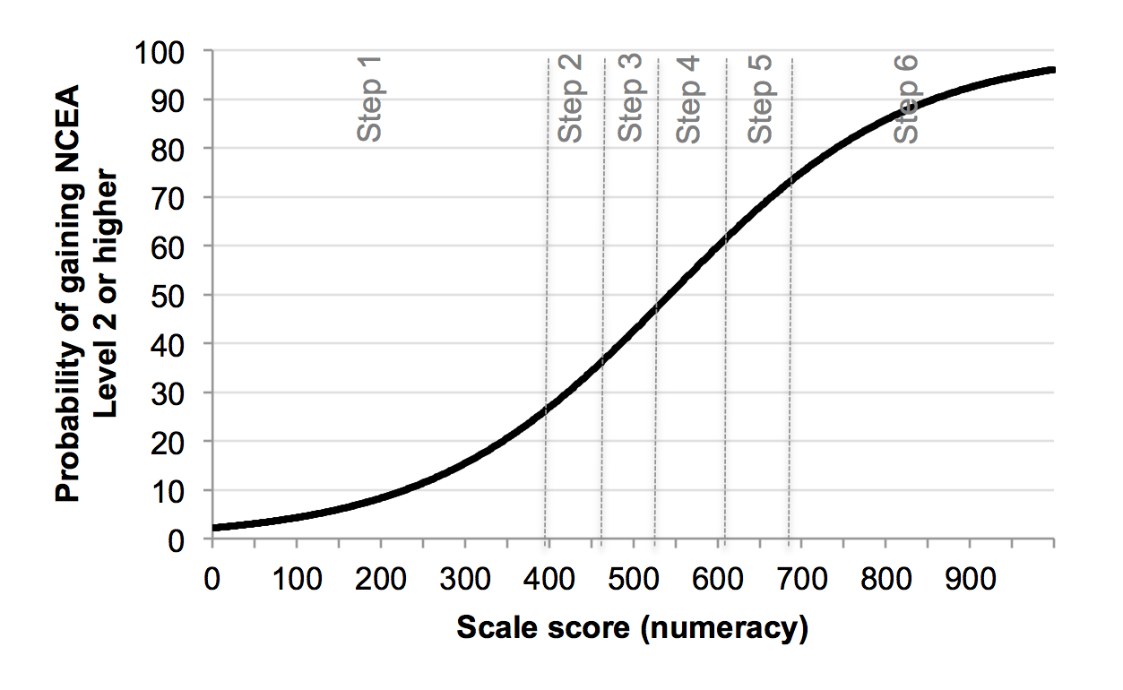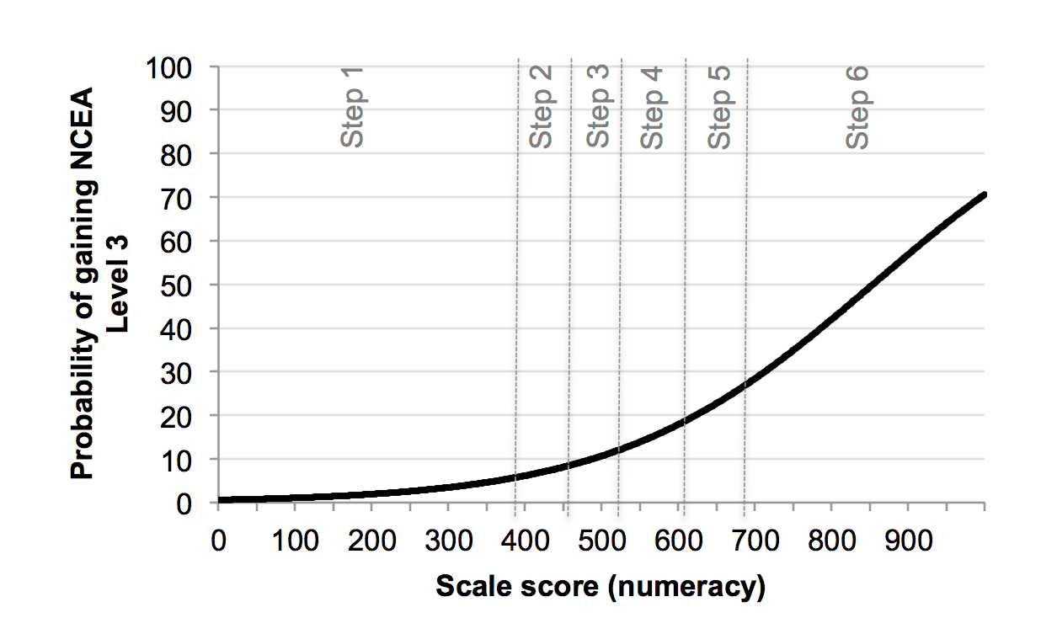
Figure 6 Logistic regression functions depicting the probability of the tertiary cohort attaining NCEA Levels 1, 2 and 3 conditioned on performance on the numeracy scale.
Figure 7 shows logistic regression functions depicting the probability of attaining NCEA Level 1 or above (top panel), Level 2 or above (middle panel) and Level 3 (bottom panel), conditioned on performance on the reading scale. Again, for all three levels, the discrimination of the logistic functions is similar, and low. This poor discrimination is perhaps more surprising in the case of reading than it is in the case of numeracy, because a majority of achievement standards can contribute to the NCEA literacy requirement, and most subjects with achievement standards entail a reading demand.
As was the case for the logistic functions conditioned on numeracy in Figure 6, there is a progressive decrease in the probability of attaining successive NCEA levels at any given reading scale score. The probabilities of attaining NCEA Level 1, 2 and 3 for students at the bottom of reading Step 4, the minimum designating a functionally adult level of literacy, are approximately 70 percent, 50 percent and 16 percent respectively.

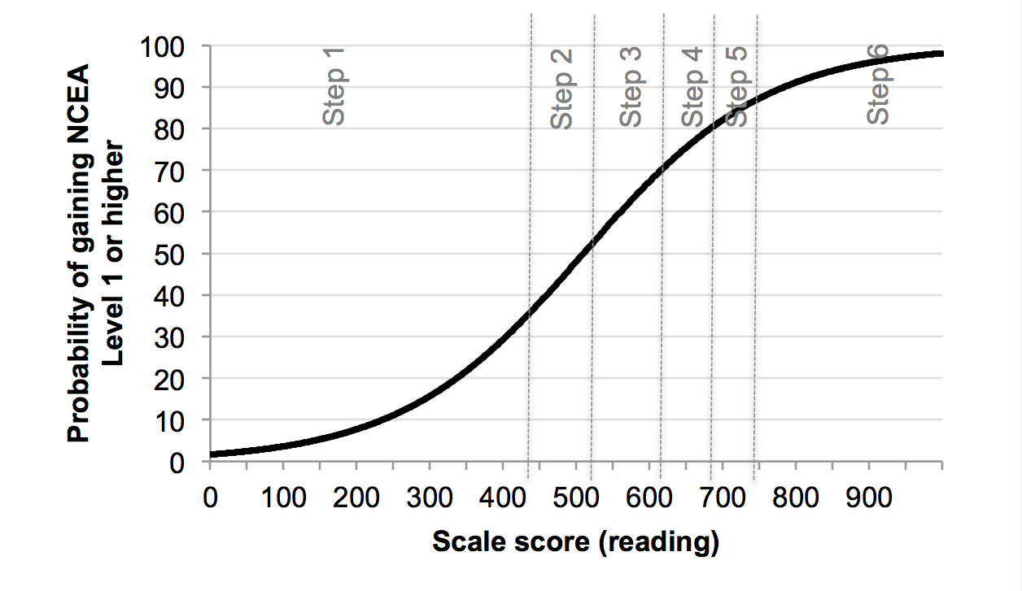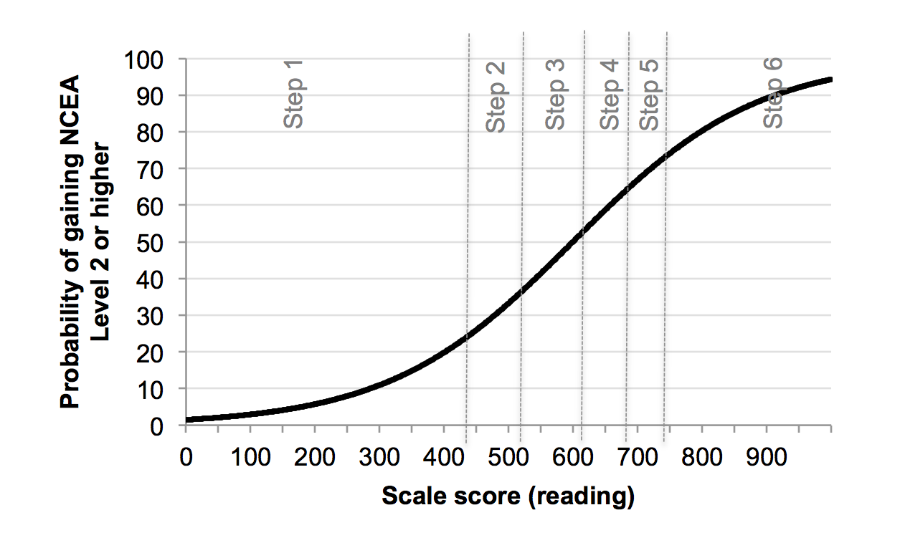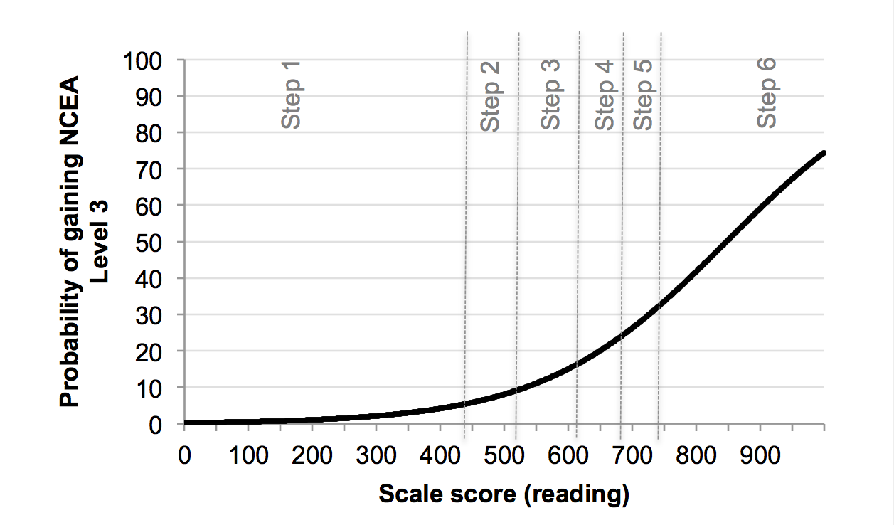
Figure 7 Logistic regression functions depicting the probability of the tertiary cohort attaining NCEA Levels 1, 2 and 3 conditioned on performance on the reading scale.

Aligning the learning progressions with the National Standards
This chapter investigates the alignment between the learning progressions and the End of Year 8 National Standards in reading and mathematics. The National Standards were designed so that a student who meets them is on track to succeed at NCEA Level 2. The research question is:
- What is the distribution on the Assessment Tool scales, and by extension, on the learning progressions, of students who are assessed as being at the End of Year 8 National Standard in reading and mathematics?
Table 11 shows the distribution of Year 8 students in the school sample by numeracy step for each National Standards mathematics OTJ category. The predominant categories for students judged to be well below, below, at and above the standards were Steps 2, 3, 4 and 5 respectively, with the majority of the remainder in each standards category reasonably evenly split between being a step lower and a step higher.
Table 11 Distributions on the numeracy steps of year 8 students in the school sample judged well below, below, at and above the End of Year 8 Mathematics Standard.
Numeracy Step | Well Below | Below | At | Above
1 | 24.5 | 4.7 | 1.1 | 0.3
2 | 39.6 | 20.0 | 3.6 | 0.7
3 | 34.0 | 42.6 | 22.0 | 2.7
4 | 1.9 | 29.5 | 49.9 | 22.1
5 | 0.0 | 3.2 | 21.3 | 43.8
6 | 0.0 | 0.0 | 2.0 | 30.4
n | 53 | 190 | 441 | 299
Table 12 shows the distribution of Year 8 students in the school sample by reading step for each National Standards reading OTJ category. A substantial majority (85.0 percent) of the sample were judged as being at or above the standard. There is a clear progression in the distributions, with almost two thirds of students judged as being well below the standard at reading Step 1, and almost all of the rest at Step 2. Three-fifths of students judged as being below the standard were at reading Step 2, with the remainder split quite evenly between Steps 1 and 3. Just over half of those judged as being at the standard for Year 8 were at reading Step 3, with the remainder predominately at Step 2, although about 12 percent were at Step 4. Those judged as being above the standard were evenly split between Steps 3 and 4 with 7.2 percent below Step 3 and 12.6 percent above Step 4.

Table 12 Distributions on the reading steps of year 8 students in the school sample judged well below, below, at and above the End of Year 8 Reading Standard.
Reading Step | Well Below | Below | At | Above
1 | 63.6 | 17.9 | 2.1 | 1.0
2 | 33.3 | 60.2 | 32.4 | 6.2
3 | 3.0 | 22.0 | 53.2 | 40.9
4 | 0.0 | 0.0 | 11.9 | 39.2
5 | 0.0 | 0.0 | 0.4 | 10.4
6 | 0.0 | 0.0 | 0.0 | 2.2
n | 33 | 123 | 479 | 403
Figure 8 shows the results of a logistic regression analysis describing the probability of being judged at or above the End of Year 8 Mathematics Standard conditioned on performance on the numeracy scale. The logistic function shows strong discrimination (i.e. the slope of the curve is steep) compared with the curves describing the probability of attaining NCEA requirements and qualifications conditioned on performance on the numeracy scale (Figures 4 and 6). For students at the bottom of Step 2, the probability of being judged at or above the standard is just over 10 percent, for those at the bottom of Step 3, it is about 40 percent, for those at the bottom of Step 4, the probability of being judged at or above the standard is around 70 percent, and for those at the bottom of Step 5, it is over 90 percent.
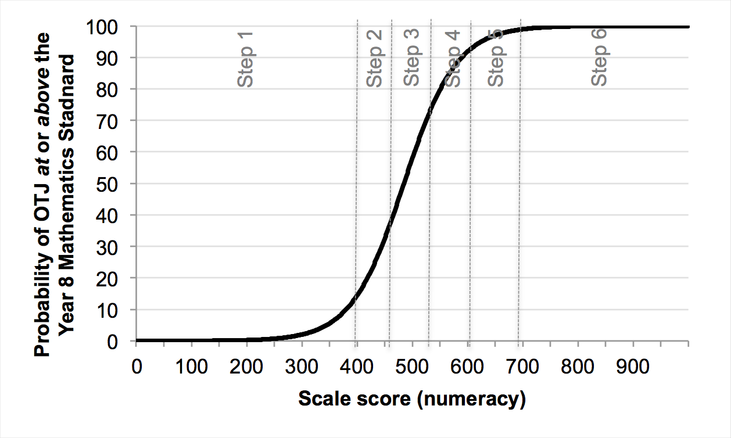
Figure 8 Probability of being rated at or above the End of Year 8 Mathematics Standard conditioned on the numeracy scale score. Probabilities were estimated using logistic regression. School sample.

Table 13 shows the empirical percentage of Year 8 students in the school sample at each numeracy step judged as being at or above the End of Year 8 Mathematics Standard. These figures include students at all scores within each step, and are therefore somewhat higher than the probabilities estimated in relation to Figure 8 which are based on the minimum score for each step.
Table 13 Percentages and numbers of year 8 students from the school sample at or above the End of Year 8 Mathematics Standard disaggregated by numeracy step.
Numeracy Step | Percentage at or above The End of Year 8 Mathematics Standard | Number at Step
1 | 21.4 | 28
2 | 23.4 | 77
3 | 51.5 | 204
4 | 83.4 | 343
5 | 97.4 | 231
6 | 100 | 100
Figure 9 shows the results of a logistic regression analysis describing the probability of being judged at or above the End of Year 8 Reading Standard conditioned on performance on the reading scale. Again, the logistic function shows relatively strong discrimination compared with the logistic curves describing the probability of attaining NCEA requirements and qualifications conditioned on performance on the reading scale (Figures 5 and 7). For students at the bottom of Step 2, the probability of being judged at or above the standard is about 40 percent, and for those at the bottom of Step 3, it is about 80 percent. For those at the bottom of Step 4, the probability of being judged at or above the standard is around 95 percent.
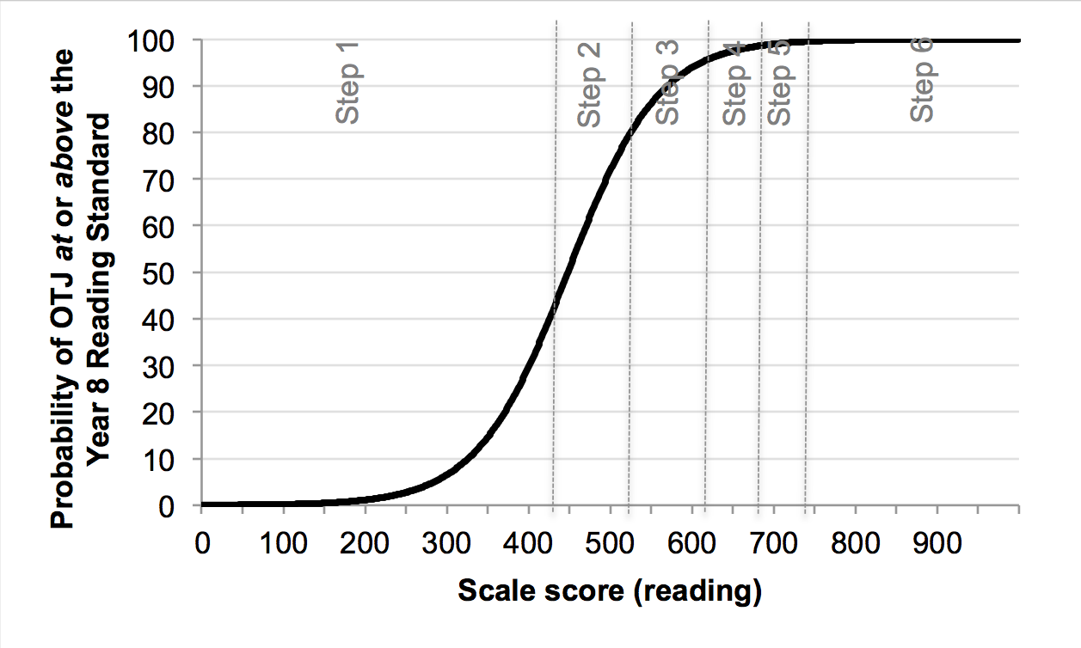
Figure 9 Probability of being rated at or above the End of Year 8 Reading Standard conditioned on the reading scale score. Probabilities were estimated using logistic regression. School sample.
Table 14 shows the empirical percentage of Year 8 students in the school sample at each step of the reading learning progressions who were judged as being at or above the End of Year 8 Reading Standard. Like the corresponding analysis of the numeracy steps (Table 13) these figures are all somewhat higher than the probabilities estimated in relation to Figure 9, because the latter were based on students at the bottom of each step, whereas the former includes students at all scores within each step.
Table 14 Percentages and numbers of year 8 students from the school sample at or above the End of Year 8 Reading Standard disaggregated by reading step.
Reading Step | Percentage at or above the End of Year 8 Reading Standard | Number at Step
1 | 24.6 | 57
2 | 67.9 | 265
3 | 93.8 | 448
4 | 100 | 215
5 | 100 | 44
6 | 100 | 9
It is informative to consider the proportions of Year 8 students that achieved at least numeracy Step 5, which we take to be well aligned to ALL Level 3. Seventy-four percent of students that were rated above the End of Year 8 Mathematics Standard were at numeracy Steps 5 or 6, while 23.3 percent of students rated at the standard were at these steps (Table 11). Almost no students rated below or well below the standard achieved numeracy Step 5.
Smaller proportions of Year 8 students achieved at least reading Step 4. Fifty-two percent of students rated above the End of Year 8 Reading Standard were at reading Steps 4 to 6, while 12.3 percent of students rated at the standard were at these steps (Table 12). No students rated below or well below the standard were above reading Step 3.

Synthesis and Suggestions
In this chapter, we consider what would be required to develop an integrated mechanism for identifying individuals below the desired minimum levels of reading and numeracy, which are currently accepted to be ALL Level 3. The research question is:
6 What would constitute an integrated mechanism for identifying individuals below the literacy and numeracy benchmarks (Step 4 of the reading progressions and step 5 of the numeracy progressions)?
In this chapter, we demonstrate how the Assessment Tool could be used as an integrated mechanism for identifying individuals below desired minimum levels in literacy and numeracy, and show how it can be used as a lynchpin for integrating information from other literacy and numeracy related measures and benchmarks. We also explore some of the caveats on this kind of usage of the tool, and suggest some further work that could increase its efficacy for this purpose.
Figure 10 depicts box-and-whisker diagrams showing the distributions of five cohorts from the two samples used in the present work on the reading scale. Figure 11 depicts the distributions of the same five cohorts on the numeracy scale. These plots enable an analysis of the relative levels of reading and numeracy across these cohorts, which span 12 to 20 year olds.
One quarter of the Year 8 sample is above ALL Level 3 for reading under the criterion defined for this research (Step 4 on the reading scale). For year 11 students with NCEA Level 1, this increased to one half, with a small further increase of 10 percent for Year 12 students with NCEA Level 2. Similar comments apply to the numeracy scale except that the proportion of the Year 8 sample above the minimum desired level (Step 5 on the numeracy scale) was slightly more than one quarter. It is worth nothing that the reading profile of the Year 12 students who have attained NCEA Level 2 is very similar to that of the literacy profile of the adult population of New Zealand, as measured by the ALL survey in 2006. The numeracy profiles of both the Year 11 students that have attained NCEA Level 1 and the students in the tertiary cohort that have met the NCEA numeracy requirement also reflect these adult levels. The figures show that, while reading and numeracy do improve as students move from the end of the National Standards system to the level of formal qualifications, they do not improve at a sufficient rate to ensure that a clear majority of students will leave school with the literacy and numeracy competencies that they need to operate in an information-rich society.
For both the reading and numeracy scales, the distributions of the tertiary cohort who had met each of the literacy and numeracy requirements for NCEA Level 1 closely resemble those of the Year 11 cohorts with NCEA Level 1. This is to be expected as the tertiary cohort includes 16 to 20 year olds studying at Levels 1 to 3 of the NZQF, and excludes university students. It is likely that on average this cohort would have had poorer reading and numeracy skills at school than those in the school sample.
The distributions of the tertiary cohort that had not met each of the literacy and numeracy requirements for NCEA Level 1 is concerning; in both cases the medians of these distributions are lower than the corresponding Year 8 sample, and in the case of numeracy, lower at the upper and lower quartiles as well. In both cases, just one quarter of this cohort meet the literacy and numeracy benchmarks. It needs to be remembered that the tertiary cohort that is the focus for this research is likely to have a lower achievement profile than the more representative school sample.
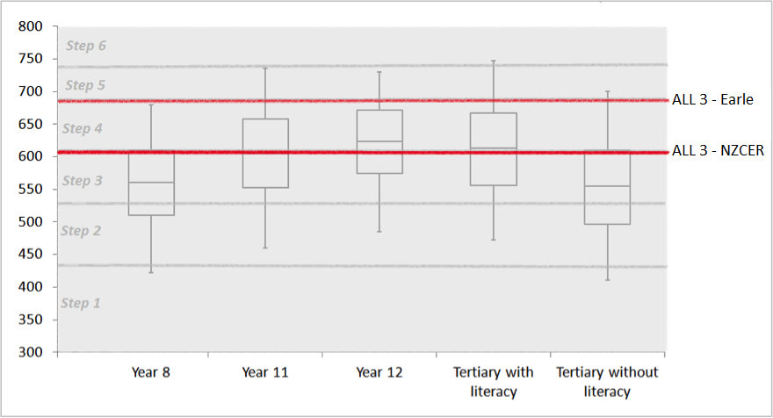
Figure 10 Distributions of Year 8 students, Year 11 students with NCEA Level 1, Year 12 students with NCEA Level 2, tertiary students with the NCEA literacy requirement and tertiary students without the NCEA literacy requirement on the reading scale.
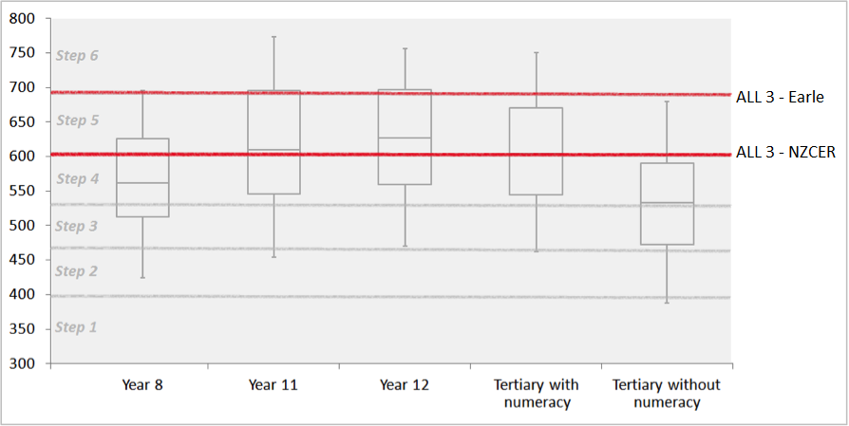
Figure 11 Distributions of Year 8 students, Year 11 students with NCEA Level 1, Year 12 students with NCEA Level 2, tertiary students with the NCEA numeracy requirement and tertiary students without the NCEA numeracy requirement on the numeracy scale.

The Assessment Tool has two very attractive features as a lynchpin or integrating mechanism: it is calibrated to a measurement scale, and its online platform and adaptive algorithm and item bank make it accessible and efficient. However, before it can be adopted as an integrating mechanism, some further work should be undertaken and some caveats apply. First, given the equivocal nature of the alignment work already undertaken, further work should be undertaken to confirm the steps on the reading and numeracy scales that best represent the minimum competencies required by New Zealand adults to participate fully in an information-rich society. Because the ALL survey has been superseded by the Programme for the International Assessment of Adult Competencies (PIAAC) which will first be conducted in New Zealand in 2014 (Ministry of Education, 2014c) it would be useful to align these minimum competencies with the PIAAC scale. Ideally, this would be done using a combination of the methods employed by NZCER (2010a, 2010b) and Earle (2014); that is, both a measurement approach and a statistical approach, using sufficient numbers of items from each of the PIAAC assessment and the Assessment Tool to reliably co-calibrate, as well as to undertake regression analyses to map the two scales onto one another.
It needs to be remembered that this project has not included measures of writing, listening, or speaking which are all important aspects of literacy. While the Assessment Tool does include an adaptive writing assessment it may be worth considering extending the scope of the tool to include these elements if it were to be used for the purpose of identifying whether individuals had met the agreed minimum competencies. Similarly, elements of geometry and statistics are not included in the Assessment Tool measure of numeracy. Additionally it needs to be noted that the Year 8, 11 and 12 students completed assessment items developed for an adult audience. While there was no indication from the participating schools that the items were inappropriate it is likely that the newly developed Youth Assessment option would be more engaging and understandable to secondary school students.
A key finding from the present project is that the literacy and numeracy requirements for NCEA cannot be used as reliable indicators of students’ literacy and numeracy capabilities. While it is not a purpose of this report to make formal recommendations regarding the policy implications of this finding, some suggestions for consideration follow.
The literacy and numeracy requirements for NCEA appear to be attainable with levels of reading and numeracy skill below the current literacy and numeracy benchmarks. While it might be desirable to demonstrate that high proportions of students are meeting these requirements, several consequences of weak criteria for meeting them might ensue. First, many individuals might be misled into believing that they are functionally literate and numerate when they are not. Second, employers or higher-learning institutions may disregard the literacy or numeracy credentials linked to NCEA and establish their own testing regimes. Third, there is a risk that policy makers may overestimate the literacy and numeracy competencies of school leavers.
Part of the solution must therefore be to ensure that the requirement is set at the appropriate level and that it is properly and rigorously assessed. The pathways themselves may also need review if they do not certify functionally adult levels of literacy and numeracy. Another component of the solution might be to institute literacy and numeracy requirements prior to the senior secondary years that must be met as a pre-requisite to undertaking formal qualifications. It might also be appropriate to consider credentialing literacy and numeracy independently from qualifications, to assess and certify the level of literacy and numeracy attained by each student before they leave school.

References
Darr, C. (2010). Inside the Assessment Tool: Part 2. In Assessing Adult Learning: literacy and numeracy competencies (pp. 41–52). Wellington: NZCER Press.
Earle, D. (February, 2014). Measures of Adult Literacy and Numeracy, Comparing the Adult Literacy and Life Skills Survey and Literacy and Numeracy for Adults Assessment Tool. Wellington: Ministry of Education.
Ministry of Education (March, 2009). How well do qualifications predict literacy and numeracy (Fact sheet). Ministry of Education, Wellington.
Ministry of Education (March, 2009a). The New Zealand Curriculum Reading and Writing Standards for years 1-8. Ministry of Education, Wellington.
Ministry of Education (March, 2009b). The New Zealand Curriculum Mathematics Standards for years 1-8. Ministry of Education, Wellington.
Ministry of Education (2014). Tertiary Education Strategy 2014 -2019. Ministry of Education, Wellington.
Ministry of Education (2014a). July School Roll Returns. Retrieved 12 June, 2014, from: http://www.educationcounts.govt.nz/statistics/schooling/july_school_roll_returns
Ministry of Education (2014b). Better Public Services. Retrieved 10 June, 2014, from: http://www.minedu.govt.nz/theMinistry/BetterPublicServices.aspx
Ministry of Education (2014c). Programme for the International Assessment of Adult Competencies (PIAAC), International Survey of Adult Skills (ISAS). Retrieved 12 June, 2014, from: http://www.educationcounts.govt.nz/topics/research/piaac
NZCER (2009). Automatic Assembly of Test Forms. Internal Technical Report for the Assessment Tool.
NZCER (2009a). Unit CAT algorithm – implemented. Internal Technical Report for the Assessment Tool.
NZCER (2010a). Notes on equating international adult literacy and numeracy scales wit the New Zealand Literacy and Numeracy for Adults Assessment Tool. Technical report 1 for the Tertiary Education Commission.
NZCER (2010b). ALL items in relation to Assessment Tool levels. Technical report 2 for the Tertiary Education Commission.
NZQA (n.d.). Level 1 literacy and numeracy requirements. Retrieved May 5, 2014, from: http://www.nzqa.govt.nz/qualifications-standards/qualifications/ncea/subjects/literacy-and-numeracy/level-1-requirements/
NZQA (n.d.a). Clarifications that apply to all Literacy and Numeracy unit standards. Retrieved 5 May, 2014, from: http://www.nzqa.govt.nz/qualifications-standards/qualifications/ncea/subjects/literacy-and-numeracy/literacy-and-numeracy-unit-standards/clarifications/all-literacy-and-numeracy-unit-standards/
NZQA (n.d.b). Background to the development of the Literacy and Numeracy unit standards. Retrieved 5 May, 2014, from: http://www.nzqa.govt.nz/qualifications-standards/qualifications/ncea/subjects/literacy-and-numeracy/literacy-and-numeracy-unit-standards/background-to-literacy-and-numeracy-standards/
NZQA (2011). Guidelines for assessing Level 1 Literacy and Numeracy unit standards. Retrieved 18 August, 2014, from: http://www.nzqa.govt.nz/assets/qualifications-and-standards/qualifications/ncea/NCEA-subject-resources/Literacy-and-Numeracy/Resources/Planning-implementation-and-assessement/Guidelines-for-assessing-Literacy-and-Numeracy-unit-standardsJan13.pdf
Rasch, G. (1960/1980). Probabilistic models for some intelligence and attainment tests. (Copenhagen, Danish Institute for Educational Research), expanded edition (1980) with foreword and afterword by B.D. Wright. Chicago: The University of Chicago Press.
Samejima, F. 1969. “Estimation of a Latent Ability Using a Response Pattern of Graded Scores.” Psychometrika Monograph Supplement 17.
Satherley, P., Lawes, E., & Sok, S. (2008). The Adult Literacy and Life Skills (ALL) Survey: Education, work and literacy. Wellington.
Satherley, P., Lawes, E., & Sok, S. (2008a). The Adult Literacy and Life Skills (ALL) Survey: overview and international comparisons. Wellington.
Statistics Canada, & Organisation for Economic Cooperation and Development. (2005). Learning a Living: first results of the adult literacy and life skills survey. Ottawa and Paris.
Tertiary Education Commission (2008). Learning progressions for adult literacy and numeracy: background information. Wellington.

This sample included 364 Trades Academy students.

