Learner Success Plans for investment in 2022
This infosheet provides background information about the TEC’s Ōritetanga Learner Success work to ensure success for all learners, and in particular more information for Learner Success Plans for investment in 2022

We need a transformational change
A system-level shift in performance is required to ensure that all learners succeed in tertiary education.
We know that tertiary education organisations that want to make a difference for learners need to shift from individual interventions and pockets of focus to a systemic learner focus in all aspects of their operations. A holistic approach is required, involving several key elements:
- strong leadership within TEOs and in relationships with key partners (including employers, family, whānau, iwi)
- systems and processes designed with the learner in mind, including teaching and learning environments
- a ‘guided pathways’ approach that makes it clear to learners before they enrol what they need to do to gain a qualification and where their qualification will lead them, and
- data and technology solutions that can be used to appropriately track learner progress.

Strong leadership is essential to enabling learner success
Because such a broad and transformational change is needed in order to effect improved learner outcomes, we need a strong dedicated mandate from leaders in the tertiary system. We all need to play our part, and face up to the question: are we the problem?
The Government has responded to the challenge in its new Tertiary Education Strategy (TES). Learner success is at the very heart of the TES, with a focus on: learners at the centre, ensuring barrier-free access, and quality teaching and learning.
The new Education and Training Act 2020 includes, in its purpose statement, the need to establish and regulate an education system that honours Te Tiriti o Waitangi and supports Māori-Crown relationships.
Learner success is also a key priority for the TEC. Our vision is: “a resilient, prosperous New Zealand – where every person has the skills, knowledge and confidence to create a fulfilling life.”
Our work with our Ōritetanga Learner Success pilot projects over the past two years has clearly demonstrated that we need TEO governance and management to make a real commitment to driving learner success across their organisations.

What we want to see in Plans
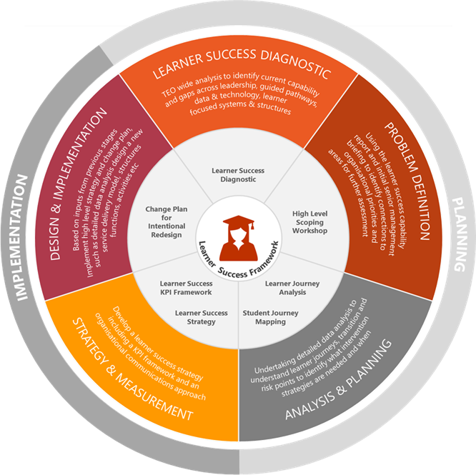
In our Plan Guidance we have said we will look for clarity and specificity in your Plans about what you are currently doing to improve participation, achievement, and outcomes for learners, and your plan for contributing to the achievement of equity in tertiary education.
Continuing our work over the past three years, as part of our Investment Toolkit this year we will again be releasing a Learner Success Plan (LSP) template to help you answer these questions, and provide specific guidance about what we want to see in your Plans. This includes:
- an understanding of what parity of participation would look like for your TEO, and whether you are currently achieving it
- a commitment at governance, management, and leadership levels to achieving parity of achievement for your all learners
Learner Success Framework
- teaching and learning that responds to the needs
of learners, e.g. use of culturally affirming teaching
practices, or content that reflects cultural knowledge and values, and
- support for learners and their families, whanau, iwi and communities to make informed decisions about, and successful transitions into, tertiary education.

We have developed and used Learner Success Plans since 2018
Over the past three investment rounds we have used LSPs to focus TEOs on the importance of improving outcomes for learners, particularly those who have historically been under-served by the tertiary education system. Each year the LSP has been reviewed and revised to improve usability and relevance. Once again we have updated the LSP and intend to use it as an integral part of this year’s investment round (for funding from 2022).

We have made few changes to the LSP
After the last investment round we realised that the LSP template was not really relevant to trainees in the workplace. We have therefore included some workplace-specific sections for those TEOs which have responsibility for learners in the workplace.

We will align use of LSPs with the Plan cycle
For this Plan round (for 2022 funding) we will require any TEO which is required to submit a full Plan and which receive more than $5m in TEC funding to also submit an LSP.
Other TEOs are not required to submit a new LSP, but they may choose to inform us of any significant changes they are making to their learner success approach. We will also ensure that current LSPs for these TEOs are included in regular monitoring and engagement conversations with their TEC Relationship Manager. Progress against commitments made in LSPs may be used by the TEC in assessing any applications for additional funding.

